URBANIZATION:
The Effect of Urban Development on
US Vehicle Travel and Fuel Demand

Table of Contents
Executive Summary 3
Introduction 23
Part I – Urban History and Geography 27
Organic Forces of Urban Development 28
American Urban History, 1776 – 1945 37
Post World War II: Flight to Suburbs
Matures Into Edge City and Polycentric Metropolis 65
Living on the Polycentric, Metropolitan Edge:
The Vocabulary of the New Urban Geography 89

Part II – Urban Trends 100
Social Trends and Consumer Housing Preference 101
Congestion 115
Public Transit 134

Part III – Compact Development Movements 154
Introduction to Compact Development 155
Smart Growth 157
New Urbanism 184
Transit-Oriented Development (TOD) 200
Assessment of Compact Development 221
Conclusion 238
End-Notes 240

Executive Summary
This executive summary will mostly be a high-level discussion of the central issues in the study, particularly concerned with exploring the historical forces of urbanization that most directly bear upon the transportation issues relevant to Fuels Institute participants. It will begin by briefly reviewing the motivation of the study, and touching on the fundamental tension between planned and unplanned development which colors, and confuses, so much of the public discourse on urbanism. Not everything that is ardently planned actually comes to pass in the manner hoped for, especially with creatures as complex as modern metropolitan areas, and not every historical force that is actually integral to the development of cities can be visibly seen without some intellectual excavation.
After presenting the motivation of the study, and the structure of the chapters, this executive summary will review the major historical forces seen by the author to affect urban form; discuss the inherent tension between these forces and the claims of the compact development movements; and then systematically present data on the limitations of the compact development movements’ potential for containing urban development and/or reducing automobile usage. All of these topics, and more, are covered in equal or greater detail in the body of the study itself.
Motivation of Study
This study has asked the question of whether trends in urbanization, on a national basis across the USA, have had an effect on the historic plateau of the long-term curve for vehicle-miles traveled (VMT). This curve, which went up nearly every year between the end of the Second World War and 2004, has now stabilized for over a decade, since 2004. As 84% of Americans now lived in metropolitan areas as of 2010, the question of urbanization is thus a very current one to ask. The situation can be summed up graphically as follows:

Source: US Census Bureau Source: Federal Highway Administration

An earlier Fuels Institute study, “Driver Demographics: The American Population’s Effect on Fuel and Vehicle Demand,” identified saturation of numerous demographic trends, among them women’s and elderly persons’ driver licensing, as well as travel stratified by income, as causes of the stabilization of the VMT curve. However, since land-use and transportation are so integrally related, urbanization must also be considered as a major factor.
Central to the discussion are activist groups who wish to alter America’s urban land-use patterns so as to make them higher-density, more walkable, more compact, and more mixed-use. They point out that with population expected to increase by nearly 100 million persons between 2014 and 2060, nearly ¼ of America’s housing units, and other types of buildings, are as-yet unbuilt.
Over time, then, this population growth presents an incremental opportunity to transform the built landscape of the future. These groups claim that their proposed changes can reduce VMT by as much as 20% to 40% over existing land-use configurations. This is based on a meta-analysis of existing research literature.
The question then becomes, what is the possible scope and extent of the smart growth programs? Can they truly become widespread enough, over time, to achieve this 20% - 40% reduction in VMT?
And what of the natural evolution of cities, separate and apart from any given planning program? After all, urban historian Robert Fishman eloquently makes the point that cities often evolve of their own accord, and that many of the great planning programs have actually resulted in the exact opposite of what was consciously intended:
“[modern urban forms] emerged in spite of, not because of, the conscious purposes motivating the main actors. The postwar housing boom was an attempt to escape from urban conditions; the new highways sought to channel traffic into cities; planners attempt to limit peripheral growth; the government programs that did the most to destroy the hegemony of the old industrial metropolis were precisely those designed to save it.”
Constructing An Answer: Structure of Report
In order to answer these questions, this study has taken a multiple pronged approach.
First of all, it outlined the growth and development of the American city from the early 1800s until the present-day, with particular emphasis on the way in which transportation technologies have shaped urban geography. The purpose is to create a common vocabulary, of the most pertinent concepts, for holistically discussing the history and geography of cities.
Second, it has presented a statistical analysis of the past half-century of urban development, in order to clarify the analysis and place it on an objective basis. Topics covered include socio-demographic trends and consumer housing preference; traffic congestion; and transit usage.
Third, and finally, this study examined the compact development movement in great depth. For each of the three major sub-movements—smart growth, new urbanism, and transit-oriented development—definitions, stakeholders, a brief history, major characteristics, and impact on VMT have been presented.
VMT Equation: Stable Framework of Analysis
All along, the study periodically returns to the “VMT equation” as a stable and consistent framework for relating findings on urban trends to the long-term VMT curve. This is meant to establish stable benchmarks and tools of analysis, in order to anchor future discussions within a common frame of reference.
The VMT equation can be expressed as:
VMT = (vehicle trips) (average vehicle trip length)
In addition, the variable of travel mode choice lurks in the background, because trips undertaken by a mode other than a motor vehicle will contribute to travel but not to VMT.
Nevertheless, the findings of this study will necessarily transcend a simple equation such as this. Urbanization is a historical process which has many non-quantifiable variables, such as the psychology and culture of a region, or the coincidence of timing of new technological applications with the particular stage of development at which a nation finds itself. The extent to which a nation is thus open to change, not only psychologically but also in terms of available open land, plays a significant role in what urban changes happen, and when.
Discussion: Organic Historical Forces and Planned Interventions
This study has not solely been a simple answer to the question, “what effect will the smart growth or compact development movements have on urban form?” This question has been answered, and the answer will be reviewed below, but there is also a historical component which has been reviewed. It is the interplay of history and planning, or of unplanned organic forces and the attempts of planners to counter these, which is really central to understanding this study. The bottom line is that the law of unintended consequences can be very powerful, and not every intended past change to America’s cities has led to consequences even remotely resembling what was intended.
Unintended Consequences: 1950s
One of the best-known examples would be the belief of Interstate builders in the 1950s that tearing up urban downtowns in order to drive elevated, limited-access expressways through the cities would somehow solve a perceived problem of “urban blight.” Instead, it ended up destroying healthy neighborhoods, hastening the flight to the suburbs, accelerating the destruction of the urban tax base, and creating isolated public housing projects which nearly all observers would agree were monumental failures. In fact, one of the most acclaimed housing projects, Pruitt-Igoe of St. Louis, had won numerous architectural awards when built in the 1950s – and was ignominiously imploded in 1972, due to a wide consensus that it was totally unlivable, an abject failure. It seems prudent to view the claims of the smart growth movement with some caution, then, because past history shows that for many projects of urban change, they may be abject failures even if implemented completely along the lines prescribed by their most vocal proponents.

“Movement Sprawl”
Further, there is something rather ironically “sprawling” about these movements, in that their claims point to urban development patterns and auto-dependence as the universal culprit of problems which many other observers would see as having very complex, multilayered origins, with no easy, static target to blame. Unlike the 1950s, when combating urban blight was a motivation of city reformers, the compact development movements address an enormous agglomeration of ills such as obesity, social cohesiveness, psychological alienation, climate change, air quality, wetlands preservation, forest preservation, and so on – all to be blamed on the current form of the city and all to be tackled by the compact, walkable principles of new urbanism and transit-oriented development. See chapter 10, “Smart Growth,” for further documentation of these claims.
In general, the topic of urban sprawl is one where many if not most authors, both on the left and right of the political spectrum, are prone to rhetorical, even polemical, overreach—the historian Robert Fishman refers to “the polemical overstatements that seem to afflict anyone who deals with these topics”—and where claims and counter-claims need to be evaluated with caution. Something about these topics seems to hit at the heart of how Americans live and how they think their neighbors should live, and sets off whirlpools of controversy and polemics, at least in policy circles among people who pay attention to these matters.
This executive summary, as well as a chapter in the study itself, will eventually, in the final section, give in-depth, data-driven information on the very strong limitations that exist to a sweeping application of the smart growth program. These results, too, should be read with caution and a skeptical eye, since America is a country which has shown itself time and again to be a repeated first adopter of new technologies, where change happens more rapidly than in almost any other nation. Unexpected paradigm shifts may occur that lead to more compact developments; it is just that they are unlikely to do so linearly in the way envisioned by the major texts of the smart growth movement. City evolution is just too complex of a process for that.
If not planning, then what? What forces are at play?
This, then, brings the discussion back to broader historical themes. What is it, in fact, which governs the shape of the American city, and can these larger historic themes be recognized and tapped into, in any coherent way?
Transportation Technology and Urbanism
This study’s multi-chapter section on urban history touches on a wide array of overarching forces, and prioritizes transportation technology and land-use economics as two factors which play a very dominant role, dividing the history of America’s cities into periods defined among other things by the dominant transportation technologies of the time, and the resultant urban geography. Transportation technology, and the land-use possibilities stimulated by new infrastructure, have always been integrally related to real-estate development and the radial or circumferential form of urban areas; “transit-oriented development” is an age-old process which is not new at all.
In brief, the periods of American urban development are as follows—these are covered in more depth in Chapter 3, “American Urban History, 1776 – 1945.” From 1776 until roughly 1815, American was an agrarian nation in which most cities were little more than walkable villages. Beginning in 1815, and running through to 1875, the “walking city” of Revolutionary times was transformed into the “young industrial metropolis” when various forms of rail transit (both interurban and intraurban) were invented and adopted, between 1815 and 1875.
The mature industrial metropolis, of 1875 – 1945, experienced its first major wave of physical expansion with the introduction of the electric streetcar in 1888, which spread nearly instantaneously as cities all over American enthusiastically adopted it and laid extensive networks of track. The second major wave of expansion was facilitated by the early adoption of the mass-marketed automobile, between 1908 and 1940. Both of these inventions—trolley and automobile—dramatically increased the possible radius and circumference of a metropolitan area, through dramatic reduction of the per-mile cost of travel and increase in possible origins and destinations of travel. The automobile, in particular, added enormous flexibility in travel origins and destinations, and as early as the 1910s, factories and homes were beginning to “suburbanize” their location away from rail lines and into large swaths of previously undevelopable land. See chapter 4, “Mature Industrial Metropolis, 1875 – 1945,” for futher information.
Electricity and Telecommunications
Infrastructure of other types plays a major role, too. The dawn of the electric age, from the 1870s onward, pushed forth a relentless series of innovations which profoundly, fundamentally changed nearly everything about the way that Americans live. The term “electropolis” was even coined in the late 1800s to describe the radically transformative changes which occurred. Tele-communications, and power generation, were of particular importance. The telephone meant that information-dependent business activity, the type of commerce at which cities have historically been most suited for the physical gathering of relevant persons, did not necessarily need to concentrate in a central business district as in the past. At least for some industries, and some tasks, the necessary information could now be obtained and disseminated remotely, and some amounts of business transacted without being face-to-face.
The radio meant that people could find entertainment, and keep up to date on current events, without leaving the privacy of their own home, and at very long distances from the broadcasting studio. The phonograph meant that one could now listen to recordings of world-class musical performances, without ever leaving home. Altogether, these inventions fused with an independent American “frontier spirit” and the ascendant transportation technology of the automobile, to make it conceivable that life away from the immediacy of the city could still be a life socially and economically connected to other people as well as society at large.
Power generation, and the development of the electricity grid, had an enormous impact as well. At the level of the individual family, a transformation in daily life took place in the early decades of the 1900s, as consumer appliances were aggressively mass marketed by electric power companies. The more that the grid was built out, the more that families could live in outlying areas and still have access to these modern conveniences – and thus the more that they could feel confident that living in a suburban location would not deprive them of any necessities of the American lifestyle.
At the level of the business firm, particularly the manufacturing firm, the build-out of the electric grid was transformative for decisions on where to site the company. In conjunction with the growth of the highway network and the increasing availability of trucks, the build-out of the grid meant that as early as the 1910s and 1920s, companies could access large acreages of cheap, previously undeveloped land for siting their factories. The extension of the electric grid meant that they could be assured of the requisite power for running their assembly lines, and the emergence of trucks meant they were no longer dependent upon monopolistic railroad companies for long-distance freight. Together these factors constituted very powerful incentives for at least some firms to decentralize and suburbanize their location. Employees, many of whom now had cars themselves, could drive to the new, decentralized location, and if they didn’t have a car, the new location of their employer would be an incentive to get one.
Permanence of Infrastructure Revolutions
It should be noted that all of the above events took place between 1815 and 1945: revolutions in transportations, communication, and power generation. The American metropolis of 2015 depends on each of these for its physical form, but since these transformations occurred outside of most persons’ living memory, they tend to be forgotten today. Nevertheless, unlike the fashionable policy prescriptions of a recent decade or two, these are permanent, underlying factors affecting urban form which have lasted more than a century each, and need to be taken into consideration in projecting future possibilities.
Layering of Infrastructure
A lesson to learn from this infrastructure summary is that cities are shaped along the lines of the infrastructure available at the time that they are developed. It is impossible to build with uninvented technologies; and it is very unlikely to build with obsolete ones. The technologies that are most prevalent, and most cost-effective, when an urban area is being created, are the ones likely to be used. Thus, the innermost areas of Boston have street grids created for horse paths in the 1700s, whereas the outlying areas of Boston have tangles of decentralized Interstate-dependent sprawl as spread out as any other metropolitan area. On the other hand, a much newer city such as Phoenix, which did not expand into a large metropolitan area until after World War II, was developed along the lines of near-total auto-dependence, with such low density that there tend to be larger than normal distances between the buildings themselves, let alone the very uncrowded population density.
Consequent Layering of Urban Development – Like Tree Rings
Accordingly, like the rings of a tree, America has many layers of urban development. The inner layers, those parts developed between the 1600s and roughly 1815, are within the urban cores of the oldest settlements, places such as Boston, Philadelphia, or New York. The next innermost layers, those developed between roughly 1815 and 1940, are quite often placed on a narrow grid pattern, suitable for either trolley lines or low-volume automobile traffic, and particularly well-suited to building skyscrapers. Finally, the most recent layers still maintain a grid pattern but it is an extremely long and broad one, where the sides of the grid are Interstates and one must drive at high speed in order to get from one “square” of the grid to the next. These recent layers also tend to feature suburban areas designed around the cul-de-sac concept, and “ring roads” or “perimeter beltways” of Interstates surrounding the inner central city. Many cities, such as Houston, are so decentralized as to actually have three sets of ring highways surrounding their central city.
Culture: The New Frontier, American Love of “The Edge”
And then there is the psychological or cultural factor. Journalist Joel Garreau, who in his book Edge City: Life on the New Frontier coined the term “Edge City” to describe the decentralized mini-boomlets of office space which he observed during travels around America in the 1980s, argues strongly that the American metropolis is shaped by an underlying “edge” philosophy that is broadly shared by Americans. He situates his Edge City construct as a new archetype, or new paradigm, of the American metropolis, and argues that it expresses fundamental values of the American spirit, saying that,
“It addresses profound questions, the answers to which will reverberate forever. It addresses the search for Utopia at the center of the American Dream. It reflects our perpetually unfinished American business of reinventing ourselves, redefining ourselves, announcing that our centuries-old perpetual revolution—our search for the future inside ourselves—still beats strong.
It suggests that the world of the immigrants and pioneers is not dead in America; it has just moved out to Edge City, where gambles are being lost and won for high stakes. It adds another level of history to places already filled with ghosts. That is why one day Edge City, too, may be seen as historic. It is the creation of a new world, shaped by the free in a constantly reinvented land.”
Garreau essentially places the Edge City both on the frontier of the present and on the frontier of the past. He recognizes the temporary nature of this particular geographic pattern, but places it within a perpetual historic cycle, in explaining that “one day Edge City, too, may be seen as historic.” Since the writing of his book, in 1991, many of the Edge Cities he identified have matured, stabilized, and been subsumed into ever-expanding metropolitan areas – but the general principle arguably holds, since as economic growth occurs new frontiers, and new edge cities, appear on the landscape.
Interestingly, Garreau’s choice of words echoes a very famous political speech from 1960 that may express the same historical continuity. The subtitle of Garreau’s book is “Life on the New Frontier,” and this has direct echoes of the presidential nomination acceptance speech of John F. Kennedy, on July 15, 1960, in Los Angeles (incidentally a metro area which may be seen as one of the prototypical edge city agglomerations). The current study is not meant in any way as a partisan or party-based document, but the following excerpt from what became known as the “New Frontier” speech echoes Garreau so closely as to give rise to the question of whether a clear historical continuity in American culture has been identified:
“the New Frontier of which I speak is not a set of promises—it is a set of challenges. It sums up not what I intend to offer the American people, but what I intend to ask of them. It appeals to their pride, not their pocketbook—it holds out the promise of more sacrifice instead of more security.
But I tell you that the New Frontier is here, whether we seek it or not. Beyond that frontier are the uncharted areas of science and space, unsolved problems of peace and war, unconquered pockets of ignorance and prejudice, unanswered questions of poverty and surplus. It would be easier to shrink back from that frontier, to look to the safe mediocrity of the past, to be lulled by good intentions and high rhetoric—and those who prefer that course should not cast their votes for me, regardless of party.
But I believe the times demand new invention, innovation, imagination, decision. I am asking each of you to be pioneers on that frontier.”
The speech is clearly political, in its call to action. As explained above, this study is non-partisan, but it is striking that the very same vocabulary of pioneers, frontier, innovation, and risk-taking are used in this speech and in Garreau’s influential book, thirty years apart. Is there a continuity in the national culture, of a science-based, risk-taking, “edge mentality” or “frontier psyche”? Does this play out in a concrete effect on America’s urban metropolitan forms?
Edge Cities: Scientific Exploration and Discovery
Kennedy’s speech situated the coming decades of American life as ones of scientific exploration and discovery, in that even though the physical frontier of the West had been settled, the quest to live on the edge of new knowledge would continue. It is very interesting that the “edge cities,” observed by Garreau 30 years later, tend to cluster some of the most lucrative, wealth-creating jobs in America and often focus on the most high-tech, cutting-edge industries, such as aerospace, semiconductors, and software engineering. Certainly, iconic “edge” tech corridors such as Route 128 outside Boston or Silicon Valley outside San Francisco give some credence to the view that the most notable tech companies do seem to locate on “the edge.” While this is an intangible analysis that can never be definitive, it seems that it cannot be discounted that there may be strong cultural forces pulling America’s metropolitan areas outward.
Federal Public Policy
Another undeniable factor is that of federal public policy. As the typical story has it, the mortgage interest tax deduction, the invention of the self-amortizing mortgage, and the building of the Interstate – all federal initiatives which commenced between the 1930s and 1950s – came together to create an ideal situation for mass suburbanization. Some observers, though, will question this narrative, such as historian Robert Bruegmann, author of Sprawl: A Compact History, who has written that in other advanced industrial countries which experienced population and economic growth in the 20th century, suburbanization patterns turned out mostly the same, with peripheral expansion driven by highway building and auto expansion. According to Bruegmann, France, England, and Germany, countries often compared to the United States, do in fact have large areas of suburban, auto-dependent living, even though their government policies have been very different than in the United States.
Politics and Business of Land-Use Zoning Regulations
A political factor which looms large in the arguments of the planning groups, but which is again of debatable importance, is that of zoning laws. These groups say that the 1926 Supreme Court decision in the case of Ambler Realty vs. Village of Euclid, which upheld segregated-use zoning as a legitimate exercise of the police power of a municipal government, has caused untold harm. In the case, the village of Euclid, Ohio, a bedroom suburb of nearby Cleveland, wished to use zoning to prevent the Ambler Realty company from building an industrial factory on 68 acres of land which it owned in the center of Euclid.
The Court’s decision, according to the smart growth groups, was so harmful, in the views of those who dislike the decision, because it created powerful enforcement tools for decades of single-use, residential-only suburbs which were excessively dependent upon automobiles. Activists cite beloved examples of American neighborhoods such as Georgetown, in Washington DC, or Old Town Alexandria, in Virginia, as examples of mixed-use communities that would have been illegal to build under the regime of single-use zoning, and decry the fact that in so many places still today, it is illegal under zoning laws to build similar places, which are prized for supposedly being classical American versions of mixed-use, walkable urbanism.
However, there are many problems with the zoning narrative which render it of questionable value. It often seems to pop up as a polemical “straw man” argument for framing a particular call to action. First of all, zoning laws have proven repeatedly in recent years to be malleable. The very first New Urbanist settlement, Seaside, Florida, was given a special dispensation as far back as the 1980s to use innovative “form-based codes” that were non-standard, demonstrating thirty years ago that zoning laws are not cut in stone and can be changed when political conditions are favorable enough. The state of Florida, early in the 1970s, had passed comprehensive land-use planning laws, and thus the political climate there was in favor of experimental zoning projects to explore alternative types of community design. Since then many battles of zoning have been won by smart growth activists in many parts of the United States – they are not powerless to affect the types of zoning outcomes they hope to see, as evidenced by the hundreds of New Urbanist and Transit-Oriented Development projects in existence.
Second, there is the question of why these groups should be considered differently than any other in the political process. This touches upon a major theme of this research study, which is the impact of land-use economics on urban form. The groups which argue so strenuously against single-use zoning, and in favor of mixed-use zoning, are ultimately seeking to make a profit, even if they are sometimes represented at a national level by non-profit umbrella organizations. Many of these national non-profit organizations, such as Smart Growth America, The Congress for a New Urbanism, or the Urban Land Institute, double as national trade associations promoting specific types of building techniques and community designs. Developers may pay hefty fees to for-profit members of these groups in order to commission a certain type of design. Although it does seem logical to argue that single-use as a default position, due to a Supreme Court decision in 1926, may predispose the discussions in a certain direction, one could just as easily see the zoning battles are merely just another fight over who gets to profit from the spoils of real-estate development. It is strongly in the financial self-interest of compact development groups to persuade governments, or owners of developable land, that their projects are more socially and environmentally sound than those of other developers and hence should be the ones selected, with suitable multi-use zoning.
Zoning is a political tool which expresses the prevailing intellectual climate of a given era, and additionally which expresses the local wishes of local residents. Any time that a piece of land is developed, the nature of free competition has it that there are liable to be multiple interested parties, and that local residents will want their say as well. Due to the considerations of multiple stakeholders from various perspectives, community participation initiatives have evolved as “containers” for the public input process surrounding new development. Why the compact development activists ought to be treated differently than any other stakeholder in this democratic consultation process is unclear.
None of this is to say that the social or environmental problems raised by the smart growth movement are without merit. It is only to say that the sometimes very heavy emphasis which they place on zoning may have a very strong dose of self-interest involved, and may not even ultimately have a long-term determinative effect on city forms, in the way that infrastructure investments, population growth, or the sheer accretion would have.
Zoning is a political tool, a means to an end, and far more prey to the laws of unintended consequences than the smart growth groups would ever seem to admit. Even if one were to build communities directly along the lines of their structures, with exactly the “right” zoning laws, this does not mean that these communities would be transformed in the ways predicted by the compact development groups. Since 1926, when single-use zoning was legitimized, the built landscape of the United States has changed enormously, and it’s anybody’s guess as to what reintroducing mixed-use zoning, on a large scale, would do to this landscape.
Is Mixed-Use A Realistic Goal? Aren’t All Cities Already Mixed-Use?
It seems extremely unlikely, if not impossible, that a city such as Houston or Phoenix, if only it were properly zoned, would become a mixed-use walkable Utopia. Large areas of these cities, in fact, contain numerous, almost countless, pockets of mixed-use – Houston’s Galleria mall contains an office tower integrated with a large retail shopping center, and every Phoenix suburb viewed by the author during a visit contained strip malls nearby which seemed to have all the necessities of life, in terms of retail shops and personal or professional services. Most suburbs also contained smaller strip malls containing these services on a smaller scale, not to mention numerous low-rise apartment complexes. To call this type of arrangement “single-use” would be to frame a straw man argument, because such places appeared to be thoroughly mixed-use, if not exactly walkable.
What Determines Walkability and Urban Landscape In A Large Metropolitan Region?
Walkability on a metro-wide basis is determined not by any given real-estate development, but by the configuration of the roads, highways, and other buildings. As a thought exercise, if one were to place ideal, mixed-use New Urbanist settlements on every plot of every metropolitan area in the United States, and even if one were change every highway into a road and replaced the cul-de-sacs with a grid system, these places would still be profoundly automobile-oriented. The fact is that such large areas of land, populated by such large numbers of people, cannot help but require large transport distances – this is why they exist in the first place. This is what makes them metropolitan regions and not villages, and this is what differentiates the 21st century from the 18th. Enormous population growth has created enormously complex and variegated markets – of labor, housing, retail goods, professional services, entertainment, and so forth – and the agglomeration of these offerings within a relatively contiguous metro area, to be accessed by whomever lives in that area, is in fact part of the organizing logic of a modern metropolitan area.
Walkability, or lack thereof, is not a function of urban design but rather a function of the underlying regional, economic, and technological forces which cause the metropolis to exist in the first place. The ubiquitous availability of the automobile, since the end of World War II, has been a major force in this evolutionary process. It has not only fostered the spatial design of the modern metropolis, but also the economic model, because of the ancillary spinoff industries and incomes related to the automobile.
The Technoburb: “Mixed-Use Automobility”
The above discussion, which implies that mixed-use by and large already exists, regardless of zoning laws, nearly everywhere in metropolitan America, brings one back to the organic historical evolution of America’s cities. The author’s travels around urban America, to roughly one and a half dozen metropolitan areas, consistently revealed an enormous diversity of uses within driving distance of one another. A term for this, “technoburb,” has actually been coined by a leading urban historian, Robert Fishman of Rutgers University. He says that,
“For most Americans, the real center of their lives is neither an urban nor a rural nor even a suburban area, as these entities have traditionally been conceived, but rather the technoburb, the boundaries of which are defined by the locations they can conveniently reach in their cars. The true center of this new city is not in some downtown business district but in each residential unit. From that central starting point, the members of the household create their own city from the multitude of destinations that are within suitable driving distance.”
The dichotomy of the central city versus suburbs no longer holds, in this telling, since the technoburb, or new city, is an organic form which has replaced them. One does not need this dichotomy any longer, when it has been superseded by unexpected integrations revolving around the individual consumer’s and individual household’s daily decisions. As Fishman continues,
“The old central cities have become increasingly marginal, while the technoburb has emerged as the focus of American life. The traditional suburbanite—commuting at ever increasing cost to a center where available resources barely duplicate those available much closer to home—becomes increasingly rare. In this transformed ecology, the history of suburbia comes to an end.”
While Fishman’s bold statement may seem too extreme to some readers—while it may be liable to the same rhetorical overreach as so much of the other writing on cities—its placement here is meant to stimulate thought, as this section of the executive summary comes to a close. Anyone who has ever driven down a major urban thoroughfare, and wondered why the very same stores seem to repeat and duplicate themselves, as in the background for an old cartoon, time and time again, may find some answers in Fishman’s telling.
The technologically-driven, auto-oriented city—which he calls the technoburb and which many other observers call the “post-industrial polycentric metropolis,” for its multiplicity of urban centers within a larger metropolitan area—takes into account the underlying forces of infrastructure, and technology, and psychology, mentioned above. It also takes into account the fact that cities may form organically, chaotically even, but still maintain some underlying organizing principles. Even if not the definitive final word, it is as good a place as any to segue into the concrete, provable limitations of its intellectual opposite: the highly planned prescriptions of the compact development movement.
Compact Development: The Data On Its Limitations
The introduction to this study introduces the concept of population growth, and the pressures it will place on America’s metropolitan areas for either further expansion – “sprawl,” in the word of its detractors – or else urban reconcentration and consolidation. There are three main compact development groups – smart growth, new urbanism, and transit-oriented development –which are strongly in favor of the latter choice, which involves building upward, and building on infill, instead of building outward. “Smart growth” constitutes the general policy program, whereas new urbanism and transit-oriented development provide concrete sets of planning tools for achieving mixed-use, walkable, and compact communities. As described in the chapter on smart growth, the motivational construct is that a remarkable variety of problems, including obesity, social breakdown, alienation, climate change, air pollution, wetland depletion, habitat fragmentation, impervious surface runoff, and others, are all primarily due to the shape of America’s built urban environment.
The basic idea of these interrelated compact development movements, in response, is that an expected national population growth of 100 million persons, between 2015 and 2060, provides an opportunity to incrementally, but steadily, reshape America’s urban landscapes. This is because essentially ¼ of the housing units of 2060 have not been built yet, since ¼ of the population of 2060 does not yet exist. It is a compelling statement, logically framed, and seeming to open up the possibility for substantial long-term changes to occur, if one takes a long enough perspective. However, this section will explain, and substantiate, a host of specific limitations to this program which render it implausible. Not impossible, but very implausible. These can be examined in further detail in chapter ___ of this study.
- Path-Dependent Infrastructure and Urban Form Limits Achievable Density
An overarching limitation is that as the population grows, it will necessarily grow into, and along with, the confines of the land-use patterns that already exist – these are the irrefutable starting point, particularly as the existing infrastructure (roads, sewers, electricity, dwellings and other buildings) cost such an enormous amount of money to install, over decades. Land-use patterns are path-dependent, meaning that new patterns cannot be implemented from scratch, but only to the extent that the old ones can be dislodged. In other words, the new must coexist with the old unless the old is destroyed, and the old will not be destroyed anytime soon.
The promoters of compact development do recognize this, in one of their flagship publications, “Growing Cooler: The Evidence on Urban Development and Climate Change”:
“The term ‘compact development’ does not imply high-rise or even uniformly high density, but rather higher average ‘blended densities.’ Compact development also features a mix of land uses, development of strong population and employment centers, interconnection of streets, and the design of structures and spaces at a human scale.”
Nevertheless, the bottom line, for smart growth, is that any sort of widespread implementation will likely result in a non-ideal realization of the intended smart growth patterns, since it must coexist with what has come before it. To underscore the arithmetical challenged faced in lifting densities to a meaningful level, during the period from 1950 to 2010, the population density of America’s central cities, the original urban cores of its metropolitan areas, fell to one third its original level:

Source: US Census Bureau
What, in fact, is the optimal density which they do desire, in order to stop “sprawling” and confine all development to infill areas? If the densest areas--the central cities—have been stabilized at one-third their 1950 level for several decades now, and if the outlying suburbs—the areas that are supposedly so problematic to planners—would likely stage fierce resistance to efforts to achieve noticeably higher densities, then what is the ideal achievable density? Where is all the new building supposed to go?
In six months of reviewing a wide variety of smart growth publications, the author of this study could not find a single straightforward evaluation of the arithmetic of increased density and the necessary densities to achieve their desired goals, whether “blended” or more idealized. One is left with the lingering impression that they do not have a clear answer for the question of optimal density.
- Abundant supply of undeveloped land
The National Resources Inventory of the US Department of Agriculture has tracked land-use in great detail since 1982, and presents their findings in an online database. Their findings show while it is true that developed land has grown rapidly since 1982, this category still remains a very small percentage of total land within the United States. This suggests, very strongly, that on an incremental marginal benefit vs. marginal cost basis, that there is little obstacle to continuing to convert more land from other uses, over the coming decades. The two most relevant charts from the USDA NRI are as follows:

Source: USDA National Resource Inventory
The total amount of developed land is circle in the graph above. If this amount is divided by the total amount of land, and presented on its own graph, then we see the percentage of developed land in the United States:

Source: USDA National Resource Inventory
While the growth has been very steady, this only underscores how much land the United States has, in relation to the number of people.
- Consumer Preference for large, detached, single-family houses on large lots
Whatever the reason may be for it – and there are many explanations offered by various analysts, ranging from a privatization of American life, to a deep-seated American desire to live on “the edge,” to an enshrinement of conspicuous consumption, and the list goes on – the indisputable fact is that single-family, detached houses have been the overwhelming preference since at least 1940. Average lots are extremely large, and the square-footage of the average house has been steadily rising. The data are as follows:

Source: US Census Bureau

Source: US Census Bureau
The rate of single-family, detached houses is so deeply entrenched, and so historically stable, that it calls into question the smart growth claim that there is a “hidden demand” amongst the American market, at large, for dramatic new amounts of other types of homes. It is not as if the other types of homes do not exist; on the contrary, they make up nearly 40% of the US housing stock. Claims that this ratio can be changed – while possibly true – are up against a very long-running and rigid pattern.
Further, the path-dependence of land-use means that even if the smart growth movement were to succeed at changing the housing preferences of some Americans, that the enormous number of single-family, detached houses – 81.7 million as of 2013 according to the Census Bureau’s American Community Survey -- reveals a very large amount of non-smart-growth buildings that are not disappearing anytime soon.
- Socio-Demographic: Smaller households, more households per capita, land-use pressures
The structure of the American family, and household, has changed profoundly over the past half-century, following a variety of cultural trends. The rates of single-parent, single-person, and non-family households have surged, and in addition, the number of children per family has plunged. These changes are the result of numerous trends of great and lasting momentum, such as social acceptance of divorce and childlessness, the introduction of the birth control pill, feminism, and so on and so forth. These changes, decried by some and applauded by others, are unlikely to reverse anytime soon.
The upshot, in terms of personal transportation, is that the number of persons per household has fallen far from its 1960 level:

Source: US Census Bureau
As a result, the amount of households per capita has surged. This variable is the converse of persons per household – if there are fewer persons per household, then, mathematically, there must be more households for any given level of population:

Source: US Census Bureau
The bottom line is that this tends to increase the amount of land needed per person, since there are more, smaller households, all needing space. If one combines this with the entrenched preference for single-family, detached houses, then all more so will there be continual pressure for greater per capita land use.
The implication is that even if smart growth land-use patterns were to be implemented widely, these socio-demographic trends—unlikely to change anytime soon and totally beyond the control of the smart growth movement—constitute a hidden barrier to the effectiveness of smart growth at achieving its desired reductions in land consumption.
- Heavy Dependence on the Interstate
The Interstate Highway System has become a fixture in American life. The following graph shows the extent of this reliance, in that the Interstate constitutes a very small amount of all US urban roads but carries a disproportionately large amount of urban traffic:

Source: Federal Highway Administration
While theoretically perhaps the Interstate could be replaced by other kinds of roads – as desired by the “Highways to Boulevards” movement of the New Urbanists—this event seems an extremely remote possibility other than in a few isolated instances in downtown neighborhoods. Enormous sums of money have been invested in the Interstate and its physical forms are extremely deeply entrenched within the landscape of nearly every American metropolitan area of any size. This constitutes a very strong barrier to the smart growth goal of reducing auto-dependence.

- Transit unlikely to replace driving
Transit accounts for a mere 2% of all household trips within the United States, and this has been stable since at least 1977, when the National Household Travel Survey began tracking it:

Source: National Household Travel Survey, 2009 Summary Trends
In recent years, there has been speculation about a “public transit revolution,” in terms of increasing transit ridership amongst young adults who have moved to central cities of large metro areas. While there does appear to be evidence for this trend, the increase in transit ridership is very much a mini-revival. The historical graph of transit ridership shows just how far it would have to go in order to meet its pre-auto levels of ridership:

Source: American Public Transit Association (APTA), 2014 Fact Book, Appendix A
The decentralization of the American population since the end of World War II, in large part owing to ubiquitous auto ownership and mass suburbanization, has led to population densities that are likely not high enough to support widespread transit use in metro areas. The following graph shows the increase in the amount of Americans living at population densities, in metropolitan areas, of 2,000 persons per square mile or less, since 1960:

Source: US Census Bureau
The fact is that the automobile moves people much faster, further, and more flexibly than transit, particularly as the time it takes to walk to transit, wait for it, and then walk to one’s destination at the other end tends to undermine any time advantage that transit may sometimes have over driving. Transit seems to have found a stable niche as a supplement to driving, to reduce congestion in the largest urban areas, and to provide mobility to those who are unable to own a vehicle due to poverty or other reasons. In raw numbers, transit does serve about ten billion trips per year. But in a world where the automobile serves 240 billion household trips per year, constitutes nearly 1,000 times as many VMT-operated as transit, and in which there is approximately one vehicle per licensed driver (on average), transit is extremely unlikely to ever become the predominant form of travel.
- Legal and political constraints

In addition, the smart growth movement will need to contend with a host of legal and political constraints to altering development patterns. But there are many additional obstacles. In brief, historic preservation laws, the fragmented nature of suburban governance, and fierce NIMBY opposition to any major change of America’s built landscapes all place a major legal and political impediment in front of the smart growth train. These are not always impossible to overcome, but doing so takes time, effort, does not always succeed, and even when it does succeed, may involve significant modifications to the original plans of a smart growth project. After going through a political process, the project that actually gets built may not fully live up to the planning ideals due to compromises that had to be made in order to win approval.

Introduction
This report will analyze the effect of urbanization on the long-term national VMT curve. Since 84% of Americans (as of 2010) now live in a metropolitan area, this is an important linkage to understand. Has the growth of the metropolitan population played a role in the historic stagnation of VMT since 2003?

Source: US Census Bureau Source: Federal Highway Administration
Structure and Method
Structure of Report
The first section of the report will summarize the history and geography of America’s cities. The second section will statistically review key urban phenomena including housing preference, congestion, and transit use. The third section will review the compact development movements – Smart Growth, New Urbanism, and Transit-Oriented Development – which perceive sprawl as a problem, and will outline what they are doing to combat sprawl.
Effect of Urbanization on VMT
Each section will try to relate the urban phenomena presented to the effect on the VMT curve. The goal in sections 1 and 2 is to set the stage for an informed discussion of the anti-sprawl movements. Since these anti-sprawl movements are quite complex—each one comprises subtle, multifaceted, and often-overlapping land development strategies--it will first be helpful in Sections 1 and 2 to independently understand factors which affect urban VMT.
Methodology: Historical Narrative Mixed With Data
This report will use a mixture of qualitative and quantitative description. Some of the most potent and underappreciated forces can best be approached through narrative history, while other factors are made more clear through presentation of data, charts, and graphs. The use of these two different styles of analysis is meant to be complementary and mutually reinforcing.
The VMT Equation
For the purposes of this report, the following explanatory VMT equation will be relied upon:
VMT = (vehicle trips) (average vehicle trip length)
Periodically throughout the study, in each section where it is relevant, the rate of vehicle trips and the average vehicle trip length will be referred to as an analytical anchor. While not all of the content of this study is so directly relatable to such a simple equation, it nevertheless is very helpful to use the equation to keep in mind that these basic arithmetical factors are the key statistical pathways for tracking vehicle-miles traveled. As such, it provides a coherent framework which is both consistent and straightforward.
Readers are encouraged to anchor the longer narrative sections on qualitative trends by asking the question of whether a given phenomenon may make trip rates, or trip length – and thus overall VMT – go up, stay the same, or go down.
Mode Choice
A travel mode is the type of conveyance used by a traveler to get from origin to destination. Thus, an additional, implicit factor in the VMT equation is that of mode choice: trips which are diverted from a motor vehicle to another mode, such as walking, biking, etc., will reduce the amount of vehicle trips and thus reduce VMT.
POVs and SOVs
Not all motorized vehicles contribute equally to VMT. The more that people ride in privately-operated vehicles (POVs), instead of publicly-operated vehicles such as transit or intercity train, the higher the level of VMT, since private vehicles hold fewer persons than public conveyances. All the more so, the more that people ride in single-occupant vehicles (SOVs) instead of multiple-occupant vehicles, the higher the level of VMT, since this will mean more vehicle trips to serve the same amount of travelers.

Population Growth, Land-Use, and VMT
Population growth is a critical factor which gives context to the discussion of urbanization. The US population has been growing steadily for decades, at a rate of roughly 25 million people per decade. The bottom line for land-use is that whenever more people are added, they need physical accommodations – places to live, work, socialize, recreate and so forth. This population growth places slow but relentless pressure on the built environment. There are only two basic choices: build up or build out. Much of the narrative in this entire study, in fact, can be at root expressed in terms of a contest between those who wanted to build upward, and those who wanted to build out.
Readers should keep in mind, as context, that through any foreseeable future time horizon, population growth will be a major factor in land-use and its effects on VMT. To give a sense of this, the most long-range US Census population forecast runs through 2060. According to the Census Bureau, and assuming an average household size of 2.50 persons per household, the US is projected to add 98 million new persons, and 39 million new housing units, between 2015 and 2060:

Source: US Census Bureau
Opportunity to profoundly alter built landscape of USA
This situation is accentuated by the fact that not only will nearly 40 million new housing units be needed (as well as office, retail, commercial, industry, etc.), but much of the existing stock of buildings will need to be refurbished, or replaced, between 2015 and 2060. This is a situation with extremely profound implications. In essence, much of the American built environment of 2060 – somewhere between ¼ and ½ -- has not even been constructed yet. Instead, it will be constructed between now and then, which presents an enormous opportunity to slowly but surely alter land-use patterns in the United States.
This situation gives acute weight to the possible long-term impact of today’s anti-sprawl planning movements. The choice between “up” or “out” is not a historical curiosity, but is very much alive. Whether the metropolitan areas will be walkable, or auto-dependent, may depend heavily on prevailing development strategies. To the extent that land-use patterns affect transportation, a slow but relentless reshaping of the built landscape could take place which could potentially have a profound long-term impact on VMT. There is even some speculation as to whether this impact has already been felt, in terms of being a contributing factor to the historic stagnation of the national VMT curve. It could very well be that Smart Growth, New Urbanism, and Transit-Oriented Development, which have been steadily growing in influence for several decades, may now be reaching an inflection point where their efforts can actually bend the VMT curve, and that this will only intensify in the coming decades.
Certainly, a well-known review of the effect of land-use strategies on VMT, by experts in this type of research, essentially concluded that smart growth strategies could reduce VMT by as much as 20% – 40%. These claims are based on a meta-analysis of many studies, and thus the methodologies are not always directly comparable, but it is a strong enough finding as to be a major consideration in evaluating the possible future co-evolution of America’s land-use and VMT patterns.
Another key question will concern the natural evolution of America’s urban spaces, irrespective of compact development planning trends. What are the primary forces which affect long-term urban development, and how are these forces likely to affect VMT, as they play out over the coming decades?
Population Growth, VMT, and Urbanization:
Has The Last VMT Growth Factor Disappeared?
The above discussion of population growth brings into focus a crucial underlying question of this study, one which carries forward insights from previous demographic investigations carried out by the Fuels Institute.
A previous Fuels Institute study, “Driver Demographics: The American Population’s Effect on Vehicle Travel and Fuel Demand,” detected that general population growth is the last remaining demographic factor that can drive long-term growth of VMT. This is because all demographic sub-groups – age, gender, employment status – seem to be saturated in the amount of drivers and driving. Trends within these sub-groups, such as the entry of women into the workforce or the increase in driver licensing for older Americans, had contributed to the long boom in VMT from 1950 through 2000, but now are saturated.
However, if one brings urbanization into consideration, it becomes clear that population growth itself may provoke a negative reaction in terms of overall VMT. This is because the relentless push of population growth may hypothetically provoke such strong reactions from anti-sprawl movements, that the population growth of the upcoming decades will be accommodated by land-use patterns designed to minimize VMT wherever possible.
Thus, a major question that this study will seek to address, is whether population growth will indeed cause such a dominant switch in land-use strategies that even this seeming “last factor of VMT growth” will become, in fact, a dominant factor of VMT reduction.

Part I: Urban History and Geography

Organic Forces of Urban Development
Cities are very complex organisms. One of the aims of this research study, as a whole, is to isolate and identify overarching historical forces which organically, and often invisibly among all the jumble of urban complexity, influence the shape and functioning of cities. As such, this chapter will introduce the historical, demographic, philosophical, economic, and political forces bearing upon the development of America’s cities and their geographic landscapes. It is intended as a prelude to the following chapters which will bring many of these forces into a sharper, more statistical focus.
Particularly when evaluating the claims of the compact development movement, which implicitly assert an ability to impose one’s will on urban form without unintended consequences totally disposing of the original design intent, this chapter will stand as a counterpoint and a foil. Readers are invited to digest the forces presented here, and to critically relate them to the claims made by the compact development movement. Are smart growth, new urbanism, and transit-oriented development harnessing the types of forces presented in this chapter, or working at cross-purposes? Given the organic forces described here, many of which can be exceptionally strong at times, what sorts of unexpected consequences might result from attempts to plan the American cities of the future, starting from the template of 2015, with the current planning toolbox of compact development?
Further, there is the question of the long-term VMT curve. What might be the effects—both direct and indirect--of this chapter’s organic historical forces on vehicle-miles traveled (VMT)? How did these forces act in the past, through the mediating factor of urban form, to affect VMT; how might such effects be playing out in the urban landscape of 2015; and how might such effects play out going forward into the future?

Technological and political revolutions
America’s urban forms have followed the progressive revolutions in daily life which the country has undergone since the 1700s. In this way, in fact, American urban form has almost always followed globalization, since all of the revolutions in American life have been global or at least international in origin and scope. World history has seen a series of revolutions since the 18th century – technological, sociological, political, economic, scientific – which have profoundly affected the shape and texture of daily life. These revolutions – be it the American Revolution, French Revolution, industrial revolution, digital revolution, etc. – have occurred at a pace which by long historical standards has been extremely rapid, and have had the notable effect of hastening the pace of daily life. A person born in 1905, who lived for 100 years, could have been raised in an environment where horse-drawn travel on mud roads was still common, and died using Internet and email after having witnessed the rapid progression from radio, to television, to ubiquitous Internet which occurred during the 20th century, one of the world’s most transformative centuries on record.
Rapidly Accelerating Rate of Urban Change
Within this wider context, it is perhaps not surprising that America’s urban spaces have changed rapidly in form, and that the rate of change of its urban forms has only accelerated in recent decades. Going back to the beginning, America was an agrarian Jeffersonian democracy when first founded at the end of the 18th century. Most persons lived in rural areas, often on farms, and the majority were engaged in farm-related work in order to earn a living. As the 19th century progressed, and the tools and techniques of the Industrial Revolution became progressively imported from England, cities began to emerge as prominent features of national life. The agglomeration of sophisticated functions, such as banking, law, insurance, shipping, and higher education, within urban centers became a noteworthy feature of the American landscape.
Key concept: Agglomeration Economies
Agglomeration is a very important concept. It involves the clustering of activities in focalized areas so as to enhance the efficiency of these activities. In what would later become a recurring theme, 19th century cities thrived on localization and urbanization economies. This is another way of expressing David Ricardo’s theory of comparative advantage, or Adam Smith’s theory of division of labor. Cities became denser because infrastructure services such as rail lines, power lines, telephone lines, and so forth were at first much more available, and much more cost-effectively, in urban centers than elsewhere. Those cities which could provide these services at lower cost than other cities were chosen for locating industry and offices. Economies of scale based on intensive use of the most important infrastructure of the day centralized around cities, and this is what is meant by localization and urbanization economies.
Modern Urban Forms Date From Late 19th Century
This story in this study traces urban forms all the way back to the transformation of the walking city, of 1776 – 1815, into the burgeoning industrial metropolis of the 1870s, connected by the integrated transportation systems of steam railroad and horsecar transit. However, the story truly begins to accelerate from the turn of the 20th century, when the automobile was in its infancy and the American city was in a classic form with a dense central business district in its center which contained skyscrapers, offices, factories, and department stores, all relying on localization and urbanization economies. Residential zones radiated out from the center in concentric circles of steadily decreasing density, and industrial/commercial services generally became less sophisticated with distance from the center. It is from this circumstance, roughly a century ago, that the American city of today has developed, and it is this circumstance which can serve as a convenient baseline for evaluating the changes that are now occurring in the early years of the 21st century.
Journalist Joel Garreau makes the interesting point that the specific moment of transformation, between the old industrial city and the modern metropolis, occurred with the completion of the one-millionth Model T Ford in Detroit. Ironically, Detroit was the last American city constructed along the lines of the classic industrial city of the late 19th century. The irony lies in the fact that the revenues from the early automotive industry were channeled into constructing a traditional downtown for Detroit on a monumental scale, and yet the introduction of the automobile actually proceeded to unleash decentralizing forces which would destroy the traditional city.
Fordist production methods would go on, in fact, to become as important as the automobile itself, in fostering a sprawled metropolis. In the late 1940s, Fordist assembly-line manufacturing of low-cost, single-family, detached houses would play a central role in creating the buildings that made mass suburban housing affordable and widespread. The iconic suburb at Levittown, Long Island, near New York City, is a prime example. Overall, the intersection of manufacturing and transportation technologies is an important motif in the accelerating rates of change in American’s cities, and ultimately came to have a direct bearing on the amount of vehicle travel that would take place.
Population Growth and Overcrowding: Build Up or Build Out?
Population growth was mentioned in the introduction to this study, and needs to be mentioned here again. The central cities of the early 20th century were exceptionally crowded; an enormous amount of persons were jammed into a very small amount of space, especially in the nation’s largest city, New York City, in large measure because the only means of transport available was either walking or electric streetcar. It has been estimated, for example, that Manhattan had the extremely high population density of 130,000 persons per square mile around 1910. One of the imperatives of public policy, at this time, was thus to de-crowd the cities due to concerns of public health as well as criminality. The post-World-War-One influenza epidemic punctuated this point even further. It seemed inevitable that some sort of solution had to be found for dispersing the housing of America’s cities.
The role of population growth is critical in assessing the urban solutions that were ultimately found. Due to public health concerns, as well as escalating downtown land prices, it was clear that “building up” – in other words, the “Manhattanization of America” – was not a long-term, viable solution nationwide. Thus, “building out” – eventually known as suburbanization, or to its eventual detractors, sprawl – became the only realistic option. In a nation with abundant supplies of cheap land, it seemed prudent to make use of this abundant resource for accommodating the increase in population. But in order to make it happen, both the economics and the aesthetics of doing so required concrete conceptualizations and viable models.
Aesthetics: Early Town Planning Movements
Aesthetically, many visions were put forward. The modern town planning industry was born in the late 1890s, in response to severe overcrowding and poverty in London, England, and many of its ideas were transported across the Atlantic to the United States. The “Garden City” concept of Ebenezer Howard gave a template for villages of 30,000 to 50,000 residents on the periphery of cities, which would have adjacent factories to provide jobs, and which would be self-contained with most of the retail and commercial services that the residents might need. A series of concentric rings of “garden cities” would create regional production and distribution networks, to ensure efficiencies of supply and consumption of goods.
The “City Beautiful” movement, by planners such as Daniel Burnham of Chicago, emphasized the importance of parks and monumental architecture. Frederick Olmsted, the designer of Central Park in Manhattan as well as several suburbs, was one of the leading lights of this movement. The City Beautiful overlapped with the Garden City concept in its stress on planned green spaces, but did not adopt quite as comprehensive of a regional perspective.
Frank Lloyd Wright, the native-born American architect par excellence, put forth his own vision known as the “Broadacre City.” Wright admired the automobile and wished to use a transportation system in order to eliminate the distinctions between farmland, forest, and human habitation. He essentially wished to erode the difference between town and country, in order to fight back at the modern urban resident’s removal from nature, and fragmented style of life. Ironically, Wright sought to use the new technologies of the telephone and the automobile—heretofore applied most notably in urban areas--in order to accomplish his aims of blending urban and rural America. There was a political philosophical component as well. He was particularly concerned with the great concentrations of power and wealth that colored the public life of his day, and thought that his plan might make it possible to return to a nation of Jeffersonian democracy where widely dispersed small proprietors, and small landholders, could run the affairs of the nation. Wright wanted to use the technologies of the 20th century in order to return to the rural world of the 18th century, in order to realize what he saw as a fallen state of grace for the original American ideals.
Ironically, this may stand as one of the early examples of unintended consequences. In the actual event, Wright gave prophecy of the “techno city” which would emerge in the late 20th century. As automobiles, telephones, radios, televisions, and other technologies proliferated, and as mass suburbanization matured into a semi-urban form, Wright’s prophecy became reality. Decentralized metropolitan regions, which featured “urban diversity without traditional urban concentration,” containing mixed-use but decentralized diversity that depended highly on the automobile, became the norm. This new reality was coined “techno city” or “technoburb” by urban historian Robert Fishman, in his 1987 book Bourgeois Utopias: The Rise and Fall of Suburbia.
Key Theme: Utopia Lost
Wright’s vision, issuing forth in the 1930s before any of the trends he evoked had a basis in reality, could serve also as an example of “American Urban Utopianism.” In a nation founded upon the ideal of a “city on a hill” serving as a beacon of hope, freedom, refuge, and prosperity, it is perhaps unsurprising to encounter this historical thread. Whatever the origin, it should be recognized, and emphasized, that the notion of “American city as redemption of lost Utopia” crops up again and again in the visions of planners, and is no less a part of the dialogue in the New Urbanism charters of 2015 than it was in the general American political culture in the early part of the 20th century (or the 17th, 18th, and 19th centuries for that matter). In their quest to revitalize – as they see it – American urbanism, the New Urbanists of today, and similar groups, openly express that they wish to return to the town planning of the 1920s, which they see as a sort of lost ideal. In practice, they have been sorely criticized for planning sterile, cartoon-like settlements catering to the rich, which do not represent any ideal except the “Disneyfication” of America’s urban landscape.
Nevertheless, they are mentioned here in order to make the point that “city as Utopia” is a link in a long chain of American thought and action, just as potent today as it was a hundred years ago. This long chain even links today’s Americans all the way back to the ancient Greeks’ ideal of the “democratic polis” as the center of social and political life. In order to understand the significance of today’s ongoing debates about city planning, it is necessary to keep in mind the mixing of ideals, dreams, and hard-core pragmatic planning that seem to have motivated many of the most prominent figures in the field. The point is not whether the ideals can or will ever be realized, but rather that they are an undeniable historical force constantly in operation – sometimes lurking in the background, sometimes prominently in the foreground – and consequently, should not be ignored.
The intersection of population growth and “lost Utopia” ideology is an interesting one, and bears directly on the forces being described in this study. The fact is, that grappling with the modern problems of mass populations – where to house them, how to feed them, how to educate and ensure quality of life – was just as current in 1920 as it will be in 2020, and as it probably will be in 2120. The magnitude of population growth forces the discussion away from the level of village, town, or even city to the regional level of the metropolis. Whether one is referring to the 106 million Americans of 1920, 318 million Americans of 2015, or Census-projected 414 million Americans of 2060, it is the very same problem of rapid scaling up without losing sight of political, social, or moral values that are seen as defining what is important and “good” about the country.
The cities are seen as an expression of the country’s unique character, and thus urban redevelopment, under the slow, dull, but intense pressure of relentless population growth, becomes a very hotly contested political arena. Urban development receives very little attention today at the level of national politics, due to fatigue from the public housing projects of the 1950s and 1960s, which were widely seen as disastrous, but for those actively engaged in urban redevelopment at local levels, there is often a surprising level of fervor and idealism.
Idealism Gives Way to Pragmatism
As the early 1900s flowed into the 1920s and 1930s, shining ideals of how to handle population growth and disperse urban populations were tried but often failed. The stylized planning approaches mentioned above were tried in a few places but did not catch on. Their last gasp, a failed experiment which proved a historical pivot of sorts to the suburbs that actually would eventually work, was the “Green Belt” concept of the 1930s New Deal. A foreshadowing of the beltway highways that were ultimately built, the “green belt” concept held that every metropolis should be ringed by a “belt” of green suburbs. This concept was undertaken as one of the bold experiments of the New Deal, and did not last very long. In order to construct the green belt cities, Rexford J. Tugwell, an economist by profession, was appointed head of the newly-created Resettlement Administration in 1935. The Resettlement Administration was meant as a government-sponsored public works project that would put unemployed people to work, and would also solve the crowding and slum problems of America’s central cities. However, the program ran out of money and ran aground in 1938, as Congressional approval was revoked. The legacy of the Green Belt can be seen in the only three such settlements that were actually built: Greenbelt, Maryland; Greenhills, Ohio (outside Cincinnati); and Greendale, Wisconsin (outside Milwaukee).

Green Belts Fail, Interstate Beltways Succeed: Ascendance of the Automobile
The failure of the Green Belt settlements, and the eventual implementation of Interstate beltways in the very urban rings where the green belts were envisioned as being placed, can serve as a metaphor for the birth of modern American suburbanization. Co-existing with American Utopianism has always been a countervailing philosophy of practicality – “whatever works” or “just do it” are two well-known slogans that come to mind. When it came to handling the relentless population growth and decongesting the urban areas, beltway highways worked where stylized green belts hadn’t. Highway belts instead of green belts provided the practical tool for decentralizing population while stimulating self-sustaining economic growth.
“Whatever worked” depended on a massive outgrowth and transformation of the transportation infrastructure, in order to ensure that people and goods could move freely and that jobs and firms could locate efficiently. It is inaccurate to say that the dismantling of electric railways in the 1950s, in favor of the massive build-out of the highway network, led to the demise of mass transit, because the private automobile—used ubiquitously, everywhere—in fact became one of the most impactful means of “mass transit” in history. As it became widely adopted in the 1950s onward, the automobile became one of the most flexible and efficient means ever devised, to effectively settle very large swaths of undeveloped American land adjacent to the crowded urban areas of the time. The way in which the confluence of automobiles, highways, and suburbs created a seemingly never-ending stream of economic growth, after the Second World War jumpstarted the US economy, is one of the central axes of modern American history.
The mechanics of this axis are as follows. As population had expanded and overcrowding had necessitated serious thinking about what to do to resettle the population, very pragmatic issues had to be addressed. The ratio of persons to available land, in economically and financially efficient measure, was crucial to determining the possibility frontier of what could actually be accomplished. It was clear that people needed to be spread across the land, but where would they go, in what density, where would they work in relation to where they lived, where would they do recreation, and how would they get back and forth? How would this resettlement affect existing industries? Could it create new industries? Could it be accomplished through democratic means, without the forced population transfers that characterized Soviet Russia at the time? The automobile turned out to be a crucial facilitator of the economics and politics of this transformative American “population spread.” Not only did the automobile provide the flexibility for efficient geographic dispersal, but it also provided the economic stimulus to either expand existing industries or create entire new spinoff industries which could help to self-finance the eventual mass suburbanization of America.
What has happened today, in 2015, is that the spread across the land has, in the eyes of many observers, become saturated. A necessary “population spread,” which took place throughout a one-hundred year cycle of successive phases of growth, consolidation, and further growth, has become seen by many as unnecessary and harmful sprawl, both socially and environmentally (these persons, roughly speaking, constituting the smart growth, environmentalist, and compact development movements).
Pragmatically – and pragmatism is important since it always plays a crucial role in motivating and sustaining concrete action—the automobile seems to have run its course as an engine of economic growth. From the 1920s onward, the automobile stimulated a wave of industry creation, in areas as diverse as gas stations, oil refining, highway construction, homebuilding, shipping, freight, and warehousing. In 2015, however, each of these industries appears to have reached natural limits, and begun a long-term process of either stabilization or contraction. The gas station industry is contracting in number of stations; the amount of US refineries has been cut in half in the past thirty years; most of the roads America will ever need have already been built; a subprime housing crisis showed the limits to homeownership levels in America; and high-tech, value-added products which have become essential to economic growth often do not need to be shipped at all, but can be carried over electronic transmission lines, or even wirelessly.
Thus, the historical evolution of America’s cities – broadly conceived – is integrally related to the automotive and associated industries, such as fuel retailing or oil refining, which are represented by Fuels Institute membership. The historical juncture at which the vehicles and fuels industries find themselves in 2015, awaiting to see which business models will accompany the mass introduction of alternative fuels and vehicles, has very direct echoes in the automobile-powered economics of mass suburbanization. Cultivating an understanding of the broader forces affecting urban development may help place into context the coming crossroads perceived by the fuels and vehicles industries, and may help to ground some of the more perplexing speculations within an analytical construct. By the nature of existence, everything has to exist somewhere and sometime, in a time and place, and since cities are the place where 85% or more of Americans will live during the time when alternative fuels/vehicles are introduced, they bear careful study.

National Security, National Defense, and Suburbanization
Before closing out this chapter, it is worth noting an oft-overlooked political factor which has surely played a supporting role in the course which mass suburbanization underwent.
The population-growth-induced build-out of America had an underappreciated national security element, to which Depression-era federal policies such as the mortgage-interest tax deduction or the creation of federally guaranteed, fixed-rate 30-year mortgages could be seen as a direct response. As broader geopolitical context, it must be remembered that the social democratic leaning of FDR’s New Deal was seen by many as the last chance of Depression-era America to save constitutional, democratic capitalism and stave off the possibility of a Communist-organized revolution or coup d’etat. Overcrowded cities populated by unhappy, economically struggling, unionized renters could be seen as easy targets for seditious Communist agents in the United States, who may have been working to promote revolution. Conceiving of a way to extend the benefits of capitalism permanently to more Americans, so that they would not fall prey to Communist inducements or fomentations, was an underlying leitmotif of nearly everything that FDR did.
With respect to the problem of too much population crammed into too few urban spaces, it was necessary to find a means of transformative mass resettlement whose mechanics of implementation could achieve the desired end goals, of spreading out across the land, within a capitalist, democratic organizing framework which respected individual rights and liberties. Keeping the population spread within a capitalist, democratic, civil libertarian framework would serve the dual goal of eroding the crowded cities as a target for Communist organizing, as well as creating an economically self-sufficient citizenry which owned its homes and took both physical and economic sovereignty over the vast stretches of American land expanse. A small band of conspirators had unleashed a successful coup in St. Petersburg, Russia in 1917, and had gained control over an enormous, sparsely populated dominion whose previous autocratic government had made it ripe for such a sweeping geographic takeover and transition of power. The political and psychological climate in America of the 1930s meant that transforming the citizenry from a crowded urban to a decentralized suburban, or metropolitan, economy, could serve as an example that such a sweeping geographic turnover could never occur in America as it had in Russia. The pride of ownership and deeply instilled familiarity with capitalism, in the more remote areas of a home-owning, dispersed, mobile, metropolitan, and economically prosperous America would discourage the formation of any dynamic where systemic discontent would seriously threaten to undermine the constitutional system of government of the United States.
So, decentralization and deconcentration of America’s cities served a very important goal of dispersing economic sovereignty in order to buttress political stability and threats of foreign sedition on domestic soil. It was during the FDR Administration that many of the key federal policy factors that later influenced suburbanization – mortgage interest tax deduction, federally guaranteed mortgages, early planning for the Interstate – were first either implemented or planned. There is a long continuity of federal policy which often goes underappreciated. At the federal level, policy levers for suburbanization were ultimately found that could more deeply entrench the capitalist and democratic system of government across the physical territory, and lessen the impact that any given political shocks in Washington could have on the consistent functioning of the American capitalist, democratic system across the entire land.
The worries of revolution are clearly far less anxious in 2015, if not totally dormant, due to the consequent sprawl which occurred in the 1940s through the 1990s, but these psychological/political forces still lurk in the background, a dull potent roar instead of a loud, conspicuous twist and shout.
Chapter Conclusion
Thus concludes a cross-sectional look at the confluence of historical, global forces affecting the growth and development of America’s cities. The chapters which directly follow will discuss the evolution of urban geography in more detail, with particular emphasis on the development of transportation technologies. Quantitative data will be presented frequently to anchor the discussions in verifiable, objective facts, including relevant quantitative data on population growth, economic development, telecom, population density, and decentralization of land area. The long road from the walking city (1800), to the monocentric industrial metropolis (1900), to the post-industrial, polycentric metropolis (2000) will be documented. Schematic diagrams will be shown to clarify geographic concepts, and a very long-running trend of urban decentralization, dating from as far back as the 1810s, will be discovered. Transportation technologies, and land-use micro-economics, will be consistent themes which tie together the entire discussion of spatial geography, in terms of exploring, “how does this actually work?”

American Urban History: 1776 - 1945
This chapter will cover the early urban history of the United States, from 1776 through 1945, in order to place in perspective the complex urban forms which have appeared in more recent times. Since the end of World War II, America’s cities have undergone a “metropolitan revolution.” Many commentators have tried to describe the confusing new landscape that now seems to exist across America, where office parks, strip malls, industrial parks, and even skyscrapers seem to take shape chaotically, without any self-evident spatial logic. Those who have focused on individual elements of the new configuration have coined terms such as edge city, edge corridor, edgeless city, and secondary downtown. In contrast, those who have focused on the entire complex have coined terms for the overall agglomeration such as technoburb, “the new city,” or Edge City, which when capitalized can actually refer to the entire mentality and economic logic underlying the overall shape of the new metropolis.
Earlier Urban History Provides Valuable Context
But the full scope of what is driving these complicated changes cannot fully be understood, or placed in context, without looking into the deeper past of America’s urban development. Everything comes from somewhere, and the American city of 1945 already exhibited many decentralizing trends which had existed for decades and which would only intensify after World War Two. There are important continuities to be explored, with respect to the role of infrastructure, technology, communications, economic development, and population growth, and the way in which these fostered a trend of urban decentralization dating back all the way to 1815.
This chapter, and the two that follow, will divide American urban history into five major periods:
- The Walking City: 1776 – 1815
- Transformation to Industrial Metropolis: 1815 – 1875
- Mature Industrial Metropolis: 1875 – 1945
- “Flight to the Suburbs” / Mass Suburbanization: 1945 – 1980
- “Urbanization of the Suburbs” / Polycentric Metropolis: 1980 - Present
Periods 1, 2, and 3, covering the years 1776 – 1945, will be addressed in this chapter, while periods 4 and 5 will receive their own respective chapters. Each period will review urban transportation systems, population growth, economic development, and other relevant trends which have driven the overall narrative of decentralization.
Setting the boundaries of periods in any historical analysis may sometimes prove blurry. But it seems, as a general rule of thumb for the purposes of this research study, that every time a new type of transportation system became fully consolidated – whether it be rail, streetcar, automobile, or any other – a new phase of urban development was at hand.
Historical Analogy: Transit-Oriented Development
The value of such an historical exploration lies in its ability to help frame present-day situations more accurately. History does not necessarily repeat itself, but it does build upon itself, particularly in cities, with their accumulated sediment of infrastructure. Analogous situations do sometimes recur.
For example, a later chapter in this study is devoted to the topic of transit-oriented development, a trend which has received high visibility in the early 21st century. Many urban planners have endorsed the idea that transit can create real-estate value along rail corridors. The early history of cities shows that this is in fact a very old idea, dating to the very first instances of rudimentary public transit networks in American cities from the late 1820s onward.
In fact, the 19th century version of transit-oriented development was an agent of suburbanization, not of reconcentration as today’s advocates would have it. The railroad and streetcar commuter suburbs were actually among the very first transit-oriented developments. This longer view brings out the insight that transit-oriented development is far more versatile, and has far more potential uses, than many of today’s advocates seem to indicate in their published materials.
In short, the longer historical view can yield fresh perspective. The same goes for many other trends that will arise in this examination of urban history, especially given the tendency of cities to accumulate built layers, of buildings, neighborhoods, districts, and infrastructure – like the layers of a wedding cake. Readers are invited to look for similar analogies, while reading this and the two chapters which follow.
Key Concept: Transport Time and Urban Circumference
There is a central relation between transport times and urban expansion to be kept in mind as various urban transportation technologies are recounted in the following sections. Throughout American urban history, whenever a new transportation technology has been invented which offered higher speeds at greater comfort and lower cost for the average person, its adoption has typically led to an expansion in urban circumference proportional to the increase in speed. It seems that the amount of time that one can travel in an hour roughly determines how spread out a city can be, because any time more than an hour generally crowds out time for comfortably accomplishing daily tasks. Fuels Institute participants might see this as a demonstration of consumer preference in action, in the context of urban development.
If one looks at a simplified table of predominant transportation technologies of the past, and their respective speeds, it will serve to illustrate the concept:
Ground Transportation Technologies, 1820s – Present
Technology | Average Speed
Omnibus (1820s) | 3 – 4 mph
Horsecar (1860s – 1890s) | 6 – 8 mph
Trolley (1890 – 1950) | 10 – 20 mph
Automobile – Road (1910 – Present) | 35 mph
Automobile – Interstate (1956 – Present) | 65 mph
Source: Kenneth T. Jackson, Crabgrass Frontier
Roughly speaking, this chart correlates to urban circumference as it has developed throughout American history. In Streetcar Suburbs, an exploration of Boston in the second half of the 19th century, Sam Bass Warner, Jr., documents how the streetcar expanded the limit of dense urban settlement from 2 miles from city hall in 1850, to six miles from city hall in 1900. Urban expansion thus reached the limit of the horsecar’s range as transit was transitioning to electric railways—and then continued to expand.
In modern-day America, densely built-up settlement can extend as much as fifty miles or more from the original core of downtown where the first settlement had occurred. A casual glance at the map reveals that in cities like Dallas, Chicago, New York, or Los Angeles, such radial extension is commonplace. This roughly corresponds to the 65 mph speed limit on the Interstate, which statistics reveal carries one-quarter of all urban traffic.

- The Walking City: 1776 – 1815
From the founding of the republic until roughly 1815, when a host of transportation revolutions began, the circumference of America’s cities was mostly limited by the distance the average person could walk comfortably in an hour. This consequently limited the radius of a city to roughly 3 miles. Industries were simple, mostly artisanal, and based around hand craftsmanship.
Population Growth
The Census Bureau took the first Census in 1790. The growth of America’s population during this period, as well as its urban population, can be seen in the following chart:

Source: US Census Bureau
From the very first census in 1790, the Census Bureau differentiated between urban and rural. “Urban” was defined as anyone residing in a place of 2,500 persons or more.
The next chart restates the previous one by dividing the bars into urban and rural. The ratio is striking:

Source: US Census Bureau
On a percentage basis, urban persons made up a very small proportion of population, under 10%:

Source: US Census Bureau
Economic Growth: Factories vs. Farms (Hamilton vs. Jefferson)
The newly-formed country was at this time very young, and two of its leading statesmen – Alexander Hamilton and Thomas Jefferson – exemplified different points of view on how to develop the economy. Hamilton wished to use subsidies, raised from moderate tariffs, to encourage diversification of domestic industry as well as increased immigration. Jefferson, on the other hand, espoused an agrarian farming economy where small-scale democracy, of the type that Alexis de Tocqueville described in Democracy in America, would be the norm.
The consequence for America’s urban development is that a Hamiltonian industrial policy would tend to encourage urbanization, since diversified industry would need dense agglomerations of people for training, production, communication, and shipping. On the other hand, a Jeffersonian policy would tend to discourage urbanization, favoring as it did the continuation of agriculture and a farming lifestyle.
This debate between Hamilton and Jefferson is not an arcane or obscure one. Instead, it exemplifies an enduring tension of urban development versus agricultural productivity, and of density versus dispersion. The nation in fact needed both manufacturing and agriculture, and both dense urbanism and dispersed agrarianism. The spatial development needed to attain both simultaneously would long be a theme of the interaction between urban and rural places. Urban places, with their diversity and density, could provide sophisticated services such as banking, shipping coordination, legal contracts, and education, whereas rural places provided manpower, natural resources, and the agricultural product itself.
Seen from the hindsight of 200 years perspective, it seems deeply ironic that instead of these pure idealized types, hybrid forms have come to exist—of the spatial and economic coordination of farming and manufacturing—which would have been nearly unrecognizable to either Hamilton or Jefferson. The nation has become part urban, part rural – metropolitan, in fact, with a vast outlying area known colloquially as “suburbs” where so much of the hybrid activity actually takes place. In terms of manufacturing, enormous quantities of goods are produced in, warehoused at, and distributed from suburban factories, in quasi-urban locations near Interstate interchanges—which often had been rural only thirty years earlier, but which despite their high-output factories have not become fully “urban” in a classical sense since they are so low-density. At the same time, agriculture now takes place under the auspices of enormous corporations whose sheer size, corporate board governance, level of mechanization, and high-tech biochemical knowhow do not resemble, at all, the independent, bottom-up, agrarian farmholders of Jefferson’s day.
While this modern arrangement of suburban manufacturing, and mechanized, corporate agriculture may not be the pure form of what either founding father envisioned, this pragmatic blend of spatial coordination is what actually came to pass. It contains lessons on the pragmatism that seems to have very often carried the day, in the development of American urbanism and its counterparts, rural and suburban life. There is a continuity of practicability that binds these disparate types of places together. Readers should keep this basic point in mind, as they continue throughout the narrative below.

2. From the Walking City to the Industrial Metropolis: 1815 – 1875
The time period from 1815 until 1875 was marked by a tremendous change in the character of America’s urban places. The nuclear walking city of the early 19th century had by the 1870s become transformed into a dense industrial metropolis, connected by several integrated systems of transportation, and attached to outlying commuting suburbs.
“Flight to the Suburbs”: New or Old?
In his book Crabgrass Frontier: The Suburbanization of the United States, a history of suburbanization which will be sourced frequently in this chapter, Kenneth T. Jackson captures the essence of the transportation-urbanism linkage, in ways that remind one of analogous situations a century later. The title of Chapter Two of Crabgrass Froniter is “the transportation revolution and the erosion of the walking city.” Jackson writes,
“Between 1815 and 1875, America’s largest cities underwent a dramatic spatial change. The introduction of the steam ferry, the omnibus, the commuter railroad, the horsecar, the elevated railroad, and the cable car gave additional impetus to an exodus that would turn cities ‘inside out’ and inaugurate a new pattern of suburban affluence and center despair. The result was hailed as the inevitable outcome of the desirable segregation of commercial from residential areas and of the disadvantaged from the more comfortable.”
This passage is so striking because it could just as well describe the “flight to the suburbs” of the 1950s and 1960s. New transportation technologies are introduced, which lead to a dramatic reshaping of the city, and a segregation of both people and land uses, which was hailed by some and deplored by others.
1815 – 1835: Ferry Suburbs (Brooklyn Heights), Invention of Public Transit (France)
The steam ferry and the omnibus were somewhat minor players in the spatial change that occurred; they were the precursors but not the main event. The introduction of the steam ferry around 1815 led to Brooklyn’s development as one of the first commuter suburbs in the United States, since citizens could now live near farmland in Brooklyn and ride frequent ferries to jobs in Manhattan. The omnibus, invented in Nantes, a city in western France, in 1826, consisted of a shared ride by horse-drawn carriage, and constituted the first public transit system in the world which charged riders a standard fare along regularly scheduled routes. The omnibus quickly spread throughout New York City but was mainly for the affluent, because fares were relatively expensive.
1830s: Railroad Suburbs
Since most cities were not situated on islands and most citizens could not afford to ride the omnibuses, the applicability of these inventions was short-lived. By the 1830s and 1840s, a new wave of technological adoption was sweeping America and reshaping its transportation systems and urban geography. The steam engine was invented in 1814 in England, and the first US rail line was completed in 1829. As railroad companies realized that the railroad could be used for intraurban travel as well as interurban, they began to place stations at intervals between cities – and the commuter rail suburb was born. These “railroad suburbs” spread out from New York in all directions between the 1830s and 1860s, and even before the Civil War, some of the further stops included significant numbers of middle-class residents who were not rich. By the 1860s and 1870s, Boston, Philadelphia, and Chicago contained many railroad suburbs as well.
Time and Space: Technology Expands Urban Radius
The spatial dynamic of the railroad suburbs consisted of a new interplay between commuting time and housing choice. By accelerating travel times past what horse-drawn travel could provide, the railroad brought previously distant places within temporal reach of the urban core, so that it now became realistic for many persons to live in a railroad suburb and work in an office in the central city. This theme, of reduced transportation times leading to an expanding urban catchment area, recurs again and again in American urban history. The development of the industrial metropolis of the late 19th century, as well as the post-industrial metropolis of the early 21st century, have both been based upon transportation technologies which pushed the spatial / temporal boundaries and made previously unthinkable housing choices into commonplace decisions.
Lessons for Transit-Oriented Development in 2015
Today in 2015, there is a movement underway to create “transit-oriented developments.” The relevant lesson to draw from the railroad suburbs—perhaps the original transit-oriented developments in urban areas—is that this is not a new trend, and that throughout American history, as early as the 1830s, it happened organically and without planning. It was an expression of changes in logistics, market forces, consumer housing preference, and real-estate developers’ perception of profits to be made. In addition, many of these early railroad suburbs, such as Riverside, Illinois (1870s), were early exercises in idealized, if not Utopian, architectural design, thus echoing another theme of American urban history.
Urban System: Economic Integration of City and Suburb
Another point of note is that in these early days, the suburbs were nearly always tied economically to the city. The idea of their layout was to create a psychological separation from the city, to simulate country life in order to create a serene, naturalistic setting for experiencing the nuclear family, in contrast to the bustling, intense, and socially mixed setting of the city where all manner of persons were in close proximity to one another. But the incomes which supported these early suburbs nearly always derived from jobs which could only take place in the city, such as finance, law, or banking, which depended upon close contacts with other persons in order to learn information, and make decisions. This is what defines these suburbs as comprising part of an “urban system” as opposed to existing as fully separate and distinct entities.
1850s: Horsecar Railway
Developing in parallel with the steam railroads was the horsecar, more formally known as the horse railway, which improved transit systems within cities as rail was improving transit between cities and suburbs. As Jackson describes, it was a mode which built upon the best of other technologies:
“the horse-drawn streetcar, popularly known as the horsecar, promised to combine the low-cost, flexibility, and safety of animal power with the efficiency, smoothness, and all-weather capability of a rail right-of-way. The horsecar was, in short, a blend of the virtues of omnibus and train.”
The horsecar, in which horses pulled trains on rails and ran on regular schedules for a fixed fare, could carry more passengers at lower cost, greater speed, and greater comfort than the omnibus. Its mass introduction was made possible by a grooved rail invented in 1852, and by the early 1860s it had superseded the omnibus as a public transit system.
1860s: Industrial Metropolis Born—Defined by Integrated Transportation Systems
Not only did the horsecars lead to a very noticeable increase in ridership, but they also integrated very well with other forms of transportation, something which was totally new in its time and which defines the transition from walking city to industrial metropolis. As Jackson writes:
“Most importantly, the horsecars contributed to the development of the world’s first integrated transportation systems. In New York, Philadelphia, Boston, and Chicago, they connected with the omnibuses which provided crosstown service, with the steam railroads which provided long-distance commuter service, and with the ferries which constantly trundled back and forth across the adjacent waterways.”
As a result of this integration of transportation, and in conjunction with industrial development, an intense and lasting transformation began to occur. The initial form of the modern metropolis began to take shape. Even if the spatial expansion of the city, of a few miles’ radius, seems limited by today’s standards, it defined a new type of metropolitan entity. Urban Americans no longer lived in a “walking city”; rather, urban dwellers now had a large variety of integrated travel options at their disposal. The infrastructure which provides the possibility for dispersed siting of jobs, housing, factories, stores, and offices, so crucial to the later development of today’s post-industrial, polycentric metropolis, had already begun to take shape.
1870s: Elevated Railroad, Cable Car
The transportation developments of this era close with the introduction of the elevated railroad and cable car in the early 1870s. The elevated railroad was mostly a peripheral instrument for overflow in extremely crowded places such as Chicago and New York, but the cable car was an important and ubiquitous step forward. Jackson describes it as superior to the horsecar in many ways:
“[the cable car] had a number of advantages over the only available alternative—the horsecar. The horsecar was cleaner (no dirt or cinders and no stable stench), quieter (most of the gear was underground), and more powerful (it could easily carry heavy loads up the steepest grades). As an added benefit, it involved no cruelty to man’s faithful friend the horse. It was also swifter than animal-powered locomotion.”
However, instead of replacing the horsecar, the two systems coexisted, particularly as the cable car had some major negative features as well. It proved extremely expensive to lay the cable lines, and there were grave safety issues, since a mechanical glitch, in which the conductor could not disengage his grip in order to decelerate, occurred on a regular basis. Conductors frequently had to clang the bell to warn passengers and passersby of a runaway train, at which time the train would not stop either until it lost momentum, or until the power company was notified to turn off the power at the central station.
Summary: Antecedents of Electric Streetcar
At any rate, the two systems together – horsecar and cable car – led to the creation, by the mid-1870s, of dense networks of rail, in every direction, in the core of nearly every American metropolis of the day. Thus the groundwork was laid for the 1888 introduction of the electric streetcar, aka trolley, and the development of “streetcar suburbs,” which will be addressed later on in “Mature Industrial Metropolis: 1875 – 1945.”

Population Growth, 1820 – 1870
During the fifty years from 1820 through 1870, America’s population grew significantly, quadrupling from 9.64 million in 1820, to 38.56 million in 1870:

Source: US Census Bureau
Urban population multiplied by more than fourteen times, from 693,255 in 1820, to 9,902,361 in 1870:

Source: US Census Bureau
Even with this very large increase in urban population, the United States still contained three-quarters rural inhabitants in 1870:

Source: US Census Bureau
Economics: Farming vs. Factory, or Jefferson and Hamilton
To return to the Hamilton-Jefferson debate of industrialization versus rural agrarianism, the United States was still a largely rural country in 1820, with only 7.2% of its population classified as “urban” and most manufacturing workers employed in small-scale enterprises. However, the antecedents of the industrial transformation of the country, which would take later place between 1880 and 1920, were already stirring in 1820, and became progressively more evident through to 1870.
In essence, as the walking city was eroded and transformed slowly into the industrial metropolis—with factories in the center, public transit systems inside the city, and outlying rail commuter suburbs for high-income workers who could afford the commute—manufacturing activity became more large-scale. Poles of population concentration formed around large factories as large amounts of workers were needed to run the factories. This took place both in “mill town” regions such as New England or the Carolinas, where wage employees often lived in dormitory-style quarters near the factory, as well as within large and growing cities such as Philadelphia or New York.
As farms adopted new technologies agricultural productivity increased, some workers were displaced, and rural-to-urban migration began to occur. Even if only a trickle at the beginning of the period 1820 – 1870, this rural-to-urban migratory flow became a major motif throughout American history, and a major source of metropolitan population right down through 1980, when agricultural workers stabilized at a mere 3% of the US workforce.
Economics statistics for this era are rather sparse, but at least some basic figures on the relative weight of farm vs. manufacturing workers are available from the US Census:

Source: US Census Bureau
This chart shows growth in manufacturing employees by 9 times between 1820 and 1870, but nevertheless by 1870 agricultural workers still outnumbered manufacturing by a greater than 2-to-1 ratio. Radical transformations, however, were just around the corner. In the next time period, America would soon become an urban, industrial nation, driven by rapid-fire invention and exuberant adoption of transformative new technologies. The “electropolis” would soon be at hand.

- Mature Industrial Metropolis: 1875 – 1945

The years between 1875 and 1945 were the heyday of the industrial metropolis, in which it reached its mature form, with a bustling central business district and an expanding suburban ring stimulated at first by the electric street railways, and then by the automobile. The 1945 – 1980 round of suburbanization which followed, aka “flight to the suburbs,” was in fact a continuation of, and not a radical break with, the decentralizing forces which radically accelerated the pace of daily life in the industrial metropolis.
It is hard to understate the radical nature of the transformation which occurred as telephones, electricity, radios, electric streetcars, automobiles, and other inventions were assimilated into American life. The following passage, from a leading urbanization textbook, may give a comprehensive sense, evoking the notion of the “electropolis” and a sense of radically accelerating progress and speed:
“The opportunities for urban development were dramatically expanded with the emergence of new technologies: gaslight, electrification, steel-frame skyscraper construction, and elevators. These changes, in turn, brought unprecedented possibilities for entrepreneurs who accumulated wealth, introduced the consumption of all kinds of new products, and financed the creation of a modern infrastructure of roads, tunnels, bridges, sewers, and street lighting.
So the networks of water, sewage, gas, electricity, telegraph, telephone, and streetcar and subway lines were fundamental to processes of urban change. As cities struggled to grow and to adapt to new industries, new institutions, and new ways of life, they also continuously made and remade their infrastructure and built environment, applying the logic of modernization and industrialization to urbanization itself. How this played out was in part a function of new technologies, the financial capability to provide them, and highly uneven power struggles and social and political biases.
In the process, the whole culture of cities was transformed. One aspect of this was the sense of progress and optimism. Cities themselves became “electropolises,” and new streets, bridges, telephone networks, gasworks, and streetcar systems became emblematic of the sense of progressive modernization. Lighting was just one of a series of radical changes to urban life. At the beginning of the nineteenth century, gas lighting had created a new urban nightlife as well as a means for securing greater law and order. By the end of the nineteenth century, electrically lit shopping arcades had become the “dream spaces” of the modern city, icons of progress and cultural transformation.
A second aspect of this transformation was that cities themselves came to be regarded as complex ‘machines’ that could be rationally organized as a single system. Engineers and reformers drew o this notion in campaigning for improved networks of infrastructure to bring order, rationality, and sanitation to the troubled and apparently chaotic industrial metropolis.”
Another passage, from Kenneth Jackson’s Crabgrass Frontier, only reinforces the remarkable amount of new inventions which poured forth during this period:
“Among the more important developments were the air brake (Westinghouse, 1868), the telephone (Bell, 1876), the phonograph (Edison, 1877), the electric light (Edison, 1879), the fountain pen (Waterman, 1884), the adding machine (Burroughs, 1885), the linotype (Mergenthaler, 1885), the small camera (Eastman, 1888), the pneumatic tire (Dunlop, 1888), and the zipper (Judson, 1891)”
Clearly, the groundwork was laid by these new inventions that would exert a systematic and decisive impact on the daily life of millions of people.
Population Growth, 1880 – 1940
During this time period, population expanded dramatically, and America became a majority urban nation in 1920. The US population nearly tripled, from 50 million in 1880 to 132 million in 1940:

Source: US Census Bureau
The 1920 Census revealed an urban population of 54 million, versus a rural population of 52 million – the first time ever that there had been more urban than rural inhabitants.
1920 – urban majority
Source: US Census Bureau
The percentage urban can be seen in the following chart:

Source: US Census Bureau
This means that throughout the entire period, there was tremendous pressure on urban infrastructure to adapt to the greater demands placed upon it. The classic “build up or out” dilemma of how to accommodate new population was confronted very directly.
Hamilton vs. Jefferson: Shifting Balance of Manufacturing and Farming
The balance of employment in the US economy began to shift from farming towards manufacturing, as new mechanization technologies rendered agriculture far more productive, freeing up surplus workers. In addition, the advances in manufacturing which made possible so many of the revolutionary improvements in life required increasing amounts of workers.
The increase in manufacturing workers, and decline in agricultural workforce, can be seen in the following two charts:

Source: US Census Bureau

Source: USDA Economic Research Service
In addition, the total number of farms, which was rising from 1880 until 1910, then stabilized and began to decline slightly:

Source: US Census of Agriculture
The upshot for metropolitan spatial organization is that workers who were released from farms took part in the rural-to-urban migration discussed in the previous 1815 - 1875 era. The hybridization of economic space, which became so central to metropolitan areas later in the 20th century, was already beginning to occur, because even at this juncture in time, urban factories were suburbanizing and suburban neighborhoods were spreading, particularly once the automobile became so widely adopted in the 1920s. The two poles—urban workers moving to suburban factories and agricultural workers moving to suburban neighborhoods—acted like spatial pincers, one migration moving from the central city outward, and the other migration moving from the farms inward, ultimately converging in the mass suburbanization which was about to take place after the Second World War.
Telecommunications: Telegraph, Telephone and Radio
The telegraph was a staple in long-distance communication at this time. Invented by Samuel Morse in 1844, it had quickly spurred a highly competitive industry, and the build out of a very extensive network. By the time of the industrial metropolis, the telegraph helped fuel long-distance transactions and negotiations between businesses, and facilitated the sending of short social messages between family or friends in distant places. The extent of the telegraph can be seen as follows:

Source: US Census of Electrical Industries
In addition, the telegraph had the ability to send and receive international messages, which helped to facilitate long-distance trade and travel. Its undersea cables grew steadily all throughout the period of the industrial metropolis:

Source: U.S. Census of Electrical Industries
In combination with the other two technologies, telephone and radio, telegraph formed an integrated communications infrastructure which stimulated physical decentralization by making it easier to stay in touch over long distances.
The telephone was invented in 1875, famously by Alexander Graham Bell and his associate Watson. After a series of depredations and false starts, it began to diffuse widely. Some of its initial uses were in downtown office towers and rural “party lines” (which the entire community could listen to). From the early 1900s onward, telephone dissemination gathered in momentum until large numbers of households began to possess one. The following graph, from the Census of Electricity shows the spread of the telephone between 1902 and 1937:

Source: US Census of Electrical Industries
Radio
From the creation of the first broadcasting stations in the early 1920s, the radio became widely diffused as well, and contributed further to the trend of hybridizing the city and country. As of 1930, the Census Bureau reports that 12.05 million US families had at least one radio, and by just a decade later, in 1940, 28.05 million occupied housing units, or 82.8%, reported having a radio.
Radio & Telephone: Stimulated Uniform Culture, Hybridized Land Use
The telephone and the radio meant that a person living on the farm could now have ready access to information that was previously unavailable, thus stimulating curiosity about the wider world as well as providing tangible means for staying in touch. This likely helped to disseminate a uniform “urban culture” broadcast from urban radio studios, and to facilitate a greater comfort level with the sweeping scope of the rural-to-urban migration that would occur after World War Two.
Together these technologies—telephone and radio—helped to decentralize the American city, and to further blur the lines between city and farm. In a precursor to the information-driven society of the Internet era, a hybrid suburban zone emerged where one could live in greater density than a farm but less density than the city, yet still participate in the national urban culture being constructed through the wireless medium of radio news and entertainment. The “hybrid zone” known as the suburb could maintain social connections to the city, through telephone calls and radio broadcasts, even without physically setting foot there. This was clearly a new era and helped to determine a more decentralized consumer housing preference.
Maturation of Electrical Grid: Jobs and Housing Effect
Devices such as the radio could not have been possible without electricity. The continual maturation of the grid during these years additionally blurred the line between city and country. Factories which had previously depended upon a reliable power source to run their daily operations could increasingly find that power supply in more outlying areas, sited near roads where it could use trucks to ship freight instead of monopolistic railroads. Households which were coming to depend upon a lifestyle transformed by modern electrical conveniences could increasingly live this way even in outlying areas in what had formerly been the “rustic” countryside. Overall, the spread of electric power further blurred the lines between urban and rural, and stimulated suburban hybridization of land uses.

Advances in Transportation in Two Phases: I. Streetcar II. Automobile
Transportation was revolutionized not once but twice during the days of the industrial metropolis. America was a nation on the move, as the electric streetcar, invented in 1888, was comprehensively adopted in very quick order, opening up all sorts of new opportunities for land development to satisfy a growing population. The private automobile, numbered only 8,000 registered vehicles in 1900, attained 35 million by 1940. It was in the 1920s that the United States first became a true “automobile nation,” as a booming economy, electrified speedup of daily life, and a restless individualism led to exuberant automobile adoption. By the end of the decade of the 1920s, there were 0.89 vehicles per household, or nearly one per family, and residences as well as businesses were suburbanizing.
For a time, the automobile and the streetcar co-existed, but eventually the streetcar was no match, because the automobile had the capacity to open up enormous areas of land which were totally inaccessible to the streetcar. In a direct echo of today’s debate over transit-oriented development, the streetcar was strictly limited to walking distance, whereas the automobile could fill the in-between spaces. Under tremendous population pressure, with severe overcrowding in central cities, and farmworkers being obviated by mechanization, the automobile provided a pressure relief valve for residential resettlement in the newly developing suburbs.
The above trends will be examined below in more detail, beginning with the streetcar and continuing to the automobile. Statistics will be used where available, to focus the story more clearly.
I: The Electric Streetcar
The electric streetcar, also known as the trolley, was developed by engineer Frank Sprague, and first applied in 1888 in Richmond, Virginia. In extremely short order, Americans enthusiastically adopted the electric railways and discarded the horse railways. A dense network of trolleys son blanketed nearly every town and city in America. By 1903, total urban railway track in the United States had expanded from 6,000 miles to 30,000 miles, of which 98% was electrified.
Of the trolley’s enormous impact on urban form, Kenneth Jackson writes:
“In the period between 1888 and 1918, when the automobile was still a novelty and a toy, the electric streetcar represented a revolutionary advance in transportation technology. Radiating outward from the central business districts, the tracks opened up a vast suburban ring and enabled trains to travel as fast as fourteen miles per hour, of four times faster than the horse-drawn systems they replaced. By the turn of the century, a “new city,” segregated by class and economic function and encompassing an area triple the territory of the older walking city, had clearly emerged as the center of American urban society. The electric streetcar was the key to the shift. So important and pervasive had the trolley become by 1904 that its inventor Frank Sprague could reasonably claim: ‘The electric railway has become the most potent factor in our modern life.’”
The powerful theme outlined at the beginning of this chapter, of the relation between transportation speed and urban circumference, resounds loudly here. Because of their fourfold increase in speed over horse-drawn systems, electric streetcars opened up large new areas of land to residential development.
The talk of the shift to a “new city” in Jackson’s description anticipates urban historian Robert Fishman, who in 1987 described the chaotic US metropolitan form of the 1980s as a “new city” and said that the “new city” was spatially defined by the driving time from any given household’s place of residence. In the 1910s, the “new city” of the day was instead defined by the transit time via streetcar, from one’s residence to the central business district.
Streetcars Densify Buildings Yet Decentralize People: Land-Use Economics
The expansion of the streetcar system by the trolley performed the peculiar trick of both densifying and decentralizing America’s urban areas at the same time. By extending the distance that one could live away from the city center, the streetcar networks created the possibility of an even larger integrated metropolis. As more and more people fit within the extended radius of this metropolis, the “hub and spoke” layout of the streetcar networks meant that throngs of people converged daily on the thriving central business district for retail commerce, professional services, and office jobs—but lived in the expanding suburban rings. This was a pattern that became more evident after World War Two, but was already happening as early as 1910.
This spatial pattern facilitated the rise of the great department stores and helped to make the skyscraper economically feasible. Sufficient critical mass of customers, and office workers, converged on the CBD every day to generate sufficient sales revenues for the department store and sufficient leasing revenues for the owners of the skyscrapers. But this causes a peculiar “vicious cycle” spiral of inflated land values which would take decades to play out, and which would later have an integral role in the demise of central cities as vibrant mixed-use areas.
Since cities are composed of so many layers of sediment—etched a pattern of land-use economics which would persist until the present-day. The basic dynamic is that the convergence of so many people in the central area of the city substantially raised downtown land values, a situation most dramatically represented by the example of Manhattan, where luxury department stores sat side-by-side with squalid tenements. The severely inflated values of downtown land meant that it was in the financial interest of the downtown business owners to purchase tenements, or even middle-income homes, to convert into commercial uses consonant with the financial value of the land. As properties were converted, the housing stock was depleted, and the former residents had little choice but to utilize the trolley to move further out to the suburbs.
But the constant purchasing of valuable CBD land in the 1900s through the 1930s by commercial interests, and consequent destruction of middle-income housing in favor of skyscrapers and department stores, had a hollowing-out “donut” effect. It meant that when offices and retail shopping later suburbanized in the 1960s and 1970s, there were very few housing structures left standing in the old downtowns. The once-thriving downtown land now lay fallow in abandoned department stores and half-rented office buildings which could not be easily converted back into housing. Ironically, the land-use micro-economics of the central city, during its economic heyday, inadvertently perpetuated the decentralization of housing which would later undermine the central city so devastatingly.
The urban renewals of the 1980s through the 2010s, and in particular the noticeable move towards mixed-use luxury apartment buildings in the metropolitan urban cores of 2015, is a much delayed re-balancing of the land-use patterns of the early 1900s. But initiating mixed-use in these idealized redevelopments, as so many compact development activists make clear they would like to do, depends almost exclusively on apartments that are high-end and often labeled “luxury” or “upscale” in their promotional brochures. Even today, downtown real-estate is expensive, and a similar dance of real-estate plays out today as one hundred years ago.
Pursuant to this discussion, one factor that is rarely mentioned by compact development activists, in 2015, is how their desire to create diverse, dense, walkable urban zones will avoid reconstructing the very same land-use dynamic which pushed housing out of dense urban centers in the first place. The same processes that played out in the CBDs of 100 years ago are but a more specific instance of general processes of land-use in a capitalist economy. Any area that is densely used tends to develop higher land-value; but higher land-values can have a “laser” spiral effect of favoring certain types of development; hence any attempt to increase density and diversity runs the paradoxical risk of increasing the land-value so much that it can no longer be easily maintained as mixed-use.
Further issues of land-use economics, which this study finds to be a major limitation to smart-growth efforts to prevent “sprawl,” will be explored again in later chapters.

Rail and Streetcar Cause Initial Suburbanization of Jobs
The residential suburbanization fostered by the streetcar, and by downtown land-value inflation, coincided with a trend towards decentralized firm siting decisions. In a pattern that would later repeat with the Interstate, the increasing build-out of the freight rail network creating an increasing number of “rail intersections,” and it was at these junctions that many firms decided to locate their factories. As Kenneth Jackson writes,
“In the nineteenth-century metropolis, industrial location was largely determined by steamships and railroads. Where they met, and only there, could factories assemble the masses of coal—their driving power—and the basic raw materials necessary to fuel industrial enterprise. And only from the railroad-navigable waterway juncture could factories ship products to distant markets. The trolley did not affect this equation, except to make it easier for workers to reach the plant from more distant residences. This simply created more favorable conditions for more factories, a point noted by Edward Ewing Pratt in his 1911 study of Industrial Causes of Concentration of Population in New York City.
As more steam-railroad lines were built in the late nineteenth-century, however, more intersections of freight-hauling tracks were created. At these nodal points, new factory locations became possible, and more regional industrial activity moved away from the center city. Olivier Zunz has carefully detailed this process in Detroit, showing how the manufacturing enterprises of the Motor City tended toward the crossing of railroads in the years between 1880 and 1920. A few older concerns continued to reflect the industrial design of the past and remained downtown, but those industries that required a great deal of space and those dealing with warehousing activities moved away from the core, where there was room to expand.”
In this way, the suburbanization of jobs was already beginning to occur, as early as the 1880s, despite the well-known narrative of tenement factories. The decentralization of jobs and factories, which in the 1960s and 1970s became visible nearly everywhere that one looked, in actuality began nearly a century before.
Advances in Transportation II: The Automobile (and Surfaced Roads)
The automobile was an even more revolutionary change than the streetcar, because it personalized transportation and made it far more flexible, allowing previously undeveloped land to now be inhabited. For the first time, entire metropolitan areas, such as Los Angeles from the mid-1920s onward, could be developed along auto-only lines. The trends toward decentralization, of residences, factories, offices, and stores, which had begun as early as the 1880s and accelerated with the trolleys, accelerated yet again, as a new round of transportation-oriented development got underway.
In 1900, there were 8,000 registered motor vehicles in the United States, but in the years up to the end of World War I, this figure grew exponentially, doubling every two or three years:

Source: Federal Highway Administration
Early automotive adoption, while quite rapid, truly accelerated into a mass market once major improvements to the roads occurred. As Kenneth Jackson explains,
“Prior to 1920, when the railroad was smoother, faster, and more economical than any other form of overland travel (even in 1920 most Americans relied on rail transportation for most travel away from home), there were almost no paved surfaces between cities in the United States. Many roads were nothing more than dirt paths cleared of obstructions.”
This would all change in the 1920s and 1930s. The following charts show the increase in surfaced roads from 1904 through 1945:

Source: Federal Highway Administration

Source: Federal Highway Administration
The charts are extremely striking: The total amount of surfaced roads multiplied nearly ninefold, from 204,000 miles in 1904, to 1,721,000 miles in 1945, and the percentage of surfaced roads, out of all roads, leaped from 9% in 1904, to 52% in 1945.
This is not all; if one excludes rural roads, and focuses only on local city streets and state highways, the effect is even more pronounced:

Source: Federal Highway Administration

Source: Federal Highway Administration
As the roads improved, automobile ownership continued to rise. The following chart shows motor vehicle registrations (excluding motor buses since these are dedicated to public transit) from the end of World War I, until the end of World War II:

Source: Federal Highway Administration
Vehicle ownership rose steadily throughout the boom years of the 1920s, and after a decreased in the first years of the Great Depression, kept on rising right through the 1930s. From 7.6 million in 1919, vehicle ownership peaked at nearly five times that, 34.8 million, in 1941, before receding somewhat during World War II.
If viewed on a per-household basis, the rate of vehicle adoption is rather extraordinary:

Source: Federal Highway Administration, US Census Bureau
Even accepting that the figure may be slightly inflated due to the inclusion of trucks (some proportion of which were probably not used for personal or family outings), the fact remains that vehicles went from a rare curiosity in 1910, to a near-standard household item in 1930. The 1920s saw a tremendously fast rate of vehicle adoption and even through the lean years of the Great Depression this was maintained, and even slightly increased. America had become an “automobile nation”; even the dirt-poor Joad family, making its way from Oklahoma to California in John Steinbeck’s The Grapes of Wrath, at the height of the Dust Bowl years, does so only because it has a motor vehicle. The Joads’ vehicle might be old and beat up, but they still possess it and use it to migrate thousands of miles. American was a nation on the move.
As vehicle ownership became standard, and the roads improved, VMT soared. The following graph shows VMT from 1900 until 1945:

Source: Federal Highway Administration
Between 1920 and 1941 (when it was curtailed by US entry into World War Two), VMT septupled, from 47 billion to 333 billion, annually. What was the impact of this massive amount of new driving on America’s urban forms?
Reciprocal Impact on Urban Form
The impact on urban landscapes of all of this automobility was profound, but should not be misunderstood as a simple one-way interaction. Rather, in a reciprocated spiral, the rapid increase of automobile ownership and VMT spurred further suburbanization, but the more suburbanization which occurred, the greater a need for additional automobile ownership and additional driving – which only further stimulated suburbanization. This type of spiral effect became deeply entrenched and helped act as an engine for the extraordinarily steep growth of the long-term VMT curve, for the century between 1905 and 2005.
Kenneth Jackson explains in extremely clear language how the automobile altered the geometrical spatiality of America’s urban spaces from the streetcar-oriented patterns:
“The pattern of settlement in the streetcar metropolis had been essentially finger-shaped. New homes were constructed and sold only within walking distance of the rail transportation corridors. In 1900 distance from a streetcar or elevated line usually produced an inferior neighborhood; the urban landscape was characterized by bands of high-priced real estate. A mile from the station or half a mile from the trolley tracks were the immutable limits…
The purchase of an automobile, in contrast, released the potential home buyer from confining his choice of residence to one convenient to a bus or trolley line. The real significance of the motor vehicle lay in its ability to move laterally or perpendicular to the fixed tracks, and thus open up land for settlement previously regarded as too remote. This meant that vacant land between the transportation corridors could be platted and sold for home sites…the interstitial land was developed between existing fingers of settlement, and the built-up area assumed a more symmetrical shape.”
The original streetcar suburb pattern, which Jackson is describing, can be roughly diagrammed as follows:
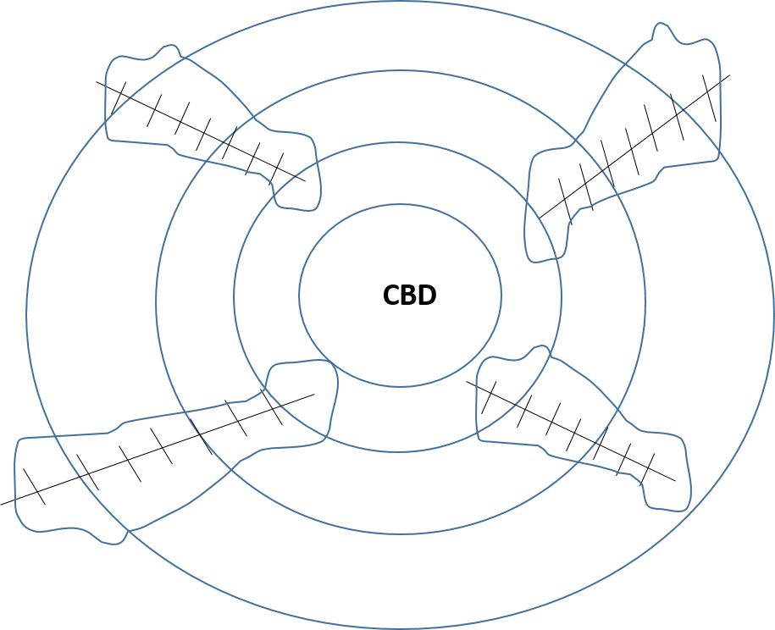
Streetcar lines and
walkable zone of development;
Cars fill space in empty wedges
Automobile-oriented development filled in the large blank spaces—the wedges—in the diagram which did not lie within the walkable zone around the streetcar tracks. Whereas this land had previously presented too long of a journey time to make development feasible, now enormous new tracts became accessible and were thus developed, both within cities and on the periphery.
Suburbanization of Housing and Jobs
Both housing and jobs suburbanized as a direct result of automobility. Jackson explains that:
“The decade after the end of World War I was the first in which the road and the car had full impact…New suburbs sprouted on the edges of every major city…Between 1920 and 1930, when automobile registrations rose by more than 150 percent, the suburbs of the nation’s 96 largest cities grew twice as fast as the core communities....By 1922 about 135,000 suburban homes in sixty cities were already completely dependent upon cars for transportation, and in 1923 National Geographic did a special feature on the automobile industry…
the impact of the automobile was even greater than suburban statistics and quotations indicated, however, because a large part of the growth within cities was in sections newly opened by the car.”
Due to the convergence of the increase in paved state highways, and the growing amount of trucks, factories had an additional motivation to suburbanize. The truck meant that small firms no longer needed to rely on costly, monopolistic railroads for shipping interstate goods, but instead could site near a major highway intersection and use their own truck to ship their goods. The number of trucks in the United States grew according to the following chart, between 1904 and 1945:

Source: Federal Highway Administration
As trucks, and the maturation of the electric grid, provided the means to situate factories in the suburbs, the manufacturing economy transformed from urban to metropolitan, and the hybridization of land use—the blurring of Hamilton and Jefferson—deepened once again. As explained by historian Blake McKelvey, in The Urbanization of America: 1860 – 1915:
“Not only did such industrial centers as Lowell, Scranton, and Youngstown, as well as Chicago, St. Louis, Pittsburgh, and Detroit, spawn clusters of factories on their outskirts, but many predominantly commercial hubs also developed industrial “parks” on their periphery. Although the migration of old concerns seldom left gaps for long, since other firms quickly appropriated the vacant spaces, most cities now barely maintained, either by annexation or internal growth, their earlier percentages of the national production. It was the metropolitan district, combining the output of urban and suburban factories, that best reflected the cumulative advance of the American economy.”
The push of factories towards the outskirts started to create a metropolitan economy which was spatially a hybrid. The dramatic decentralizations that deepened after World War Two were already well underway in the heyday of the classic industrial metropolis.

Post World War II – Present (1945 – 2015):
Flight to Suburbs Matures Into Edge City & Polycentric Metropolis

The period from 1945 until the present time has seen dramatic, even chaotic, changes in America’s urban landscape. The hybridization of city and country has created a true metropolitan nation. A pair of seemingly revolutionary phases, each lasting about 35 years, has dramatically extended the decentralizing trends which began in 1815 when the first commuter suburb grew up in Brooklyn Heights.
This two chapter tandem will give a general overview, both historically and with spatial diagrams, of how the entire period 1945 – 2015 has evolved. This chapter will cover the “flight to the suburbs” (1945 – 1980) in some detail, and the next chapter, “Living on the Polycentric Edge: The Vocabulary of the New Geography, 1980 – 2015 ” will explicate the complex and often baffling changes to America’s urban landscapes since the end of World War II. Overarching data trends, such as population growth, the rise of the knowledge and service worker (which has superseded the classic Hamilton-Jefferson debate), or the development of information technology, will be covered in this chapter for the entire period 1945 – 2015, in order to provide long-term context which makes more sense when viewed holistically. The following chapter will be data-free and purely narrative history.
Overview: Flight to the Suburbs (1945 – 1980)
The “flight to the suburbs,” which lasted from roughly 1945 until 1980, emptied out the intense population growth pressures that had gathered force during the period of 1880 – 1940. A pent-up housing shortage dating to the Great Depression, and worsened by the outbreak of World War II, exploded during peacetime prosperity into the sparsely populated outlying areas of America’s metropolitan periphery. This mass migration captured the imagination of the national media and was a widely shared national experience. The conventional historical narrative, which will be recounted in this chapter, explains it through the combined force of population growth, soaring automobile ownership, the creation of the Interstate, and the creation of modern federal housing finance policy, including self-amortizing mortgages and the mortgage interest tax deduction. It should be noted that most of these trends had begun in the 1930s or earlier, and it was the combined weight of their simultaneous, parallel maturation in the 1950s which gave such force to the mass suburbanization movement of the day.
Media Impressions Create False Dichotomy: City vs. Suburbs
The degree to which the “flight to the suburbs” captured the national imagination, however, obscured the fact that it was merely a stage and not an end in itself. A popular image of a dichotomy between city and suburb became commonplace, when in fact this dichotomy proved to be merely a brief, passing moment. What happened instead was the “urbanization of the suburbs,” which eventually became, through natural evolution, the multi-centered, dispersed “polycentric metropolis” ringed by edge cities, edge corridors, and edgeless cities.
This maturation process, to be described in more detail in the following chapter, had to do with the centrifugal, gravitational pull of the mass relocation of housing to the outlying areas. As housing suburbanized, so did retail—in the form of shopping malls and strip malls—as well as jobs, in the form of suburban factories and offices. It only stands to reason that this would occur, in order to reduce commute times and enhance efficiency. While the auto-dependence of the new land-use configurations ended up creating the unintended problem of traffic congestion, it also fundamentally reshaped America’s metropolitan areas into new forms and patterns which at first seemed very chaotic. Eventually, a series of commentators emerged to articulate and name the perplexing expanses of the “new city,” to uncover the underlying order which may have animated the outer forms that were manifested.
Attempts to Name and Describe “The New City” (1980 – 2015)
These attempts will be explicated in much greater depth in the following chapter. But they are important to review here, momentarily, in order to understand the trajectory of the flight to the suburbs, as well as the data for the period 1945 – 2015 as a whole which will be presented on the knowledge society, telecom, and the service economy.
One of the first attempts was made by real-estate developer and scholar Chris Leinberger, who in the mid-1980s noted the phenomenon of dense “urban villages” forming on the metropolitan fringe in areas that had previously only been suburban. In 1987, Rutgers University historian Robert Fishman coined the term “technoburb,” to describe the totality of the “new city” taking shape, which provide “urban function without traditional urban form.”
In 1991, a very well-known, paradigm-defining book called Edge City: Life on the New Frontier was published by Washington Post journalist Joel Garreau. Having traveled extensively across America, Garreau noticed office towers and large retail shopping centers appearing seemingly in the middle of nowhere, in otherwise very low-density areas. He created a systematized definition of these areas called Edge City, which referred both to a certain basic amount of dense office and retail space, as well as a state of mind he referred to as Edge City, which expressed something intangible in the American psyche. Garreau’s book hit a chord, and out of all of the perspectives received the most media attention.
Post-Garreau, an urban scholar named Robert Lang continued to examine office geography and discovered that edge cities can occur in a proliferation of shapes, including but not limited to the dense clusters encountered by Garreau. Lang was particularly interested by the phenomenon of what he called “edgeless cities,” basically a name for the low-density, single-story “sprawl” of office and retail space which seems to exist adjacent to endless expanses of American Interstate highways. Lang actually set out to measure the office geography of 13 large metropolitan areas, dividing them into primary downtown, secondary downtown, edge city, and edgeless city.
Common Theme: Polycentric Metropolis, Clustered Decentralization, Auto-Dependent
What all of the above perspectives have in common is that they have recognized consistent logic and structure to the seemingly chaotic development of the modern metropolis. Urban scholars have come to call the contemporary metropolis the polycentric metropolis, since no matter what it is called, it seems to comprise of numerous poles of density, both large and small, within a dramatically expanded spatial region. The importance of the central business district at the beginning of the 20th century has been replaced by a proliferation of dispersed centers of urban density, all tied together by the automobile. The paradoxical term “clustered decentralization” can be used to describe this seemingly odd situation, where an residentially dispersed population still gathers daily in dense places to obtain face-to-face contact for work and play, notwithstanding the time costs of traffic congestion or the financial costs of gasoline, auto ownership, insurance and maintenance, and so forth.
Historical Continuity: Decentralization A Constant Force Since 1800s
Whatever one calls the current configuration, there is no doubt that it has been a dramatic continuation and deepening of the decentralizing tendencies which began in the 1800s. It has been characterized by plunging population densities in the central city, enormous additions of outlying land to the metropolitan area, and the rise of the knowledge worker which has undermined the traditional Hamiltonian-Jeffersonian dichotomy between manufacturing and agriculture. This chapter will review all of these trends in more detail, providing schematic diagrams, data, and historical narrative in order to substantiate what seems to have occurred.
Spatial Diagrams
It may be helpful to begin by looking at spatial diagrams which simplify and stylize the phases of change which have occurred. These are presented below. These diagrams will stretch back into the early 1900s, in order to graphically cohere together the continuities described in this study.
At the beginning of the 20th century, American cities contained a central business district with density declining outward in concentric rings. This might be referred to as the monocentric model:
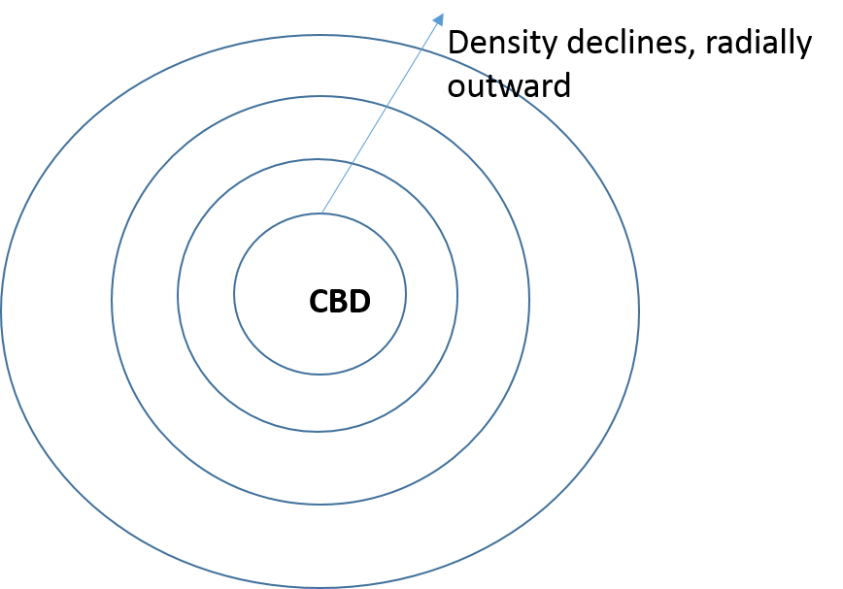
Early 20th Century: Monocentric, Industrial Metropolis
At first, this monocentric, industrial metropolis developed along “fingers” of rail lines and streetcar networks. The hub-and-spoke layout of transit meant that most residential development had to be within walking distance of a rail stop, thus leaving wide open spaces in between.
Early 20th Century: Rail and Streetcar Suburbs
As the automobile was introduced and the Interstate system matured, the “flight to the suburbs” ensued. At first, this migration was mostly residential, thus requiring ample commuting between the original city and the new suburbs:
Early 20th Century: Rail and Streetcar Suburbs
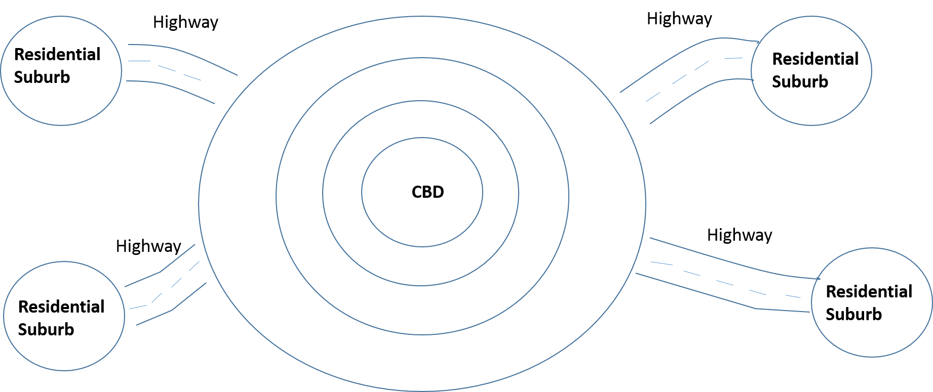
“Flight to the Suburbs” (1945 – 1980)
However, the gravitational pull of the residential development upon retail, commercial, office, and industrial uses pulled massive amounts of new development out near the original suburbs. This created the clusters dubbed urban villages, edge cities, edge corridors, and edgeless cities, all encompassed within the larger construct of the polycentric metropolis.

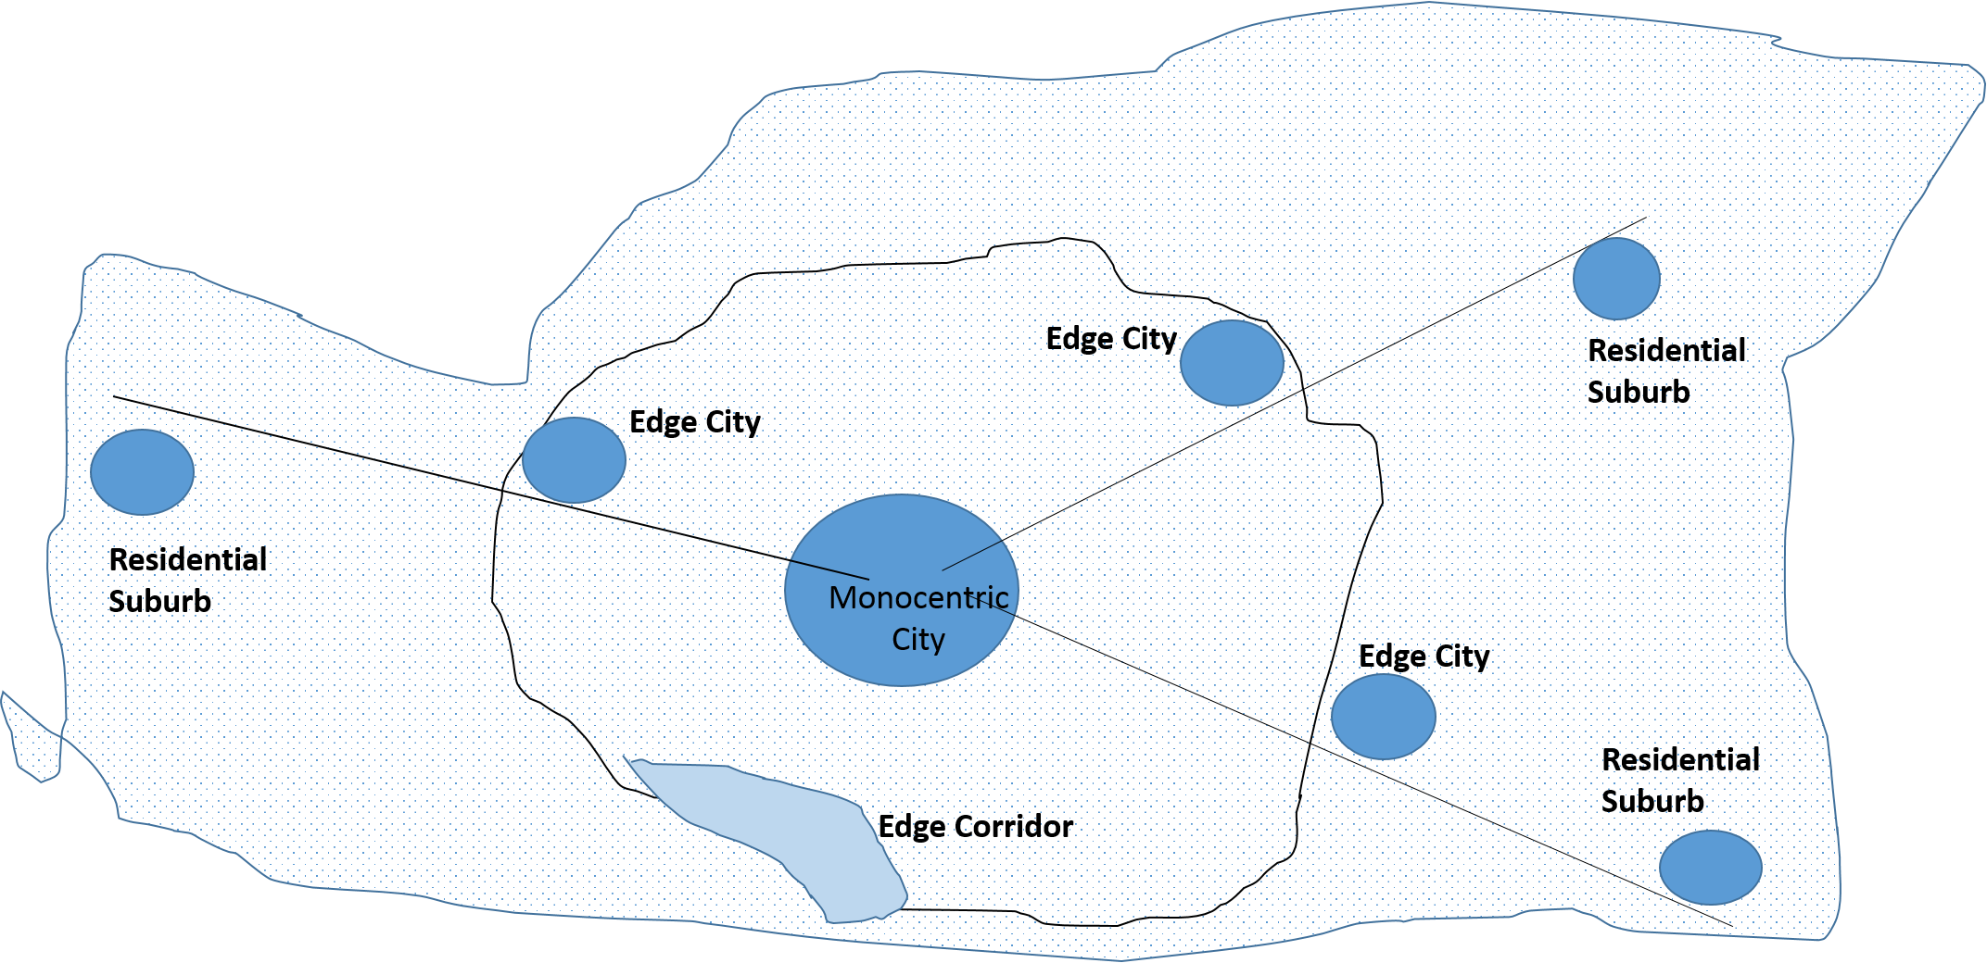
Polycentric Metropolis
In the above diagram, every solid shaded area contains mixed-uses. The residential suburbs contain retail, both big-box strip malls and indoor shopping malls; and the edge cities contain a mixture of retail, office space, and high-density apartment housing. The edgeless cities are basically represented by the lightly-shaded areas, since the edgeless cities are the nameless expanses of low-density strip mall development that many observers refer to as sprawl.
Generally speaking, the polycentric metropolis is the prevalent form in 2015, and is what seems likely to continue existing for the foreseeable future.
Population Statistics
After World War II, the Census Bureau began to track metropolitan area statistics, which allowed for a working statistical definition of suburb to emerge. A metropolitan statistical area (MSA) contains contiguous counties where there is a central city of 50,000 or more persons, and the countries are connected by commuting sheds and other regular people movements. The political boundaries of the city named in the MSA constitute the “central city,” whereas all the outlying area contains the “suburbs.” While this is necessarily approximate, as many central cities may contain older areas viewed by most persons as inner-ring suburbs, it nevertheless provides a working benchmark.
America’s metropolitan revolution since 1950 can be seen in terms of population in the following graph:
1980 - 2015:
Polycentric Metropolis,
Edge Cities, Edgeless Cities
Source: US Census Bureau
The “X” or “scissors” shape of the graph shows the great transformation which occurred during the “flight to the suburbs” between 1950 and 1980, and which has only widened since then. From a nation which was majority non-metro in 1950, America has become a majority suburban nation. Nearly 160 million persons lived in Census-defined “suburbs” as of 2010, comprising a little more than half of the US population.
The above chart can be expressed in percentage terms as follows:

Source: US Census Bureau
What is interesting to note is that the proportion of Americans living in the central cities has remained more or less constant during the period from 1950 through 2010. It is the non-metro areas which have by and large changed places with the suburbs, as the farmworker has been transformed into the knowledge worker. This only underscores the hybridized nature of the “new city” which has organically developed, where enormous amounts of blended economic activity take place in the suburb instead of in the city or on the farm.
Population Density and Land Area
For the time period from 1950 onward, the Census Bureau has published population density and land area data for metropolitan areas. This gives deeper insight into the nature of the land-use and economic changes which have occurred since 1950. One of the most noteworthy features has been the plunging population densities in central cities, leaving behind buildings without people:

Source: US Census Bureau
Since 1980, population density in central cities has stabilized at just over one-third of what it was in 1950. This illustrates the deconcentrated and decentralized nature of the polycentric metropolis. The deconcentration and decentralization can be even further underscored by looking at the dramatic expansion in metropolitan land area:

Source: US Census Bureau
Remarkably, metro land area nearly tripled between 1950 and 1980, and then nearly doubled again between 1980 and 2010.
This was due in large part to population growth, which meant that more and more outlying countries were considered part of metro areas. General population growth also meant that the number of metropolitan statistical areas (MSAs) itself increased significantly, due to an increase in the number of cities meeting the “central city” population threshold of 50,000 persons. The following chart shows the increase in the number of metro areas:

Source: US Census Bureau
The most dramatic increase in number of MSAs came during the “flight to the suburbs” period of 1950 – 1980, and then stabilized with only moderate further increase during 1980 through 2010.
For the period from 1980 onward, data for land area can be divided between central city and suburbs. Nearly all new land area was added in the outlying suburban counties:

Source: US Census Bureau
Since these outlying counties are so much larger than the central cities left behind, their population densities are far lower:

Source: US Census Bureau
Putting all of this information together, it can be seen that when migrating from central cities to suburbs, vast numbers of people settled in areas of much lower density. In reading these figures, it should however be understood that the “suburbs” densities are much lower than what most suburban residents actually live at, since metro areas are defined on a county basis and the suburban counties often include large areas of open, uninhabited land. Nevertheless, it is clear that the “flight to the suburbs” resulted in much lower population densities than previously. This is a good segue to examining the reasons for this flight.

Explaining The Flight to the Suburbs (1945 – 1980)
As seen above, the “flight to the suburbs” took place from roughly 1950 through 1980, and can be represented by plunging population density in central cities, and a massive increase in outlying metropolitan land area.
The standard narrative of the flight to the suburbs contains five major components:
- Fordism: Levittown and the Tract Suburb
- Federal Housing Finance Policies
- Interstate Highway System
- Single-Use Zoning
- Automobile Ownership
Each of these will now be summarized.
- Fordism: Levittown and the Tract Suburb
The famous Levittown suburbs, built by Levitt and Sons in Long Island, New York, were prototypes of tract suburban housing in prefabricated, mass-produced, single-family detached houses. This prototype showed that pleasant (if identical) single-family houses could be produced quickly, en masse, and sell for affordable prices to middle-income Americans. Market demand was intense and this model was soon copied all over the country.
- Federal Housing Finance Policies
The mortgage interest tax deduction – passed by the Roosevelt Administration in the 1930s, and strengthened in the federal Housing Act of 1949 – often made it cheaper, after taxes, to won a suburban house versus rent an urban apartment. In addition, the creation of the self-amortizing mortgage, involving standardized 30-year repayment of the principal at a fixed long-term rate, replaced the previous system of interest-only payments followed by balloon payments for the principal. These policies made homeownership possible for much larger numbers of households.

- Interstate Highway System

The National System of Interstate and Defense Highways, signed into law in 1956, followed nearly two decades of planning by Bureau of Public Roads officials, and built upon a burgeoning parkway and turnpike network that had already begun to wind its way around the nation. The Interstate Act called for the creation of a 41,000 mile system of elevated, limited-access expressway whose construction would be 90% federally funded. Construction begin in 1956 and most of the original 41,000 mile plan was complete by 1971.

The main effect of the Interstate was to channel high-speed, high-volume traffic flow from the suburbs to the central cities. It was constructed both between cities and within cities, thus providing both inter-urban and intra-urban travel. Nearly every city in America saw an Interstate beltway, aka perimeter highway, constructed in a ring around its outskirts, and most cities saw Interstates routed through the city center in an effort to make transportation more efficient and to uproot perceived slum areas. This latter feature was not without discontent, as many citizens groups protested fiercely to avoid bisection of their neighborhood by the Interstate. Some protests won either the cancellation or the rerouting of downtown routes,, but in most cities this citizens’ dissent was of little avail. These activist battles are being reprised as part of today’s “highways to boulevards” New Urbanist agenda.

- Single-Use Zoning
Single-use zoning, which had been affirmed legal by the Supreme Court in Euclid v. Ambler Realty in 1926, was an integral part of the tract suburb, because it enabled builders to apply Fordist methods at relevant scale, and it maintained the land values of tract suburbs. By mandating that all structures would be for the same use – residential – single-use zoning prevented the possibility of land-value inflation which had pushed housing out of central business districts, and thus maintained affordability. By the same token, the homogeneity of land value meant that home values might appreciate, since there was now a limited amount of single-family houses on a set piece of land, thus limiting supply and creating a dynamic that could push prices upward. In this way, a house in a tract suburb became not only a place to live – but an investment. Millions of persons who previously had lived in cramped apartments, paying rent, could now pay a mortgage on their own family’s house and watch the house’s price appreciate at the same time.

In terms of VMT, mass application of single-use zoning seems to have tilted the balance in favor of increased driving, by causing longer distances between different types of origins and destinations, such as residential units, retail shopping, medical offices, and churches. In addition, it stimulated a need for women’s driving, since now homemakers who didn’t need to commute to work still had need of an automobile to accomplish daily errands such as groceries, to/from school, and other household or personal errands.
- Automobile Ownership
There is a reciprocal causation between suburbanization and automobile ownership. The more that the suburbs developed, the more that the average American household needed to own a car to attend to daily needs. But the more that car ownership increased, the more that the suburbs could develop, since the automobile facilitated development in places which streetcars or railroads could not reach.
As with VMT (below), the trajectory of automobile ownership during the years 1945 – 1980 spiked steeply upward from the previous decades:

Source: Federal Highway Administration
The graph above is extremely striking, showing how automobile ownership grew nearly fivefold during the period from 1945 through 1980, when central city population density was plunging and cities were rapidly decentralizing. This spike in automobile ownership derived from travel patterns induced by suburbanization, but at the same time spurred demand for additional automobile ownership.

Effect on VMT of “flight to suburbs”
The effect of the “flight to the suburbs” on VMT can be summarized very succinctly – it went upward. This mass migration set off an unprecedented wave of new VMT. The shape of the long-term VMT curve between 1920 and 1980 can be seen in the following graph:

Source: Federal Highway Administration
As shown in the graph, vehicle travel sextupled between 1945, from approximately 250 billion to 1.5 trillion VMT.
Recounting the Forces of Decentralization
The growth and spread of metropolitan population effected, and was affected by, numerous decentralizing forces, many of which are deeply interrelated. The forces will be independently broken out and summarized here.
Of particular note is that every type of decentralization happened in lockstep; once residential housing suburbanized, for instance, retail had no choice but to follow it, and similarly with offices. Professor Jon C. Teaford, in his book The Metropolitan Revolution: The Rise of Post-Urban America, provides a lively telling of this interlocking movement toward the urban periphery:
“In the late 1950s and early 1960s, the signs of a metropolitan revolution were undeniable. Not only did suburban housing tracts continue to proliferate, but mammoth shopping centers and malls joined them along the metropolitan fringe. New factories lined suburban highways, providing blue-collar jobs, and a number of new office and corporate campuses testified to the outward migration of white-collar jobs and executive decision makers. Along outlying thoroughfares, new chains of auto-oriented restaurants and motels meant that more people were eating and resting in the fringe areas rather than flocking downtown for food and hotel accommodations.”
Suburbanization of Retail
Teaford puts particular stress on retail trends, writing:
“Nothing testified to the loosening grip of a common metropolitan hub as forcefully as the emergence of suburban competitors to downtown retailing. Throughout the postwar period, suburbia had been captured by a growing share of retailing dollars, but the change was especially marked in the late 1950s and early 1960s…Downtown retail sales were falling because suburban retailers were attracting the customers who had formerly headed to the urban core.”
He says that the suburban shopping malls were a focal point:
“The great landmarks of this decentralization of retailing were the massive shopping centers arising along the suburban fringe. There were some suburban shopping centers before the mid-1950s, but most of them were small strip centers with a few stores lined up beside a supermarket and pharmacy. In most metropolitan areas there was no suburban center that posed a serious threat to the supremacy of the giant downtown emporiums in the marketing of apparel and accessories. In the mid- and late 1950s, however, a surge in the construction of ever larger and more elaborate suburban malls anchored by major department stores revolutionized American retailing.”
Suburbanization of Offices
On offices, Teaford writes,
“Another symptom of the massive reorganization under way was the growth of office employment in the suburbs. In the late 1950s and early 1960s, low-rise office buildings and landscaped office parks were appearing on the metropolitan fringe throughout the United States.”
This trend will be covered in more detail in the following chapter on the polycentric metropolis, since office geography has been an intense preoccupation of those who have tried to name the features of the “new city.”
Suburbanization of Factories
For factories, it may be helpful to look again at the growth of truck registrations as a proxy for understanding this trend:

Source: Federal Highway Administration
The number of trucks nearly septupled during 1945 – 1980, from 5.1 million to 33.7 million. Growth in the number of trucks was noted in the previous chapter as a facilitator of suburban site choices for factories and warehouses, since the privately-owned truck offered a much greater degree of flexibility and much lower cost than dealing with very large, rigid railroads. The trend of factory suburbanization continued during the “flight to the suburbs,” and will be touched on again in the following chapter on the polycentric metropolis.
Hamilton & Jefferson, 1945 – 2015: Superseded by Knowledge Economy and Service Worker
The old duality between manufacturing and agriculture, as represented by the debate between Hamilton (factories) and Jefferson (farming) in the 1790s, finally was eclipsed after World War II. As the transition of farmers into the metropolitan workforce completed itself, as advances in manufacturing created surplus pools of workers, and as the US economy became more information-oriented, the “knowledge economy” was born. Along with its close cousin, the “service economy,” the knowledge economy actually began as early as the 1940s.
The Bureau of Labor Statistics has tracked a distinction between “service-providing” and “goods-producing” workers, dividing all nonfarm workers into either one category or the other, annually since 1939. The following chart compares “goods-producing” and “service-providing” workers between 1945 and 2015:

Source: Bureau of Labor Statistics
By 2014 service-providing jobs had become fully 86% of nonfarm US employment. The service economy over time superseded both Hamilton and Jefferson – both manufacturing and agriculture – as it inexorably came to represent by far the dominant type of worker in America. Interestingly, these service jobs tracked urbanization rates in an eerily similar pace:

Source: US Census Bureau, US Bureau of Labor Statistics
The above chart shows that in nearly every decade, the percentage of service workers, out of total nonfarm workforce, was roughly equal to the percentage of metropolitan residents in the US population. This striking correspondence does not mean that every metropolitan worker was a service worker, nor that every service worker lived in a metropolitan region, but it does make the point that the “metropolitanization” of America is strongly associated with service jobs.
All of these service jobs have corresponded as well with a striking increase in the prevalence of college education. The following chart shows educational achievement levels since 1950:

Source: US Census Bureau
Meanwhile, there has been a striking rise in agricultural productivity since the end of World War Two, as new mechanization and chemical fertilizer techniques have corporatized agriculture and dramatically increased yields. The following chart shows the trend in agricultural productivity since 1948:

Source: USDA Economic Research Service
As agricultural productivity has soared, rural-to-urban migration has finally saturated as the percentage of the workforce employed in agriculture could barely go any lower:

Source: USDA Economic Research Service
What seems to have happened is that a much more educated workforce, employed mostly at knowledge-based or service jobs, now populates the US metropolis. Factories and farms have emptied out in favor of the modern knowledge worker.
Consequently, one may see the underlying population dynamic supporting the emergence of office “edge city” clusters noted by Joel Garreau, as well as the seemingly endless “edgeless city” office sprawl noted by Robert Lang. These configurations—which will be described in the following chapter—exist in part because broadly speaking, there is an enormous pool of relevant workers—educated, service-oriented, knowledge-oriented, living in metropolitan areas—to support the companies occupying these “edge” offices.

Information Technology and Telecom
This section will briefly chronicle the continued rise of information technology and telecommunications, in terms of household access, in order to summarize the scope to which communications advances affect nearly every household in the United States. It will review the uptake of televisions, telephones, mobile phones, computers, and Internet in the period from 1950 through 2010.
These technologies have exerted a decentralizing force in that they provided the American metropolis with a large variety of tools for communicating at a distance. Even as very few Americans worked at home (only 4.1% of workers as of 2010, according to the Census Bureau journey-to-work tables), Americans could take psychological comfort from the ability to reach other persons at long distances, and could “stay in touch” even when choosing the most far-flung housing locations.

Televisions
Between 1950 and 1970, the television went from being a marginal item, possessed by only one in ten households, to being a ubiquitous device possessed by nearly every household. This can be seen in the following Census data:

Source: US Census Bureau
The rapid adoption of the television created a national audience for news and entertainment, and meant that even if Americans were sitting in the living room of their suburban houses, they could still feel “connected” to the wider world. The television helped foster a hybrid suburban space, where information about world events, and about the affairs of the local metropolitan region, mixed with the average person’s daily life, of commuting, nuclear family, house, and yard.
Telephone
During the period from 1970 through 1990, the telephone was nearly ubiquitous in the American home, with 87% of households having one in 1970, and with this figure increasing to 95% of US households by 1990. Telephonic social interaction became an everyday, near-universal experience.

Source: US Census Bureau
With the advent of mobile phone, in 2000 the Census Bureau started tracking homes with telephone service available, instead of homes where phones were physically present. These data show an even higher rate of telephone access:

Source: US Census Bureau
Mobile Phones
The cellular phone industry began in earnest in 1984. The Federal Communications Commission (FCC) has data available on its website to demonstrate the growth of the mobile market between 1984 and 1997:

Source: Federal Communications Commission
For the years 2000 through 2013, the International Telecommunications Union provides annual US data:

Source: International Telecommunication Union
It can be seen that per-capita cellular subscriptions had reached nearly total saturation in 2013, at 96% of the US population. The added mobility of the cell-phone meant that one could be located nearly anywhere, so long as it was in range of a cell tower, and remain “connected” and “in touch.” Researchers are still trying to determine the resultant effect on urban form, but it is certain that a dynamic new variable has been added into the mix, and that the nature of locational flexibility, for personal communications, has changed.
Internet
Internet has attained high levels of per-capita usage. The following chart shows the rate at which this has happened:

Source: Pew Research Center
Moreover, Internet usage has been increasingly high-speed due to increasing spread of broadband:

Source: Pew Research Center
Much has been made of the rise of the Internet, mobile technologies, and their possible impact on urban transportation. While a detailed analysis is beyond the scope of this study, what can be remarked in the context of urbanization is that decades and decades of chaotic changes in urban forms preceded the rise of the cell-phone or Internet. Due to the layering effect of cities, whereby they accumulate buildings and infrastructures like volcanic sediment, the previous decades of urban development are rather permanently etched into today’s landscapes.
As a result, the new mobile technologies—while they may certainly have a strong effect on personal travel and may yet prove to be a very disruptive, chaotic influence on urban development—have come into existence within a context of pre-existing cityscapes. Any changes which they stimulate must, of necessity, encounter the existing built environment, and will be path-dependent on what has come before. Any analysis of the effects on vehicle travel, of digital mobile technologies, must take this path dependence into account.
Chapter Summary: VMT and Vehicle Ownership, 1980 – 2015
Until now, this chapter has not reviewed the key transportation variables—vehicle ownership and VMT—for the period 1980 – 2015. This will help round out the analyses that have been presented in this chapter, and set the stage for the next chapter’s discussion of edge cities and the polycentric metropolis.
Despite its stagnation since the mid-2000s, VMT has still grown by very substantial amounts since 1980:

Source: Federal Highway Administration
Urban driving, as a percentage of VMT, slowly crept up to 68% of VMT in 2013:

Source: Federal Highway Administration
On average, the typical household now contains more than two vehicles:

Source: US Census Bureau, Federal Highway Administration
It was seen in the previous chapter, that America had reached nearly one vehicle per household by the end of the 1920s, and had become a majority-urban nation in 1920. Now, nearly a century later, American households contain two vehicles; every adult member has a mobile phone; most persons have high-speed Internet access; and a large majority of workers belong to the knowledge or service economy.
If America in the 1920s can be characterized as an “urban automobile nation,” today’s America might deserve the tag, “metropolitan mobile nation.”

Looking Ahead to Life At The Polycentric, Metropolitan Edge
Thus, the context for reading the following chapter has been set. The next chapter will provide an in-depth summary of the geographic configurations that have come to characterize today’s “metropolitan mobile nation.” The role of the automobile will be further explored, particularly in Robert Fishman’s technoburb, and the rise of the knowledge economy will figure prominently in the urban villages, edge cities, and edgeless cities where so many of these knowledge workers seem to populate the “new office geography.”

Living on the Polycentric, Metropolitan Edge:
The Vocabulary of the New Urban Geography

As the suburbs have urbanized and the entire metropolitan construct has matured into some kind of “new city,” many attempts have been made to name and identify what’s really going on. This chapter intends to explain the underlying meaning behind a bewildering array of neologisms that have been coined to describe the new urban geography that has taken shape since the 1980s.
The basic chronology is that the metropolitan expansion of America which was initially known as “flight to the suburbs,” in the 1950s, eventually became transformed into “urbanization of the suburbs,” as shopping malls and offices followed housing outward from the 1950s onward. However, many observers noticed that the “new city” did not appear to be taking on the form and structure of traditional cities, even if it did contain a relatively traditional mixture of diverse uses. Starting in the 1980s, and continuing into the early 2000s, there has been a remarkable array of attempts to name what has occurred.
What has become clear overall is that the suburban portion of the American metropolis has flowered into something much more complex than simple bedroom communities, with geographical dispersion somehow held together in some kind of invisible cohesion, by automobiles, roads, information technology, and service employment. Reviewing the efforts to articulate the new metropolis is important because it gives clearer insight into the urban landscapes that readers of this report are likely to encounter in their day-to-day lives.
Many of the observers discussed in this chapter have had a particular preoccupation with office geography. These include the following three constructs:
- Urban Villages (1986, Christopher Leinberger)
- Edge City (1991, Joel Garreau)
- Edgeless Cities (2003, Robert Lang)
On the other hand, Robert Fishman, an urban historian at Rutgers University, has tied the “new metropolis” together into a larger construct which situates around residential transportation patterns, and which he refers to as the “technoburb” or the “new city.”
Chapter Structure
This chapter first reviews the concepts of urban villages, edge cities, and edgeless cities, and then will explain at the end how they are integrated into Fishman’s universal construct of the “techno-city.” The relevance for the fuels and vehicles industries is to glean pragmatic insights into how today’s cities really work, and to learn how to read the landscape of culture, infrastructure, and spatial economics, so as to anticipate underlying changes which may in future have profound effects on transportation. If transportation technologies shape the city, it is equally true that the city shapes transportation, and it is hoped that this chapter will provide insight into how this is so, on the playing field of the urban landscapes that actually exist in 2015.
Office Geography: Urban Villages, Edge Cities, Edgeless Cities
The theories which focus upon office geography all look to concentrations of office space as a signal as to how spatial decisions are made in the new metropolis.
These theories include the urban villages of Leinberger, the Edge City of Garreau, and the edgeless cities of Lang.
- Urban Villages
Perhaps the first to characterize the “urbanized suburbs” was real estate scholar Chris Leinberger. In an article in Atlantic Monthly in October 1986, co-authored with Charles Lockwood, Leinberger explains that:
“Now it appears that the much-reviled postwar suburban sprawl, with its sea of split-level houses surrounding retail businesses and apartment complexes strung randomly along its highways, was merely a transitional phase between the traditional compact pre-war city and today’s metropolitan area. Our cities are becoming groups of interdependent ‘urban villages,’ which are business, retail, housing, and entertainment focal points amid a low-density cityscape. Each urban village has its core—a kind of new downtown—where the buildings are tallest, the daytime population largest, and the traffic congestion most severe. And each urban village has its outlying districts, which may stretch as far as ten miles from the core.
Urban villages represent a dramatic restructuring of America’s cities and suburbs—one that is already affecting how millions of Americans live and work. Almost every city is swept up in the urban village phenomenon—not only fast-growing Sunbelt cities like Atlanta and Phoenix but also slow-growing older ones like St. Louis and Kansas City, and archetypal cities like New York and Baltimore.”
The above quote comes from the introduction of the article, which is entitled, “How Business Is Reshaping America: The rapid growth of office space is creating ‘urban villages,’ which are confronting local governments with new kinds of urban-planning problems.” As to why the urban villages have formed, Leinberger lists many of the same reasons that have already been documented in this study:
- Shift from manufacturing economy to service/knowledge base
- Shift in transportation modes from rail to trucks for freight and cars for personal
- Telecom advances – falling long-distance phone rates, telecopiers, faxes, and modems
- Cheaper business operations in urban villages (construction, rent, parking)
- Consumer preference for concentration of services

- Edge City
In 1991, Joel Garreau, a journalist for the Washington Post, wrote a full-length book, Edge City: Life on the New Frontier, where he used the urban villages—which he calls “edge cities” and for which he provides his own definition—to jump off into a much broader discussion of what causes America’s metropolitan areas to form in the way that they do. Garreau attempted not only to define and characterize office and retail patterns, but to peer into America’s psyche. Striking a chord nationwide, and receiving wide media attention, Garreau articulated what he viewed as a uniquely American preference for living “on the edge.” He describes it as follows:
“It comes to this. One vision of the American natural landscape was that it had inherent value and should be treasured for what it already was and had always been. The other saw in the land nothing but satanic wastes; there could be placed on it no value until it was bent to man’s will—until civilization was forced into bloom.
The history of America is an endless repetition of this battle. We are fighting it to this day, nowhere more so in our current frontier, Edge City. In the unsettled, unsettling environment of Edge City, great wealth may be acquired, but without a sense that the place has community, or even a center, much less a soul. And the resolution of these issues goes far beyond architecture and landscape. It goes to the philosophical ground on which we are building our Information Age society. It’s possible that Edge City is the most purposeful attempt Americans have made since the days of the Founding Fathers to create something like a new Eden.
Edge City may be the result of Americans striving once again for a new, restorative synthesis. Perhaps Edge City represents Americans taking the functions of the city (the machine) and bringing them out to the physical edge of the landscape (the frontier). There, we try once again to merge the two in a newfound union of nature and art (the garden), albeit one in which the treeline is punctuated incongruously by office towers.
If that is true, Edge City represents Americans once again trying to create a new and better world—lighting out for the Territory, in the words of Huckleberry Finn. If that new world happens to be an unknown and uncharted frontier, well, that’s where we’ve headed every chance we’ve had—for four hundred years.”
In Garreau’s telling the edge cities have well-defined characteristics but Edge City is a deeper philosophical paradigm which is expressed in these physical structures.
At any rate, Garreau defined an “edge city,” lower-case, according to five consistent traits:
- Has 5 million square feet or more of leasable office space—the workplace of the Information Age.
- Has 600,000 square feet or more of leasable retail space.
- Has more jobs than bedrooms.
- Is perceived by the population as one place.
- Was nothing like a “city” as recently as thirty years ago.
To summarize, Garreau’s edge city holds the information workers of the modern economy during the daytime, and creates places for them both to work and to shop. However, most of them empty out at night, as these workers head to other locations to carry on their personal lives. The edge city is typically brand new, having grown up from virtually nothing thirty years ago, and the local population recognizes it as a single coherent place.
Reading this definition closely may clue one into a very interesting feature. Item #5, the requirement that it was nothing like a “city” as recently as thirty years ago, means that as edge cities grow up, they are eventually no longer edge cities, once they reach the 30-year mark in age. This highlights the constant dance of change and evolution in the metropolitan areas, under the pressure of population and economic growth. Edge cities form, mature, and finally become integrated into the larger metropolitan fabric, almost like the formation of a planet within a solar system. Indeed, there is yet another neologism known as the “galactic metropolis,” coined by cultural geographer Peirce Lewis, which may in part refer to this trend (as well as to the tendency of edge city towers to appear different sizes and distances from different vantage points, similar to stars).
In all, Garreau lists 242 edge cities in his book. He says that approximately two-thirds of all office space in the United States, as of 1991, was located in an edge city, a figure which others have disputed, including Robert Lang, whose concept of edgeless cities will follow. Nevertheless, nearly all urbanists are in general agreement that the edge city is a very real phenomenon which is highly visible in American metropolitan areas, regardless of details of definition or the total amount of office space attributed to it, which in any event is sizable.
- Edgeless Cities
In fact, Robert Lang opens his book, Edgeless Cities: Exploring the Elusive Metropolis, in direct response to Garreau, countering Garreau’s claim that edge cities mean “density is back” with the riposte that:
“the long-standing presence of ‘edgeless cities’ means that sprawl is back—or, more accurately, that it never went away.
Edgeless cities, a form of sprawling office development that does not have density or cohesiveness of edge cities, account for two-thirds of the office space found outside downtowns. Among the nation’s largest office markets, edgeless cities have nearly twice the space of edge cities. And they are everywhere—no major metropolitan area is without them. Edgeless cities are not mixed-use, pedestrian-friendly areas, nor are they easily accessed by public transit. They are not even easy to locate, because they are scattered in a way that is almost impossible to chart. Edgeless cities spread almost imperceptibly throughout metropolitan areas, filling our central cities, occupying much of the space between more concentrated suburban business districts, and ringing the metropolitan area’s built-up periphery.”
In plain language, perhaps the best way to describe Lang’s “edgeless cities” is to say that they are the ubiquitous, low-rise, low-density suburban business parks that one sees lining the highways on the outskirts of nearly all American metropolitan areas. From the perspective of land-use micro-economics, perhaps the companies in the edgeless cities cannot afford the rent of edge city office towers, and so choose to locate in lower-cost low-rise buildings. Or perhaps they choose to locate “edgelessly” for other reasons such as company culture, location of CEO’s home, preference of firm’s customers, proximity to firm’s customers, or the specific type of work done by the company.
Lang goes on to explain that what makes edgeless cities significant is that they represent a new type of spatial configuration. It is a configuration which instead of arranging its space as a downtown but on a fractally smaller scale, as in Leinberger’s urban villages, actually arranges itself in a much looser and low-density manner while still achieving many of the urban functions that a traditional downtown can provide. Lang explains, equating edgeless cities with “suburban business districts”:
“This study finds that most contemporary suburban business districts do not resemble traditional downtowns, uptowns, or satellite cities. Except for a few large, dense edge cities, suburban commercial districts lack, for example, a dense business core. They therefore can be seen as distinct from traditional cities—not so much in their function as in their low-density, loose spatial configuration.”
Lang continues on with some strong words about the future of American’s edge cities. According to him, edgeless cities are a fundamentally different phenomenon from edge cities, existing in parallel. He seems to believe that edge cities will eventually become superseded by the edgeless cities which he describes. Lang writes,
“Whereas factory towns, secondary cities, and even edge cities share a spatial logic with big cities, albeit on a smaller scale, edgeless cities represent a departure. Edge cities are perhaps the last stop on the road away from traditional urban forms. One day edge cities may be seen as a transitional urban form—an attempt to build auto-based, low-density downtowns before developers realized that for the most part, cars made such places unnecessary.
Edgeless cities are not edge cities waiting to happen. Instead they represent a concurrent, competing, and more decentralized form of office development…Ironically, some big edge cities face the same land cost and congestion pressures as old downtowns, for now they too are central places. It therefore appears that even many edge cities are starting to lose their edge. Edgeless cities may be the result of a metropolitan process that has been tearing apart concentrated commercial development for the better part of a century. One alternative title considered for this book was The Rise and Fall (or Stall) of Edge Cities. In many ways, the study is as much about the fate of edge cities as it is a depiction of edgeless cities.”
What is perhaps most noteworthy about Lang’s study is what it does not say. Garreau’s study seemed to have wider resonance because it focused on a deeper philosophical meaning of urban forms, whereas Lang tabulates the amount of edgeless city office space for 13 large metropolitan areas, writes a report on what he found, and leaves it at that. In other words, Lang comments on edge cities but is silent on Edge City.
It would seem, though, that Edge City as a philosophical expression of the American psyche could just as well apply to edgeless cities as edge cities, in that both of these represent a decentralization of the general economy deep into the fringes of suburbia, in turn converting these fringes into an integral part of the metropolitan system, overall creating the dynamic of an ever-expanding metropolitan frontier. This “new frontier,” whether edge or edgeless, exists by any measure and is a central target of much discussion, whether praised by Garreau, analyzed by Lang, or decried by smart growth activists.

Robert Fishman: Techno-City and Technoburb
Tying together all of these trends into an integrated, universal construct is the “techno-city” or “technoburb” concept of Robert Fishman, an urban historian. He explicates this idea in his 1987 book Bourgeois Utopias and is worth quoting at length, since his articulation is so clear:
“In my view, the most important feature of postwar American development has been the almost simultaneous decentralization of housing, industry, specialized services, and office jobs; the consequent breakaway of the urban periphery from a central city it no longer needs; and the creation of a decentralized environment that nevertheless possesses all the technological and economic dynamism we associate with the city. This phenomenon, as remarkable as it is unique, is not suburbanization but a new city.
Unfortunately, we lack a convenient name for this new city, which has taken shape on the outskirts of all our major urban centers. Some have used the terms ‘exurbia’ or ‘outer city.’ I suggest (with apologies) two neologisms: the ‘technoburb’ and the ‘techno-city.’ By ‘technoburb’ I mean a peripheral zone, perhaps as large as a county, that has emerged as a viable socioeconomic unit. Spread out along its highway growth corridors are shopping malls, industrial parks, campuslike office complexes, hospitals, schools, and a full range of housing types. Its residents look to their immediate surroundings rather than to the city for their jobs and other needs; and its industries find not only the employees they need but also the specialized services.
The new city is a technoburb not only because high tech industries have found their most congenial homes in such archetypal technoburbs such as Silicon Valley in northern California and Route 128 in Massachusetts. In most technoburbs such industries make up only a small minority of jobs, but the very existence of the decentralized city is made possible only through the advances communications technology which has so completely superseded the face-to-face contact of the traditional city. The technoburb has generated urban diversity without traditional urban concentration.
By ‘techno-city’ I mean the whole metropolitan region that has been transformed by the coming of the technoburb. The techno-city usually stills bears the name of its principal city, for example, “the New York metropolitan area”; its sports teams bear that city’s name (even if they no longer play within the boundaries of the central city); and its television stations appear to broadcast from the central city. But the economic and social life of the region increasingly bypasses its supposed core. The techno-city is truly multicentered, along the pattern that Los Angeles first created. The technoburbs, which might stretch over seventy miles from the core in all directions, are often in more direct communication with one another—or with other techno-cities across the country—than they are with the core. The techno-city’s real structure is aptly expressed by the circular superhighways or beltways that serve so well to define the perimeters of the new city. The beltways put every part of the urban periphery in contact with every other part without passing through the central city at all.”
All of the themes so far presented in this research study are here in Fishman’s techno-city: Decentralization, the Interstate, the spread of telecom, the rise of knowledge industries, and the eclipse of the central city in favor of an interconnected but sprawling metropolitan complex.
Readers are invited to contemplate whether Fishman’s writing still aptly describes American cities in the year 2015, and whether it is likely to do so in the future. Has the pendulum swung back towards the central city, since then? Both Fishman and Garreau wrote of knowledge industries choosing to locate on the periphery; why, then, has the downtown skyline of Austin, Texas shot upward since the year 2000, to hold a quite literally skyrocketing influx of knowledge workers? Why is knowledge work seen by both authors to be such a driving force in their city models? Readers are invited to speculate on such questions and on their relation to other trends explored in this study.

Automobility As Locus of Consumer Housing Preference
At any rate, of particular note for Fuels Institute participants, with Fishman’s techno-city / technoburb, is the emphasis he places on the intersection of automobility and consumer housing preference. This interrelation is crucial to the existence of the technoburb and techno-city. He writes eloquently of the hybridization of life experienced by most Americans in the new metropolitan system, which essentially expresses the creative synthesis of Hamilton’s urban factories and Jefferson’s agrarian farms into a totally new model:
“For most Americans, the real center of their lives is neither an urban nor a rural nor even a suburban area, as these entities have traditionally been conceived, but rather the technoburb, the boundaries of which are defined by the locations they can conveniently reach in their cars. The true center of this new city is not in some downtown business district but in each residential unit. From that central starting point, the members of the household create their own city from the multitude of destinations that are within suitable driving distance. One spouse might work at an industrial park two exits down the interstate; the other at an office complex five exits in the other direction; the children travel by bus to comprehensive schools in their district or drive themselves to the local branch of the state university; the family shops at several different malls along several different highways; every weekend they drive fifty miles to a rural (but rapidly developing) area where they have a second house; all they need and consume, from the most complex medical services to fresh fruits and vegetables, can be found along the highways. Once a year, perhaps at Christmas, they go “downtown,” but they never stay long.”
Fishman’s construct emphasizes the creative individualism of Americans, in choosing the patterns of their daily life within the technoburb. His placing of the locus of personal decision for the techno-city in each residential home, if true, has enormous implications for the future of fuels. It means that home electric refueling, and distributed generation, could fit in very well with the prevailing spatial and psychological organization of the American household. A continued preference for the detached single-family house would not be an impediment in any way whatsoever, but rather a smooth integration with the enormous locus of consumer choice offered by the technoburb – a locus of choice for which housing preference might be considered “exhibit A.”
Later in the chapter Fishman articulates further about commuting patterns, and comes to conclusions very similar to the Public Transit chapter of the current research study, regarding the future viability of mass transit relative to the automobile:
“For commuting within the technoburb is multidirectional, following the great grid of highways and secondary roads that, as Frank Lloyd Wright understood, defines the community. This multiplicity of destinations makes public transportation highly inefficient, but it does remove that terrible bottleneck which necessarily occurred when work was concentrated at a single core within the region. Each house in a technoburb is within a reasonable driving time of a truly “urban” array of jobs and services, just as each workplace along the highways can draw upon an “urban” pool of workers.
Those who believed that the energy crisis of the 1970s would cripple the technoburb failed to realize that the new city had evolved its own pattern of transportation in which a multitude of relatively short automobile journeys in a multitude of different directions substitutes for that great tidal wash in and out of a single urban core which had previously defined commuting. With housing, jobs, and services all on the periphery, this sprawl develops its own form of relative efficiency. The truly inefficient form would be any attempted revival of the former pattern of long distance mass transit commuting into a core area.”
Spatial Efficiency and Cities As Agglomerations
Fishman raises a vital point often missed by environmentalist supporters of compact development, or smart growth. Cities naturally tend towards efficiency; spatial organization that is unsustainable will naturally dissipate; American urban forms have spread as they have because they contain within them hidden logics of efficiency which drive the engine of spatial decision-making. This message rings out just as clearly as in Leinberger’s description of “urban villages,” which listed several interlocking reasons why American metropolitan areas are organized as they are. In brief, if it didn’t work, people wouldn’t do it; since it does work, they do it.
Another way to frame this is within the key concept of cities as agglomerations. This was outlined in the first chapter of the urban history section of this study, on overarching forces. The original reference point mentioned for this was the need of industry, in late nineteenth-century industrial metropolises, to be situated within the central city in order to take advantage of infrastructure services such as electricity and telephony which were only really available at this central node. But as the power grid matured and reached across the entire nation, and as the telephone system expanded into an array of tele-communications including radio, television, low-cost long-distance calling, and ultimately Internet and cell-phones, an enormous amount of locational flexibility resulted. By the nature of land-use micro-economics in a capitalist system, the resulting patterns – articulated so clearly by Fishman – need to be efficient on the micro-economic scale of the individual decision-maker, whether a consumer choosing housing or an employer choosing where to site an office or factory.
While it is certainly possible that smart growth activists are right, and that the decisions of millions of individual Americans made choices which were rational on an individual basis but inefficient or worse on a social, collective basis, the fact is that individual decision-making is what drives the system and what makes things happen. “Top down planning” has little basis in the history of American civic governance, which has been noticeably marked by fragmentation, to a degree almost unheard of in any other country, as suburban municipalities assert their prerogative to self-government and fiercely resist annexation by surrounding central cities. It is not hard to conceive of greater metropolitan regions where a single consolidated government wields power; but this has not been the case in America, other than in a few examples such as Portland, Minneapolis, and perhaps New York City. Rather, fragmented governance, with constant deal-making and ad hoc coalitions, on an issue by issue basis, seems to have permeated the administration of the thousands of suburban splinter towns, each with their own government, adjacent to the central cities of metropolitan areas.
Fragmented, Limited Governance Favors Spatial Decision-Making by Individuals and FIrms
If one frames this in terms of the founding fathers, to find an archetype, one might say that in suburban governance, Jefferson’s ideals of self-governance, small-scale and responsive to local concerns, won out rather decisively in urban politics over Hamilton’s desire for a strong, farreaching federal government. While the federal government did grow enormously large in areas such as national defense, taxation, diplomacy, or highways, its scope has been far more limited with cities and land-use. The urban renewal policies of the 1950s and 1960s were seen as resounding failures nearly across the board, and more recent affordable housing policies, at the federal level, have been much more restrained. Efforts to create a national land-use policy, pushed forward in the 1970s as part of the anti-sprawl movement and the 1974 Costs of Sprawl report, never got passed and have not been revived. Rather, land-use law has evolved through states such as Hawaii, Oregon, Florida, New Jersey, Maine, Vermont, Rhode Island, Georgia, and Washington, which experimented with comprehensive land-use planning acts at the state level of jurisdiction from the 1970s through the early 1990s.
Where this fits into Fishman’s characterization of the “techno-city” is that it underscores the unplanned, organic nature of its development. Government follows instead of drives, as demonstrated by the prevailing trend of incentive recruitment schemes, and private-public partnerships, to lure desirable employers to stimulate local development. The economic decision-making of individuals and firms has been primary, and while it may not have resulted in the growth patterns that many would like to see, this playing out of land-use micro-economics has got to be recognized for what it is, one of the most intensely influential forces driving the spatial organization of America’s cities. This will be returned to in the chapter on the limitations of the compact development movements, but for now it is important to recognize this as an organic force which, for better or for worse, plays a significant role in American urban development.
Houston, Texas: Absence of Zoning Produced Pure-Form Edge City Agglomerations
Perhaps it is no accident that Houston, Texas, which is unique in having no zoning codes, expresses the “edge city” and “technoburb” concept with great purity, with three heavily built-up areas, any one of which is dense enough to constitute a traditional downtown in a smaller metropolis. The Galleria / Post Oak area, the original core downtown, and the Anderson Cancer Center medical area, each contain striking agglomerations of office towers which from high above the city look like identical mirror images, as if somebody had painted them on in a fit of comic absurdity. These edge cities only stand out precisely because they are surrounded by low-density areas, thus raising the question of why or how one would go to the trouble of creating such a noticeable mixture of low and high densities, instead of simply having discrete zones which taper off the further away one goes.
Technoburb Articulates Micro-Economic Efficiencies
Such configurations may seem nonsensical or absurd to those nostalgic for the primacy of the old central business districts. But the reality is that they wouldn’t exist if they weren’t, on some fundamental level, highly efficient ways to organize space within the context of the given political and economic system, and national or regional culture. Fishman’s technoburb concept articulates the efficiencies of what has evolved and gives a cohesive indication as to what cities do, and why. It may be incomplete and many people may disagree with it – but again, those who disagree with it are challenged to come up with an alternative that would work better, and to explain why if their alternative is truly more efficient, it hasn’t been widely adopted yet, and why there is reason to believe that millions of micro-economic decisions could be made in demonstrably new ways that would negate the current ways of thinking and acting.
A Nation of Constant Reinvention
The United States is a nation well-known for its quest of constant reinvention. It is certainly plausible that throughout the 21st century, housing and business locational preferences could evolve numerous times as paradigms change. Perhaps the educational efforts of smart growth and new urbanism will continue to strike a chord, and will start to influence decision-making much more broadly, as evidenced even already by the creation of entities such as the LEED Green Building certification council. Perhaps energy inefficiency will finally catch up to the US household, and different decisions will need to be made on the form and magnitude of daily energy consumption. Perhaps currently inconceivable advances in infrastructure will be invented, disseminated, and become so commonplace as to provide a whole new economic framework for the individual siting decisions of households and firms.
Bottom-Line Indicators: National Culture and Abundant Land Supply
One bottom line, if one is seeking reliable variables or indicators to monitor, is that national culture is likely to hold constant even if its manifestations change according to the technologies available at any given time. Garreau situates the “edge mentality” of Americans all the way back to the Puritans at Plymouth Rock in 1630, and their leader William Bradford who was quite literally the original leader of the archetypal “city on a hill” referenced four and a half centuries later by President Ronald Reagan in his “shining city upon a hill” farewell speech. If such an exploratory, innovative paradigm has lasted for so many centuries, it would seem that the urge to continue building on the edge may be very deep-seated. Certainly, as shown elsewhere in this study, the United States still does contain enormously vast expanses of undeveloped land – as of 2007, 94% of US land was undeveloped, even despite decades of supposed “sprawl.” So there is ample space to continue building “on the edge,” and the interplay between land supply and culture is a “constant variable,” lurking in the background, that should not be underestimated.
Agglomerations, Infrastructure: Invisibly Integrate Spacious Metro Areas?
Whatever does evolve will do so in the context of national culture, land supply, and very pragmatically in response to organic, overarching forces which may invisibly integrate even when they seem to visibly fragment. Agglomeration efficiencies are a topic of prime importance and monitoring developments in infrastructure, to see what sorts of sweeping new spatial agglomerations may result, should be of high interest to those wishing to anticipate how cities may develop.
Lessons for Fuels Institute Participants
For Fuels Institute participants, how does this tie back to the evolution of the fuels and vehicles industries? There is, in fact, a very fundamental set of linkages. New technologies, of the kinds now being developed such as the integration of the power grid with personal transportation, or the use of digital mobile devices to make transportation more efficient and interactive, could become the kinds of paradigm-redefining infrastructure technologies that could dramatically change the incentives behind the built spatial layout of the American city. The city, in response, would iteratively grow and change in relation to the introduction of these technologies, as technological change is both cause and effect of urban development.
With 85% of America’s population in metropolitan areas, and this figure only likely to rise in coming years, urban places are the physical setting where transportation is most frequently created, consumed, bought, sold, and distributed. Those in the transportation industries should place prime importance on understanding the continued evolutionary dynamics of cities– which must necessarily include the edge city, edgeless city, Edge City, technoburb, techno-city—and how culture, incentives and efficiencies affect the feedback loop between urban development and transportation.

PART II – Urban Trends
Social Trends and Consumer Housing Preference
Congestion
Public Transit

Social Trends and Consumer Housing Preference
The purpose of this chapter is to document the interrelation between social trends and consumer housing preference, and to explain the effect that these have had on urban dispersal patterns as well as VMT. It turns out that the family choices of Americans – age of marriage, number of children, marital status, whether to live alone or with others – have taken on a very recognizable demographic footprint since 1950. This footprint has played a hidden but pervasive role in urban decentralization, and would seem to be a factor beyond the control of urban planners –since they cannot control social or family choices—which would systematically frustrate compact development efforts.
The bottom line is that the average household size has plateaued at a much lower level than 50 years ago, resulting in a converse need for more housing units for any given level of population. This means that as the population grows, more space is needed per capita than in the past. Combined with American preferences for large, detached single-family houses on large lots, this results in a veiled pressure towards urban extension – or, as some would have it, towards sprawl. If one decides to use the politically charged term of sprawl, one might even describe Americans’ social trends and housing preferences as “social and housing sprawl.”
A basic point to keep in mind is that the intangible of consumer housing preference can to some extent be pinned down objectively, by reviewing the trends that will be presented in this chapter. This can be very helpful for understanding the complicated political dance that occurs between developers, planners, local governments, civic associations, and environmentalists, because underlying all of this is a relatively stable set of background factors which profoundly informs consumer housing preference. In a democracy such as the United States, where overwhelming public preferences can occasionally overwhelm the political system into a fundamental change of direction, the housing data presented here can give a steady background context on whether the changes proposed by smart growth, and other anti-sprawl groups, actually have a chance of occurring in real-life.
The chapter will be divided into two parts:
- Socio-Demographic Trends
- Consumer Housing Preference
Part I: Socio-Demographic Trends: “Social Sprawl”
In 1960, the United States was a country where the vast majority of people married young, had many children, and did not get divorced. This has changed dramatically since then: Many people marry later or not at all; households have fewer or zero children; and the number of adult Americans divorced, at any given point in time, has quintupled. The “bottom line” statistical indicator, which combines all of these trends into one number, is average household size, which fell significantly between 1960 and 1980, and has stabilized at roughly 1980 levels ever since.
This section will present the hard demographic data on these trends, beginning with marriage and children, progressing into single-person and single-parent households, and ending with the summary variable of average household size.
Marriage
The place to begin is with a look at marriage, since traditionally this was the life event that most influenced the formation of families and households. Since the early 1970s, there has been a noticeable trend towards an increased age of marriage, as shown in the following chart:

Source: US Census Bureau
Delayed first marriage means that many more Americans than before have never been married, thus contributing to the number of both single-person and single-parent households. In addition, once Americans are married, there is a much higher probability than in the past, that they will be divorced. The following chart reviews changes in the distribution of marital status since 1950:

Source: US Census Bureau
As the chart shows, the number of Americans who are married has fallen from two-thirds, in 1950, to just over half, 54%, in 2010. While the proportion of those widowed has remained relatively constant, the percentage of American adults who are divorced has quintupled, from 2% to 10%, and the percentage who have never been married has increased from just under one-quarter, 23%, to nearly one-third, 31%.
Children
The other traditional “fundamental” of household composition, in addition to marriage, has been children. This variable, too, has seen a dramatic change since the 1960s. The introduction of the birth-control pill, in the early 1960s, was a major cause of ending of the Baby Boom in 1964. The following chart graphically illustrates the long-term trend:

Source: US Census Bureau
The average number of children, among families which had children present, peaked at 2.44 in the mid-1960s, before falling to a stable level of roughly 1.90, where it has remained steady since the early 1980s.
New Family and Household Patterns
Bringing together the trends in marriage and children shows a stark decline in the number of “family” households.
A “family” is defined by the Census Bureau as:
A family is a group of two people or more (one of whom is the householder) related by birth, marriage, or adoption and residing together; all such people (including related subfamily members) are considered as members of one family.
Further, a “family household” is defined by the Census Bureau as:
A family household is a household maintained by a householder who is in a family (as defined above), and includes any unrelated people (unrelated subfamily members and/or secondary individuals) who may be residing there.
The decline in the proportion of family households, out of total households, can be seen in the following graph:

Source: US Census Bureau
Reviewing the above chart raises an obvious question – what happened to all the former family households? What has filled the void? As it turns out, there has been a tremendous increase in the number of single-person households:

Source: US Census Bureau
A related trend has been the rise of single-parent households. The increase in the number of Americans who are either divorced, or have never been married, means that more and more family households with children involve a single parent:

Source: US Census Bureau
The data are quite striking – nearly 10% out of all US households, including those without children in the denominator, are single-parent households. This represents triple the rate of 1950.
If one narrows the denominator only to those families with children under the age of 18 at home, the results are even more striking:

Source: US Census Bureau
This graph represents perhaps one of the most startling demographic changes in American society. As a percentage of families with children, single-parent families have nearly quintupled in the period between 1950 and 2014.
Net Effect: Declining Household Size
The net effect, of all the family trends presented above, has been a steady decrease in the number of persons per household:

Source: US Census Bureau
Pathways to VMT
The above graph is the “bottom line”—the key pathway—of social and housing sprawl and its direct interconnection with the VMT curve. When there are fewer persons per household, it means that more housing is needed to accommodate any given level of population. The number of households per capita is the “shadow graph,” or inverse graph, of the declining household size:

Source: US Census Bureau
This chart is pivotal for understanding the effect of social trends on urbanization, land-use, and VMT. This is because it operationalizes personal, family-related decisions, such as whom to marry and how many children to have, into a very concrete outcome: where to live. Since nearly all persons in the United States live in a dwelling, social and familial arrangements must necessarily affect the number and type of dwellings for any given level of population, and this in turn affects the relation between population growth and VMT growth.
The rising rate of households per capita exerts a centrifugal, or dispersive, force on America’s urban development. It means that whenever the economy of an urban area develops to the point where new housing is needed, that this new housing will need to be accommodated with a greater number of housing units than otherwise (i.e., if the average household were larger). As a result, more acute pressure is placed upon the land-development decision to “build up or build out,” since more households, than in a general situation of more persons per household, will need to be accommodated. In any locale where “build out” is the prevalent land-use choice, the outward building will need to consume more land than if there were fewer households per capita. In this way, a higher number of households per capita places direct pressure on increased land-use.
A related consideration is that since all vehicle trips are made up of both an origin and a destination, and since the home is the most common origin, increasing the number of households per capita will increase the number of trip origins per capita, and thus tend to increase VMT.
Another important linkage is that between household vehicle trips and households per capita. Since members of a household are the most likely to share vehicle trips (as they live in the closer proximity to one another than anybody else), reducing the household size will tend to reduce the opportunity for shared trips, and thus would tend to reduce average vehicle occupancy and increase VMT.
Yet another factor is that the more that households are split into greater numbers, the greater the upward pressure on vehicle ownership. The reduced opportunity for shared trips means that there will be a greater incentive for the members of the smaller household to own a vehicle, since there’s nobody else’s vehicle available to share for necessary daily trips. Unless the household member(s) live(s) within walking or transit distance to work, the reduction in household size may place very strong pressure on some proportion of the population to own a vehicle when they would not otherwise need to, if living in a larger household. This is particularly pertinent given the rise in single-person households to nearly 30% of all households.
The groundwork is now laid to explore the interaction of these social trends with Americans’ enduring preference for large single-family detached houses on large lots, which only intensifies the effect of social trends such as family or household size.
- Consumer Housing Preference: “Housing Sprawl”

As a result of the above trends, consumer housing preference – which has its own inherent tendencies towards sprawl, or dispersion – takes place within a social context which already tends to encourage more dwellings being built per given unit of population. The additional fact that the dwellings are growing in size, situated on large lots, and contain low levels of persons per room only extends the dispersive pressures noted directly above.
While America does contain a significant proportion of multi-family dwellings, and always has, the steady preference has still been the single-family dwelling in a detached, freestanding house:

Source: US Census Bureau
Many urban historians have situated the origin of this preference very deeply into American history, some placing it as far back as an English shift towards the nuclear family in the 1700s due to the ideals of the Evangelical movement as well as the explosive urban growth of London. Other historians focus the lens on prominent social theorists in 19th century America, who urged the virtues of nuclear-family, individuated home occupancy, with ownership being preferable if financially possible.
Whatever the origin may be, it seems clear that a subjective “American Dream,” which includes nuclear-family homeownership as an aspiration, has become a major part of the American psyche and national mythology. This dream is referenced frequently in popular media, to this day.
In addition to cultural or philosophical influence, the sheer abundance of land in America has also been a major consideration in housing preference, because it has made it relatively cheap to acquire the land on which to build a house. At least in the early days of American suburbanization, abundant land supply, particularly in relation to the average person’s wages, tended to reduce real prices of undeveloped land and made it cheaper for individual families to afford land on which to build their own home. This point is made by Kenneth Jackson in Crabgrass Frontier:
“The rapid suburbanization of the United States cannot be viewed in isolation from the material prosperity of its people and the sheer abundance of its land. By the middle of the nineteenth-century, Americans were already a ‘people of plenty.’ The wages of the working man, no matter how meager, were almost invariably higher than those of his counterparts elsewhere in the world. Geographically, the amount of space potentially available to each citizen was also staggering. Other countries—Canada, Australia, and Russia—were as large as the American republic, but much of their space consisted of treeless desert or frozen tundra. The United States, by contrast, was composed substantially of heavily forested or grass-covered ground, most of it habitable by human beings. In comparison with other countries of the world, the real estate of North America was almost literally endless.
In urban areas, and especially in developing suburban sections, this translated into land that was cheap by international standards.”
Land is obviously not quite as cheap or accessible in 2015 as in the nineteenth century, but nonetheless Americans seem to prefer large lots where possible. Unfortunately, statistics dating back to the Second World War, or earlier, are unavailable. Regardless, the following graph shows the average lot size since it was first tracked by the Census Bureau in 1977:

Source: US Census Bureau, Characteristics of New Single-Family Houses Sold
Lot size has actually been relatively constant over time, belying some worries of anti-sprawl groups of its inexorable upward climb. Nevertheless, the very fact that lot size is a factor at all, due to more than 60% of American households choosing a single-family home, means that vast amounts of land are used for housing, in aggregate, which would perhaps never be used at all if more Americans lived in higher density, multi-family dwellings.
In fact, data in the above chart can be broken out somewhat further, to differentiate between attached and detached houses. Such data are only available since 1992, and the above chart was displayed in order to show a longer historical trend. But if one looks at the data available from 1992 onward, the huge gulf between detached and attached houses becomes extremely evident:

Source: US Census Bureau, Characteristics of New Single-Family Houses Sold
Remembering that as of 2010, roughly 62% of Americans lived in single-family detached dwellings, whereas single-family attached dwellings constituted only 6% of all households, gives a further sense of just how much land is used by Americans’ enduring preference for the single-family detached house.
While the average lot size has been large but stable, the average house size – the square footage of the structure itself – has grown very sharply:

Source: US Census Bureau, Characteristics of New Single-Family Houses Sold
Taken altogether, the trends in both house size and lot size indicate that houses in the United States tend to take up large amounts of space for fewer people, and in this way to contribute to sprawl. It should be noted that lot size is somewhat more important, in that the space consumption of houses is determined, physically, most directly by lot sizes. Nevertheless, the increasing house size remains an extremely important indicator of consumer housing preference because of the upward pressure it places on lot sizes, as does the sustained, decades-long preference for detached single-family houses, the single most land-consuming of the major types of housing choices.
The long-term significance of the growth in average floor area of a house becomes more compelling if viewed in conjunction with another trend: the decline in crowding. The Census Bureau measures crowding as dwellings with more than 1 person per room, on average. The following chart shows the trend since 1940:

Source: US Census Bureau
The chart shows a steep drop in the crowding rate, particularly between 1940 and 1980, to a level in 2010 that can barely get any lower. The “flight to the suburbs” of 1950 – 1980 is clearly visible, as Americans moved out of crowded apartments in the urban core to relocate to suburbs such as Levittown. In fact, if one refers to the chart on units in housing structure, one can see that the years 1960 and 1970 in fact had the highest rate of single-family detached house occupancy.
The crowding rate helps to deepen a composite picture of American housing patterns. It seems there has been a sea change in the roominess of US housing, from roughly 1940 when smaller dwellings (whether houses or apartments) contained large households confined into a relatively small space, to the 1980s and beyond with large dwellings containing relatively few persons in each dwelling. Thus not only has the land area per person increased, but also the amount of space available per person within any given dwelling.
The physical orientation of housing may thus have an influence on attitudes towards privacy and personal space. One is tempted to wonder whether the average increase in personal dwelling space subtly leads to a widespread mentality of greater comfort with physical separateness, and which thus encourages more driving trips to occur within single-occupancy vehicles – thus placing upward pressure on VMT. This is a subjective intangible which cannot be directly proven, but the data on housing do paint a picture of a far more individuated experience of housing, for the average American, in recent decades than in 1940 or earlier.
Chapter Conclusion
The bottom line, for the information presented in this chapter, can be expressed in the relation between household sizes, households per capita, and preferred type of housing structure.
The first step in constructing this interrelation is to recognize that household sizes have steadily fallen since 1960, due to social trends such as birth control, divorce, later age of marriage, and single-person households.
The second step is to understand that the falling household size is the converse of an increasing rate of households per capita. The fewer the number of persons per household, the more housing units needed to contain any given level of population, and the greater the pressure for increased land-use for any given increase in population. This tends to place upward pressure on VMT, by lowering vehicle occupancies per trip, and by increasing the total number of permutations of trip origins and destinations.
The third step is to look at housing structures. If household sizes were falling, but Americans preferred to live in high-density apartment buildings, or in multi-family configurations within the same housing unit, then the effect of falling household size on sprawl and VMT would be relatively muted during periods of population growth. However, since Americans have shown a consistent preference over many decades for the detached single-family house, the fall in household sizes since 1960 has placed strong pressure towards dispersed residential land-use patterns as population has grown.
All told, if Americans preferred to build upward, sprawl would be greatly moderated. In reality, though, Americans have consistently shown a preference for building outward with their housing choices, thus reinforcing and extending sprawl.
In terms of VMT, the confluence of social trends and housing preference presented in this chapter appears to contain a mass predisposition towards more sprawling land-use patterns. Thus, it can be said that the variables discussed in this chapter place strong upward pressure on VMT, both in terms of trip rates and trip lengths, and that these factors appear very stable, unlikely to abate anytime within the foreseeable future.
The shrinking size of the American household, and longstanding preference for single-family, detached houses is likely to act as a hidden variable to frustrate the efforts of smart growth activists, since the nature of land-use economics in the United States is such that housing choices cannot be “top-down” mandated. This is why smart growth activists go to such trouble to write publications documenting a so-called “hidden demand” for housing in multi-family dwellings, under the premise that single-family houses are not really important at all to the average American. These activists argue that if only the market supplied large quantities of multi-family, attached dwellings, that large, preponderant numbers of Americans would purchase them, and would thus facilitate a transition towards more compact development patterns.
Readers are invited to consider the implications of this circular logic: people purchase what the market supplies, and since the market tends to supply only single-family houses, this is the most frequent or typical housing choice. But why did the market supply such housing in the first place? This question touches on the confluence of individual culture, preponderance of the nuclear family, and abundant land supply, factors which are rarely if ever discussed by compact development activists.
In all, housing preference exerts a substantial effect on land-use and vehicle travel. It constitutes a constant background variable which should be tracked and monitored by Fuels Institute participants wishing to understand how land-use patterns may shift over time.

Congestion
American cities have wrestled with congestion problems for a very long time, dating to the development of the dense industrial metropolis in the mid-1800s. The original congestion was in fact not primarily that of vehicles and traffic, although this certainly existed, but of people. Many American cities by the beginning of the 20th century, with Chicago and New York as the archetypes, experienced terribly overcrowded living conditions. All manner of ideas, from Ebenezer Howard’s garden city to Frank Lloyd Wright’s “broad-acre city” to various factory-town-in-the-countryside schemes such as Hershey, Pennsylvania were floated as the cure for this “people congestion.”
The ultimate tonic to crowding, as we have seen in the previous chapters, was the mass suburbanization which occurred at the end of the Second World War. This did indeed lead to plummeting densities in America’s central cities, and also to more dwelling space per person in housing units more spacious than what they replaced.
The following graphs, which have been shown in other chapters but are repeated for clarity and context, give a sense of the dramatic “people decongestion” in America’s cities which occurred between 1950 and 1980:

Source: US Census Bureau

Source: US Census Bureau

Source: US Census Bureau
As shown in these charts, living conditions and residential densities became considerably more spacious, as mass suburbanization progressed. However, the more general problem of congestion did not go away; rather, it shifted from “people congestion,” which was more or less resolved, to “vehicle congestion,” which has remained unresolved to this day. Vehicle congestion had become a noticeable public issue as far back as the 1920s and 1930s, as auto ownership became a mass occurrence, and it only seemed to become worse, not better, as central cities emptied out and Americans began to travel regularly on wide, high-speed, high-capacity expressways.
To understand how the high-speed highways and dispersed residences of the mass suburbanization—which with the best of intentions were intended to unclog roads—could paradoxically cause severe traffic congestion, it is helpful to understand additional background of why these highways were built. One of the major reasons for clearing out central city downtowns had been the perceived need for urban renewal, in response to a multi-decade, lingering perception from the 1910s through the 1950s, that inner cities had become irretrievably “blighted” and needed to be fundamentally cleared out and redone in order to become viable again. A diverse political coalition, including city planners, downtown businesses, public housing advocates, and urban renewal enthusiasts believed that using highways to disperse the population could actually serve the dual purposes of clearing away blighted neighborhoods while at the same time stimulating more traffic downtown to benefit downtown businesses.
However, what happened instead was that office space, retail space, and residential districts all suburbanized simultaneously, in lockstep. As a result, as people moved between new suburban houses, shopping malls, and offices, more and more driving for both commuting and shopping was from suburb to suburb via the Interstate network, and the newly built Interstates became filled with traffic congestion. It did not seem to matter how many lanes were built to widen the highways, because if all new traffic was rerouted onto the same road, then new travel demand had no choice but to crowd onto the same route instead of branching out onto alternative ones.
A loop emerged, where the more roads that were built, the more that drivers seemed to travel, the more roads that seemed to be needed, and so on and so forth, until the spatial limits for new roads had been reached and the new traffic began to get clogged. This feedback loop phenomenon has become well-researched and is called “generated traffic.” As described by transportation consultant Todd Litman, in an article entitled “Generated Traffic and Induced Travel,”
“Traffic congestion tends to maintain equilibrium. Congestion reaches a point at which it constrains further growth in peak-period trips. If road capacity increases, the number of peak-period trips also increases until congestion limits further traffic growth. The additional travel is called ‘generated traffic.’ Generated traffic consists of diverted traffic (trips shifted in time, route, and destination) and induced vehicle travel (shifts from other modes, longer trips and new vehicle trips).”
As the initial suburbanization of the 1950s gave way to the “urbanization of the suburbs” and edge cities of the 1980s and 1990s, several other trends came together, like a jigsaw puzzle, to intensify traffic congestion. First, vehicle ownership continued to soar, as did VMT per person, so that more vehicles were on the roads more of the time. Second, the edge cities tended to concentrate office space in small nodes relative to an entire metro area: Edge cities tended to be located in what real estate expert Chris Leinberger calls the “favored quarter,” the quarter of a metro region that experiences a majority of job and population growth and infrastructure investment. Third, the wealthiest Americans tend to have the highest vehicle ownership rates and highest levels of VMT, and these are the most likely Americans to live and work in the “favored quarter” where the edge cities are located. Fourth, public transit systems were severely cut back nationwide, due to lack of density to fiscally sustain them, thus removing alternative mode choice options.
These interlocking trends created a situation where trip destinations tended to concentrate along certain corridors of the Interstate, thus intensifying congestion. The large density of workers employed in edge cities, who tended to have the highest-incomes through being employed in the highest-paying professional services firms, were also the most likely to drive alone to work. As a result, the areas with the greatest density of development (and thus the largest volume of drivers) in the new urban geography drew the workers with the largest propensity to drive.
This effect was not isolated only to the highest-income workers, though. The density of the edge cities, and their typical location at the intersection of two or more Interstates, meant that that they typically could support a very large catchment area for workers. The regional labor market was expanded for just about everybody who could drive: Any employee with a car could in theory reach the edge cities and take part in the labor market which they encompassed. The greatly expanded size of the regional labor market meant that workers could now seek jobs even further from where they lived; if the job paid enough to make the time lost during the commute worth it in the worker’s view, then a profit-maximizing person would take the job and endure the longer commute.
Thus, on any given day in a large metropolitan area which contained a large amount of non-downtown, “edge” office space, there could be congestion resulting from a spatially inefficient “jobs-housing balance,” a term that is very common in urban planning literature. Rush hour auto commuters bypassing an edge city, or edge corridor, located near their place of residence in order to reach their job in a more distant edge city of the same metro area, would now overlap on the road with workers who were coming from residences further away to access the edge cities near the aforementioned workers’ homes. A further twist is that the new road capacity could stimulate new or denser development; the government’s investment in permanent new road capacity could give a signal to private developers that the given area was popular and could support leasing of additional office space.
In all, the buildup of density along the Interstates, the lack of alternative routes, and the explosive population and job growth in metros such as Atlanta, Houston, or Dallas meant that no matter how many new roads were built, the amount of drivers and driving would always increase much faster.
Bird’s-Eye View of Congestion – Demographic Growth Rates
The system-wide effect of the above confluence of trends—essentially, the mismatch of road and driver/vehicle growth rates--can be actually be expressed from a bird’s eye overview perspective, with annual data drawn from reliable sources. Quite simply, the rate of population growth, as well as the rate of growth of the vehicle fleet, were respectively much higher than the rate of growth of the roads. Practically speaking, a road has a much more limited ability to add capacity than the surrounding buildings, because while a road can only be widened, buildings can also build both upward and downward. Thus people and vehicles could be added to the use of a given road much more quickly than the roads could keep up. This can be seen in the following chart:

Sources: Federal Highway Administration, US Census Bureau
Quite simply, the number of motor vehicles has grown faster than the number of people, and in turn both of these variables have grown significantly faster than the total road capacity. The result has been congestion.
If one looks instead at VMT, the mismatched growth rates become even more pronounced. During the period in question, per-capita VMT increased greatly, at the same time as increasing amounts of drivers were being added, thus leading to a dramatic increase in VMT. Yet, the roads could not keep up, as shown in the following graph:
Lane-Miles
VMT
Source: Federal Highway Administration
The above chart clearly shows that the capacity of the roads has been overwhelmed, as the relative growth rate of VMT has been nearly double that of the roads.
Since this study focuses specifically on urbanization trends, it will be helpful to isolate urban VMT and urban road capacity. If one focuses solely on urban areas, the following chart results:
Urban Lane-Miles
Urban VMT
Source: Federal Highway Administration
While the chart shows that urban roads have increased faster than the national average for roads, urban VMT grew even faster than urban roads, thus resulting in congestion.
Summary: Bird’s Eye View
In sum, no matter how one looks at it, the data support the contention that growth of jobs, population, vehicle ownership, and VMT have far outpaced the rate of road capacity growth – and congestion has been the result.

Congestion’s Effect on VMT: Travel Times and Mode Choice
This study is ultimately concerned with determining the effect of urban phenomena on VMT. Recall that the VMT equation is:
VMT = (vehicle trips) (average vehicle trip length)
Also recall that mode choice is expressed indirectly in the above equation, in that any person trip undertaken which does not use a motor vehicle will not show up in VMT.
This section will look at how each of vehicle trips, trip length, and mode choice may be affected by congestion. Mode choice will receive by far the most attention, since it relates most directly to the fundamental question of travel time – will people simply give up driving altogether, and change to a different mode such as walking or transit, if driving takes too much time out of their day?
Nevertheless, the section will begin with the basics of trip rates and trip lengths, before proceeding onto an extensive presentation of data related to mode choice and travel time.
Trip Rates
The greater the amount of trips, the more likely that there will be drivers on the road, and the greater the chance of congestion. Since 1969, the average annual amount of trips per household has gone up dramatically (even excepting that some of the increase 1983 – 1990 may be due to changes in NHTS survey methodology):

Source: National Household Travel Survey, 2009 Summary Trends
If the above average is multiplied by the total number of households, one can see a similar trend, but with extremely large numbers:

Source: National Household Travel Survey, 2009 Summary Trends
The total annual tally of vehicle trips has increased 150% since 1969, from roughly 100 billion trips per year, to 240 billion trips per year. It would seem that this cannot help but have an effect on congestion levels, due to flooding the roads with tens of billions of vehicle trips which did not occur before.
Trip Length
The aggregate distance traveled can contribute to congestion, since for any given trip, more time is now spent on the road in a car. The National Household Travel Survey reveals that since 1969, trips have become longer in general, for all purposes, as well as specifically for work commutes.
The following chart shows trip lengths in general:

Source: National Household Travel Survey, 2009 Summary Trends
The following chart focuses specifically on work commutes:

Source: National Household Travel Survey, 2009 Summary Trends
Bringing Together Trip Rates and Trip Lengths
The data on trip rates, and trip lengths, show an enormous increase in the number of trips, as well as a smaller but still non-trivial increase in the average trip length. More Americans than ever before are driving, and this raises the question of just how much more the system can hold, before drivers start changing their mind and either cancelling vehicle trips or else shifting them to different modes.
From the viewpoint of an individual driver, or household, if vehicle trips start to take too much time without yielding sufficient benefit, then they may begin to stop taking these trips. If this micro-economic decision occurs so frequently that it becomes a macro-economic trend, then significant, congestion-induced changes in levels of vehicle travel could occur, at least conceptually.
The following section on mode choice and travel times, which will be quite extensive with comprehensive data and charts, will pick up from this angle of consumer tolerance for trip times. Despite imperfect data for answering the question directly, more than enough exists for at least forming an overall picture of the scope and scale of what is at play. The objective will be to begin developing an informed appreciation of who measures travel time, what the trend shows, and how this relates to consumers’ decision-making constructs with respect to vehicle travel.
Mode Choice and Travel Time
The Texas Transportation Institute, a research organization within Texas A&M University, publishes an Urban Mobility Report with annual data on a diverse assortment of congestion measures. The report measures traffic in 498 urban areas in the United States, and the time series is currently available for the years 1982 – 2011.
The 498 urban areas of the Urban Mobility Repot are classified by size as follows:
Size | Definition
Very Large Urban Areas | over 3 million population
Large Urban Areas | over 1 million and less than 3 million population
Medium Urban Areas | over 500,000 and less than 1 million population
Small Urban Areas | less than 500,000 population
Source: TTI Urban Mobility Report
To following table breaks out the proportion of people that reside within in each urban area:
Size of Urban Area | Population, 2011 (millions) | % of TTI Urban Population
Very Large | 92.4 | 53%
Large | 51.5 | 30%
Medium | 22.2 | 13%
Small | 7.4 | 4%
Source: TTI Urban Mobility Report
Travel Time Index
One of the central congestion measures of the TTI is a “travel time index.” This is defined as:
“the ratio of travel time in the peak period to the travel time at free-flow conditions. A value of 1.30 indicates a 20-minute free-flow trip takes 26 minutes in the peak period.”
In layperson’s terms, the travel time index is meant to illustrate how much longer it takes to reach a destination during peak periods of travel, than at times when there is a “free flow” of traffic – that is, very light traffic and no impedance of speed.
The trend since 1982 can be shown as follows:

Source: TTI Urban Mobility Report
The above graph says that in 1982, vehicle travel took 7% longer during peak periods than during free flow periods. This rose to 23% longer in 2005, before settling at 18% during 2008 through 2011.
It can also be broken out to show the travel time index for varying size of urban area:

Source: TTI Urban Mobility Report
Perhaps unsurprisingly, the graph shows that the larger the urban area, the greater the amount of time delay.
Annual Hours of Delay
The travel time index may seem to some too abstract, or not concrete enough. The Texas Transportation Institute remedies this concern by also calculating an estimate of annual hours of delay. According to the Urban Mobility Report, the annual hours of delay soared between the early 1980s and mid-2000s, before stabilizing:

Source: TTI Urban Mobility Report
The above graph can also be broken out per capita, to reflect an average annual delay faced by the average auto commuter, due to congestion:

Source: TTI Urban Mobility Report
Both of the above figures can also be expressed per size of urban area. The aggregate annual time delay, due to congestion, is by far the greatest in the largest urban areas, which is perhaps unsurprising given that more people, in aggregate, live in these areas:

Source: TTI Urban Mobility Report
If, however, one looks at per commuter annual time delay, the differences between urban area sizes are much reduced. Drivers in “very large” urban areas still experience the longest delay, but it is much less pronounced per driver, than in aggregate:

Source: TTI Urban Mobility Report
National Household Travel Survey: Additional Measures of Travel Time
The Texas Transportation Institute is not the only source for data on travel times. The National Household Travel Survey (NHTS) includes questions on this topic as well. Since 1990, the NHTS has tracked average daily driving time for all drivers, and since 1977 has tracked the average commute speed and average commute travel time in a privately-owned vehicle. The NHTS data are only collected every 5 to 8 years, and not annually, but regardless still represent a credible alternative data source.
In overview, the NHTS data on daily driving time shows a similar trajectory to the data from the Urban Mobility Report: increasing through the mid-2000s, followed by decline/stabilization.
The following chart shows daily time spent driving, for all purposes, by surveyed drivers:

Source: National Household Travel Survey, 2009 Summary Trends
There appear to be increasing time costs through the mid-2000s followed by a slight decline in 2009. The following chart breaks out the data by size of metro area:

Source: National Household Travel Survey, 2009 Summary Trends
The chart shows that drivers in the largest metro areas spend the most daily time driving. What might be somewhat surprising is that rural, non-metro drivers spend the next-most time driving. Other than that, the results are somewhat predictable, with daily driving time descending in the order of metro size.
In addition to driving time for all trip purposes, the NHTS also surveys commuters, specifically, on the average daily commute time, one-way, within a privately-owned vehicle:

Source: National Household Travel Survey, 2009 Summary Trends
The NHTS graph shows that on average, auto commuters have steadily spent longer time traveling, from 1977 through 2009. It should be noted that for the most recent data points, the trajectory is somewhat different than the Urban Mobility Report data, which from the mid-2000s onward had shown less time-delay for auto commuters.
The converse of time is distance. The NHTS surveys respondents on commute travel speeds:

Source: National Household Travel Survey, 2009 Summary Trends
In broad strokes, this graph is consistent with the above graph on commute travel time. As commute travel time has gone up, commute speed has declined. Any variations from this inverse relation may be due to normal fluctuations of survey sampling and methodology.
How much travel time causes reduction in vehicle trips?
It is hard to know exactly when is the tipping point that would cause either the marginal average traveler, in a micro decision, or large numbers of Americans, in a macro trend, to transition from driving to a different travel mode. The reason that people drive in the first place is that it is perceived as being the most flexible and convenient trip mode for achieving trip modes, and as such had stimulated enormous amounts of real-estate development which is driving-only, as far back as the 1920s but accelerating 1945 and afterward.
Future research to pinpoint, and quantify, the junctures at which people will systematically change modes may helpfully include surveys asking drivers to compare the time and other differences between the travel modes available. This would help to better understand the realistic options, and the tradeoffs between them, which drivers have at their disposal during peak congestion times.
Journey-to-Work Mode Choice: Stable for Decades
At any rate, if historic trends in journey-to-work mode choice is any indication, Americans do not appear to have changed their habits much for decades. The Census Bureau has collected data on journey-to-work mode choice every 10 years since 1960. Roughly the same amount drive to work as at any time since 1980:

Source: US Census Bureau
The Census Bureau has also tracked the travel time to work, decennially since 1980, and while the data do show slight increases in travel times, nothing particularly dramatic has occurred. For Americans as a whole, there has been a slight decrease in the amount of work commutes under 30 minutes, and a slight but steady increase in those of 30 to 59 minutes:

Source: US Census Bureau
If the axes are flipped on the above graph, it can give added clarity:

Source: US Census Bureau
The Census data on travel time to work are quite geographically detailed, and can be broken out even further into metro and non-metro areas:

Source: US Census Bureau
Both metro and non-metro show the same trend, of slight but steady decrease in under 30 minutes, and slight but steady increases in the other two categories. Metro residents seem to take longer to get to work than non-metro residents.
For metro areas, the trend can be broken out even further, into central city and suburbs:

Source: US Census Bureau
Both of these breakdowns, as well, show the pattern of slight decrease in number of shorter commutes offset by increase in number of longer commutes.
Interestingly, the suburbs, where hypothetically there will be the greatest amount of traffic due to the greatest focalization of trip origins and destinations, show the greatest decline in the number of shorter commutes of any type of geographic area for which data are available. The above graph will be shown with axes reversed, in order to make the point clearer:

Source: US Census Bureau
Nearly one-third of suburban residents spent between 30 to 59 minutes commuting to work one-way in 2010, the highest rate in that time category for any geographic grouping that has been presented. This perhaps illustrates the point made in the narrative introduction to this chapter, which explained how the concurrent suburbanization of office, retail, and residential space, in conjunction with the rise of “urbanized suburbs” such as edge cities, has led to greater focalization of traffic on the suburban parts of the metropolitan Interstate.
Additional data from the Texas Transportation Institute may lend further insight into the focalization of congested travel. The TTI reports on the percentage of peak VMT which are congested, versus the percentage of the road “system” that is congested at peak travel times. The following chart shows an interesting divergence between the two, over time:

Source: TTI Urban Mobility Report
The percentage of congested travel has grown at a far greater rate than the percentage of congested roads since the 1980s, as shown by the divergence on the graph. If more travel is congested than roads, it would suggest, arithmetically, that there must be some roads that are receiving an intensified, focalized level of congestion.
However, due to the aggregate nature of the available metric, it is impossible to know whether these would always be the same roads. But the general finding “fits,” in general, with the hypothesis that suburbanization, urbanization of the suburbs, big-box shopping malls, and edge city office towers have led to the creation of very dense “nodes” on the urban Interstate where congested travel tends to occur the most frequently, and with the greatest intensity.

Conclusion
This chapter has examined the issue of congestion from both a qualitative and quantitative perspective. Historically, in urban development, congestion was at first a matter of “people congestion,” and then as mass suburbanization occurred—and residences as well as retail, offices, industrial, and commercial space suburbanized—it became a matter of “vehicle congestion.” The population and the number of vehicles grew faster than the roads and resulted in clogged arteries in the very suburbs which had been meant to reduce congestion.
It seems that the largest urban areas, those of more than 3 million population, are the ones most likely to see significant time lost to congestion every year, but this is unsurprising and a majority of Americans do not live in the largest urban areas. Further, several measures of congestion, including the travel time index, annual hours lost to delay, and daily travel time per driver, seem to have actually leveled off or fallen in recent years. As such, it is possible that congestion has stabilized, at least for the time being. Nevertheless, annual time-series data from the TTI Urban Mobility Report indicate significantly more congestion in 2011, the most recent year for which data are available, than in 1982, the first year in which these data were tracked.
One intriguing question is whether the new sharing services, such as ride-share like Lyft or car-share like ZipCar, may reduce congestion and enhance utilization rates. At heart congestion is a problem of system utilization, since the vast majority of the 250+ million registered motor vehicles in the United States are parked more than 98% of the time, thus taking up valuable land which could otherwise potentially be used to reduce congestion. If citizens were to possess fewer cars, but use the new services to continued riding in automobiles, thus concentrating more travel in fewer vehicles, would this initiate a long-term alleviation of congestion? Further research may prove valuable.

Public Transit
This chapter will review the historical trajectory of public transit usage in the United States. Much of the material presented will be closely interrelated with that described in the urban forms section. However, this section will go into greater detail on providing statistics on ridership by mode, and physical extent of the transit system by mode. The historical statistics presented below will paint a very long-range, in-depth picture of trends.
The main point to make is that while transit use has been rising slightly for the past two decades or so, it is nowhere near the dominant levels seen between 1890 and 1950, and it is unlikely to ever return to such high levels. Since the mid-1990s, many cities have built light-rail systems, and other cities have extended established heavy-rail systems, but statistically, this resurgence can best be described as a “mini-revival” or even a “micro-revival.”
To give a sense of overall perspective, the following graph illustrates that since 1977, transit trips as a percent of all person trips have held steady around a mere 2%:

Source: National Household Travel Survey, 2009 Summary Trends
Transit use is at such a low level, proportionately, that even a doubling or tripling would only take it to 4% or 6% of all trips. The rest of this chapter will document how things got to be this way, and what are the prospects for the future.
Structure of Chapter
The chapter will begin with historical patterns of transit usage and system extent. The chapter will then look at the factors which would limit or prevent any serious resurgence of transit dominance. The chapter will close by summarizing the trends examined and assessing factors that may influence future transit usage.
Historical Transit Usage
The historical ridership of transit in the United States can be shown in the following graph:

Source: American Public Transportation Association (APTA) 2014 Fact Book, Appendix A
The graph shows many separate phases of transit use. The initial phase lasted roughly from 1890 through 1950, and could be called “transit dominance in American cities.” During this period, nearly every American city had an extensive network of electric railways, which served as the bulwark of mobility needs for the vast majority of citizens. By the 1930s, the automobile was becoming widely adopted and starting to encroach on the dominance of public transit, as can be seen by lower levels of transit usage during the 1930s. However, the Second World War rationed the use of gasoline and constrained the manufacturing and sale of new cars, leading to a spike in transit usage. The all-time peak in transit usage was 1946, when veterans returned from the war to crowded cities.
The precipitous drop in transit during the 1950s parallels the ascendance of the automobile as the main mode of American travel. Across the country, nearly every city tore up its network of electrified railways, to reduce traffic congestion and create space for the automobile. In addition, the Interstate was built out beginning in 1956, thus creating even further demand for automobiles and lessening demand for the narrowing range of destinations to which transit could go. The profound shift in land-use patterns, from monocentric industrial metropolis oriented around the central business district to dispersed, decentralized polycentric metropolis, essentially spelled the end of transit dominance.
Since the late 1950s, transit usage has mostly been low and flat if one compares it to the high levels of 1890 – 1950. However, if one zooms in further, one can see that the ridership curve did show a moderate upward trend in the 1970s, and again from the mid-1990s until the present time. In all likelihood, this is due to the construction of new heavy-rail systems during the 1970s, in Washington DC, San Francisco, and Atlanta, and then to a slew of both light-rail and heavy-rail system openings, in many metropolitan areas, from the mid-1990s onward. Cities as diverse as Houston, Dallas, Denver, Charlotte, Phoenix, San Diego, Seattle, and Portland have all added new transit infrastructure in the past two decades, as a sort of “mini revival” occurs.
If the above graph is zoomed into the period from the 1960s onward, the two “mini revivals” can be more clearly seen:

Source: APTA 2014 Fact Book, Appendix A
However, it is very important to keep the above “mini renaissances” in historical perspective. While there has definitely been some amount of increased transit usage at a national level, this increase has not propelled transit to anywhere near the dominance which it once had.
Physical Extent and Usage of System, by Mode
This section will present transit system extent and usage by mode, historically, in order to further make sense of the above graph which presented overall ridership over time.
For system extent, the metric of record is “VMT-Operated,” which shows the physical mileage operated by each given mode, annually, on a national basis. It should be noted that “VMT-Operated” constitutes not the actual length of all track lines, but the total amount of mechanical travel over those track lines. Clearly, the greater the amount of track, the more VMT-operated there is likely to be, but it is not identical with actual track mileage. VMT-operated is chosen both because of easier data accessibility as well as due to it being a more accurate representation of the dual measurement of track mileage plus track operation by transit vehicles.
For ridership, unlinked passenger trips is the primary metric.
Light-Rail
Light-rail, whose technology built upon earlier horse-drawn and cable-operated cars, encompasses the old electric street railways as well as today’s modern light rail installations. The following graph shows VMT-operated for the years 1926 - 2012:

Source: APTA 2014 Fact Book, Appendix A
The above chart shows, very graphically, how prevalent electric railways were from the 1920s through the 1950s, and how completely they were dismantled nationwide, throughout the 1950s. There has indeed been a growth in VMT-operated of light rail since about 1990, as several metropolitan areas such as Dallas, Houston, Denver, and Portland have installed light-rail routes. But this is a “mini-revival” which in no way approaches the comprehensiveness which light-rail routes once had nationwide.
Light-rail ridership data are available for a longer time span, 1890 – 2012:
Primary mode of urban transport
Shared with buses and cars
1950s, dismantled
2000s, mini-revival
Source: APTA 2014 Fact Book, Appendix A
The light-rail curve follows the shape of the general ridership curve during the years 1890 – 1950, since light-rail was such a primary source of ridership and at various periods during this time, especially 1890 – 1920, essentially comprised the entire curve. After many decades of decline, and reaching an all-time ridership low of 103 million annual passenger trips in 1977, light-rail has climbed nearly fivefold, to 498 million annual passenger trips in 2012. But this is a very small increase relative to historical levels, and emphasizes how light-rail is supplementary to other modes of transit, extremely far from the dominant mode which it once was.
Motor Bus
The following chart shows the total VMT-operated for motor buses, 1926 – 2002:

Source: APTA 2014 Fact Book, Appendix A
The graph shows the steep increase in VMT-operated of buses during the 1940s. This was a period when General Motors allegedly engaged in a widespread practice of purchasing financially-struggling electric railway companies, closing the streetcar routes, and replacing them with motorized bus routes. But it is also a period when the economics of the streetcar companies were being undermined, since they could not raise prices enough to finance continuing operations, nor could the electric trolleys compete with the flexibility of the automobile nor the cultural shift in favor of personal transportation.
Notwithstanding the rise in bus system extent since the early 1970s, America’s buses are relatively sparsely used by passengers. The following chart shows aggregate ridership for motor buses:

Source: APTA 2014 Fact Book, Appendix A
From a peak of 10.8 billion bus trips in 1948, ridership has stabilized at approximately 6 billion annual bus trips since the late 1960s. However, this masks the fact that population has been steadily growing all throughout this time, which means that the average American’s bus ridership has been in steady decline since 1960:

Source: APTA, US Census Bureau
Heavy-Rail
The following chart shows total system mileage of heavy-rail – subway and commuter rail – from 1926 through 2012:

Source: APTA 2014 Fact Book, Appendix A
From the 1920s through the 1970s, heavy-rail VMT-operated was stable, consisting mostly of subways and/or commuter rails in Boston, Chicago, New York City, and Philadelphia. In the 1970s, a wave of subway building began including new subway systems in San Francisco, Washington DC, and Atlanta, as these cities sought to modernize their transport infrastructure to accommodate population growth and stimulate economic growth. The steady rise in VMT-operated of heavy-rail from the mid-1980s onward signifies a continuing build-out of the above cities’ systems, as lines were extended to include further regions of the metro area on the subway. In addition, a few other cities, such as Los Angeles and Miami, built new heavy-rail systems.
Heavy-rail is the one major transit mode where ridership has mostly been on an upward trend (with a few plateaus interspersed) for more than four decades, with a noticeable spike between 1999 and 2012:

Source: APTA 2014 Fact Book, Appendix A
Some commentators have optimistically written of a “public transit revolution” in recent years, and if this can be seen anywhere, it is in the heavy-rail statistics. The marked upward trend since the mid-1990s means that per-capita heavy-rail usage is actually increasing (even on a national basis which includes metro regions which have no heavy-rail at all):
Upward trend
Source: APTA, US Census Bureau
Factors responsible for this surge in heavy-rail use may include the following:
- 20-somethings and 30-somethings, i.e. millennials, are more likely to live in the central city of a metropolitan area than at any time in the past few decades
- Central cities of large metro areas such as Boston, New York, Washington DC, or San Francisco are the most likely to have extensive heavy-rail networks
- Millennials drive less, on average, than two decades ago
The migrations of young adults can be shown graphically, as follows:

Source: US Census Bureau
The above graph says that out of all adults aged 20 to 34, living in the United States in 2010, 4 in 10, or 40%, lived in a central city. It can additionally be seen that this percentage has steadily tracked upward since 1970, and that as of 2010, this is the age cohort most likely to live within the central city of a metropolitan area.
The following graph shows driving behavior for the same age cohorts as the above graph:

Source: National Household Travel Survey, 2009 Summary Trends
Thus, the data do show an association between young adults moving back to central cities and driving less. However, correlation does not mean causation, and even at 40% of young adults living in central cities, this still means that 60% of young adults do not. Moreover, the increase in per capita heavy rail ridership is very moderate when compared to per capita heavy-rail ridership levels before 1945.
Bringing Transit Modes Together: Overview of Mode Share
To conclude this historical look at transit, the historical mode share of each mode will be presented. The following chart breaks out transit by mode between 1890 and 2012 :

Source: APTA 2014 Fact Book, Appendix A
The above chart provides a comparative perspective. It shows that bus shares have been decreasing since the late 1960s, while transit rail shares have been increasing since the late 1960s, with heavy-rail increasing more than light-rail. In the long-term, light-rail ridership may get a boost as long-term, multi-decade plans by metropolitan governments to build out light-rail systems eventually come to fruition.
Will transit usage continue to rise? Limitations of Boosting Transit Usage
Notwithstanding the apparent trend of increasing transit usage, and in particular increasing rail transit usage, there appear to be strong limitations on the possibility for increased nationwide transit usage. There are several reasons for this:
- Automobile Ownership: Transit competes with the automobile, and the extremely high levels of automobile ownership in the United States preclude wider transit acceptance, due to the enhanced flexibility and convenience of the automobile.
- Population Density: Americans do not live at high densities. This makes it hard to fiscally justify extensive transit installation, and ridership, in most regions of the country.
- Interaction of auto ownership and population density: The above two factors combine into a reciprocal interaction whereby the automobile enables low-density living, which in turn undermines the feasibility of transit, which only further entrenches automobile use, further entrenches low-density living, and so forth in a self-reinforcing loop.
- Most Americans do not live in metro areas of more than 3,000,000 residents. Transit is most frequently used as a travel mode in metro areas of greater than three million residents. However, even if the amount of Americans living in such metro areas will grow, transit is used so infrequently even in these areas, that a doubling or tripling of transit usage would only lead to marginal overall growth in transit usage.
Each of the above four factors will be treated in its own sub-section.
Growth in Automobile Ownership
Historically, the decline in transit usage in the second-half of the 20th century coincided with sharply rising rates of automobile ownership. The following graph shows the transit graph against the amount of registered motor vehicles in the United States, 1890 – 2012:

Sources: APTA, FHWA
If the above chart is viewed on a per-capita basis, the differences become even starker:

Sources: APTA, FHWA, US Census Bureau
Another way to look at this is in terms of new travel created by the automobile. In a classic textbook on transit, Public Transportation and Land Use Policy, by Boris Pushkarev and Jeffrey Zupan, the point is made that the automobile has created an enormous amount of travel which could not possibly have ever been created by transit modes. Pushkarev and Zupan say that since the automobile reduces trip times to roughly 1/10th that of transit, a society with mass vehicle ownership can travel roughly ten times further than with transit, and can build cities to accommodate average travel distances of ten times longer than previously. An enormous number of trips to previously unreachable destinations can now take place. Quite simply, the flexibility, speed, and personalization of the automobile facilitates motorized travel in orders of magnitude greater than transit ever could.
To test Pushkarev and Zupan’s proposition, national statistics for “VMT-operated” of transit are available dating to 1926, and if these are compared to VMT for motor vehicles, the difference is stark:

Sources: APTA, FHWA
In 2012, there was 939 times more mechanized travel in motor vehicles than transit: 3 trillion VMT worth of driving versus 3 billion VMT-operated of transit. Even if one accounts for the fact that motor buses and freight are included in the motor vehicle VMT statistics (due to statistical lack of availability), these do not make up the bulk of the aggregate VMT figure. This VMT comes squarely from personal transportation and shows just how extraordinarily mobile the privately-operated motor vehicle has made the average American since 1945. It goes a long way towards explaining, if any single graph can, why America’s metropolitan areas have become as dispersed as they have.
Viewed from this perspective, transit usage may increase at the margins, but will not become dominant. American life now depends on the enormous amount of mechanized travel created by the automobile – an amount orders of magnitude greater than transit has ever shown itself capable of sustaining.
2. Population Density
The role of population density is closely related to Pushkarev and Zupan’s point about the inverse relation between travel distances, auto ownership, and extent of city configurations. As auto ownership has become ubiquitous, and travel distances have increased, Americans have increasingly taken to living at relatively low population densities, even in metro areas which are supposedly more “urban” or more built up than non-metro areas. This has a major dampening effect on transit use, which will be explored in this section.
The following graph shows the distribution of population, by population density, for America’s metro areas from 1960 through 2010:
Vast increase in lower-density metro living
Source: US Census Bureau
The effects of decentralization and deconcentration can be clearly seen here. The amount of US metro residents living at densities below 2,000 persons per square mile has soared, while the amount of US metro residents living at densities of greater than 10,000 persons per square mile – never especially high – has fallen. The amount of those living at medium densities has increased somewhat, but nowhere near as much as those living at very low densities.
Given that the cost feasibility of transit services requires density at both the origin and the destination, the above graph strongly suggests that extensive transit is only feasible in densely populated regions such as Boston, Chicago, New York, Washington DC, or San Francisco. This is because these are the only types of areas where the requisite density can be created both at origin and destination, instead of only at one or the other.
To sum up, once again the available data suggests that transit may increase at the margins, as the largest metropolitan areas grow and perhaps become denser, but that transit is highly unlikely to ever become dominant nationwide, due to lack of high enough population densities.
3. Interaction of Population Density and Vehicle Ownership
If one puts together the growth of auto ownership and the trend towards decreasing population density in metro areas, then the inference becomes even stronger, that transit ridership can experience an increase only at the margins.
There is extensive statistical documentation to show that Americans only give up vehicle ownership when living above densities of 10,000 persons per square mile – and as seen above, very few Americans live above this density. The following charts, from the National Household Travel Survey, show vehicle ownership patterns by population density:

Source: National Household Travel Survey, 2009 Summary Trends
The above charts clearly demonstrate that it is only at a density above 10,000 persons per square mile that the majority of US households do not have 2 or more vehicles. Given that a very small proportion of Americans lives at densities of greater than 10,000 persons per square mile, it would appear that the absolute majority (> 50%) of US households will continue to own two or more vehicles, and that the near-total majority of US households (> 90%) will continue to have at least one vehicle. This suggests strongly that POV travel will continue to be heavily favored over transit ridership.
- Most Americans do not live in metro areas of greater than 3,000,000 residents
If one looks at the rising number of Americans who live in very large metro areas, and the fact that transit usage increases with metro population, one might be tempted to infer that as America grows in population and contains a growing number of very populous metro areas that transit use may increase. Further, recurrent discussions about the possibility of high-speed regional rail transit often revolve around the growing number of very large metro areas. This section will explore statistics related to this chain of reasoning. While true that growth of large metro areas may increase transit usage at the margins, this does not imply renewed transit dominance, or even parity.
As a statistical beginning point, it appears that the more populous the metropolitan area, the more likely it is that the residents will choose transit as a travel mode. The following graphs from the National Household Travel Survey illustrate this point:

Source: National Household Travel Survey, 2009 Summary Trends
The above chart shows just how small a proportion of all travel is constituted by transit, even in the largest metro areas. Even a doubling, tripling, or quadrupling of transit trips, with respect to all other trips, would only lead to 8%, 12%, or 16% transit usage with the largest metropolitan areas of greater than 3,000,000 persons.
The following chart demonstrates the increasing proportion of Americans who live in metro areas above 3,000,000 persons:

Source: US Census Bureau
The jump in the number of persons in the largest metro areas reflects a new census method of combining statistical areas into “combined metropolitan statistical areas” (CMSAs) from 2000 onward. But this is not merely a statistical artifact, as it reflects developing on-the-ground realities of “multi-city regions.” In 1961, the geographer Jean Gottmann wrote an influential book called Megalopolis: The Urbanized Northeastern Seaboard of the United States, in which he coined a new term, “megalopolis.” Gottmann characterized the urban developments between Boston and Washington DC as one integrated urban region. In recent years, other areas have become integrated in similar ways, such as Southern California. The literature of Smart Growth is filled with references to regional governance and to the growing prevalence of the “multi-city regions.”
It is possible that as such regions mature, that they will plan and implement new transit infrastructure which provides for more holistic, integrated transit connections within the “megalopolis.” The current debate over the high-speed rail in California, linking San Francisco-San Jose to Los Angeles and San Diego, is one instance of this. Another example is a perennial proposal to create a high-speed rail transit system connecting cities in 12 Midwestern states as well as the Canadian province of Ontario.
The overall point is that the growth of the “megalopolis” may indeed ultimately drive much more integrated and extensive transit connections in America’s largest metropolitan areas. To give a sense of whether a need urgently exists for such transit, it may be helpful to think about the phenomenon of mega-commuters. Since 1990, the Census Bureau has tracked the emergence “mega commuters,” persons whose daily commute to work is more than 90 minutes each way. The following chart shows the growth of mega-commuters:

Source: US Census Bureau
While the number of mega-commuters has roughly doubled since 1990, potentially as a direct result of the extension of the megalopolis, these long-distance commuters sill comprise only 2.4% of all commuters, as of 2010. It is intriguing to speculate whether the mega-commuting trend is the “tip of the iceberg,” signifying larger developments in the growth and maturation of America’s metropolitan areas, which may eventually lead to the need for high-speed regional rail. For the time being, this is a trend to watch, through monitoring legislative developments and studying the regional rail transit proposals.
Overall, it is important to keep in mind that even if numerous regional rail transit systems came to exist over the next several decades, it remains highly unlikely that high-speed regional rail transit would ever achieve a dominant share of travel modes even in the very large “megapolitan” regions to which it might be best suited. The fact is that due to the rigidity of fixed-guideways, regional rail would probably be used mostly for interurban trips, instead of intra-urban, as there would still be enormous amounts of origins and destinations that could be reached most quickly and conveniently by automobile.
Today transit accounts for only 4% of trips in America’s largest metropolitan regions, and this includes the fact that many large metropolitan areas, such as Philadelphia, Boston, or San Francisco, already operate sophisticated regional commuter rail systems with significant ridership and may not see much increase in ridership from further development of regional rail. Even if regional rail were to lead to a doubling or tripling of transit use within the largest metropolitan areas, this would still only account for 8% or 12% of "megapolitan” travel. If this increase were limited solely to the largest metro areas, and did not affect travel patterns in less populous metro areas, then the effect on the national transit mode share would be muted.

Conclusion: Expect Marginal Transit Growth—But Not Dominance
This chapter has summarized the historical usage of public transit in the United States, particularly with respect to the growth of private automobile usage. The overriding conclusion has been that while it is true that transit usage has increased slightly during the past 20 years, transit is exceptionally unlikely to ever regain parity with the automobile, let alone dominance, as a choice mode of transit. Transit may continue its “mini-revival” due to a proliferation of new rail systems in recent years, and a moderate increase in carless Millennials in central cities of metro areas, but this mini-revival will be starkly delimited, unless something totally unexpected happens.
The bottom line is that neither rail nor bus can match the flexibility of the private motor vehicle. So long as private motor vehicles exist, whose flexibility permits a much greater choice of travel origins and destinations, American cities will likely continue to be low-density, spread-out, and auto-dependent. The fact that motor vehicle VMT was nearly 1,000 times that of transit VMT in 2012 (the most recent year for which comparative data are available), only seems to underscore the point.
As professors Boris Pushkarev and Jeffrey Zupan put it in their classic textbook on public transit, Public Transportation and Land Use Policy:
“The density of urban development in the United States today averages about one tenth of that historically prevalent in the Western world. This low density is both the consequence and the cause of the nation’s dependence on the automobile.”
Another factor to consider is the economic cost of shifting away from an automobile-oriented city and economy. Tearing up roads to build a transit system extensive enough to maintain the same flexibility as automobiles – even if possible, which is itself debatable – would be neither simple nor cheap. Since the early 1900s, the United States has made an enormous investment – at minimum, several hundreds of billions of dollars – in constructing and maintaining an extensive network of paved, surfaced roads for widespread automobile use. This infrastructure could only be “un-built” at almost unimaginably high economic cost and disruption.
Consumer preference is yet another factor arguing against anything other than a marginal increase in transit usage. The well-known “American love affair with the car,” which ran all throughout the 20th century, may have abated somewhat with the shift to the digital economy. Nevertheless, the ascendance of digital devices only more deeply reflects a common thread: the consumer is king. America has evolved a mass culture which is deeply individual, market-driven, and consumer-oriented. Whether digital devices in the 2010s or automobiles in the 1910s, new products tend to gain mass acceptance when they increase, not decrease, the perceived autonomy and flexibility of the individual consumer. To drastically alter America’s cities in order to accommodate a revolutionary public transit network would likely engender a mass consumer revolt and would be exceptionally unlikely. Moreover, the sheer logistic impracticality of uprooting established consumer patterns – choice of housing, school, retail store, personal services – seems to argue clearly against the feasibility of a mass transit network extensive enough to seriously cut into the VMT-share of private motor vehicles.
One last notion to keep in mind, though, is that of paradigm shifts. The future may not necessarily continue as a linear extrapolation of the past. It is possible that new forms of technology could be invented which would blur the distinctions between public and private transportation. One may already see this occurring with the Uber and Lyft ride-sharing services, as well as with the ZipCar and Car2Go car-sharing services. All of these services, enabled by handheld digital technologies which were unheard of as recently as a decade ago, cost exponentially less than owning a private automobile while providing a much greater flexibility of origin and destination than traditional mass transit ever could.
Self-driving cars are yet another development in progress which may have a significant effect on further blurring the traditional distinctions between travel modes, once the technology reaches its full maturity. There are sure to be other advances, as-yet uninvented and with enormous implications for transportation paradigms, which will surface during the coming decades.
Nevertheless, going on the basis of what is currently known, and assuming no radical paradigm shifts in the near future, the dominance of private over public transportation is likely to continue. Transit may certainly grow at the margins, but even doubling or tripling its mode share would take it from 2% to only 4% or 6% of all person trips. This may cut slightly into total VMT, and could contribute to further long-term stagnation of VMT, but will not cause any dramatic reduction of VMT.
If anything, the automobile and the Interstate have replaced transit as the true forms of “urban mass transportation,” the difference being that the automobile and the Interstate are individualized and consumer-oriented, traits which appear much more likely to find long-term favor with the American public. The one caveat is whether digitally enabled car-sharing services may blur the line between private and public transportation enough to cause a fundamental rethinking. Paradigm shifts, such as car-sharing, ride-sharing, or self-driving cars, may eventually blur the lines between public and private transportation, as may totally unforeseen paradigm shifts that cannot even be imagined today.

Part III: Compact Development Movements
Intro to Compact Development
Smart Growth
New Urbanism
Transit-Oriented Development
Assessment of Compact Development

Introduction to Compact Development
The essence of all of the programs presented in the rest of this report – smart growth, new urbanism, transit-oriented development – is compact development. The goal is to prevent the continued spread of metropolitan areas, or at least to contain it, through creating land-use patterns where each person “consumes” less land on average. The following curve shows the amount of developed land in the US, per person, from 1982 – 2007:

Source: USDA National Resources Inventory
The compact development movements would essentially like to reverse the trend in the above graph. While the increase of land use per person is very small and incremental, in the aggregate it adds up to a very large increase in developed land, and in the view of these movements, contributes to unwanted and excessive suburban sprawl.
Statistically, the heart of the compact development movement lies in increasing population density of developed land. This variable can be calculated as follows:
Population Density = Population / Land Area
For the currently built up areas of the United States, the compact development movements would like to hold land area, the denominator, as fixed as possible. Holding the denominator constant means that as population – the numerator – increases, population density must increase as well. In other words, they would like to prevent further building on the fringe of metro areas, through denser occupation of existing built-up land.
As a practical matter, this means that these movements answer the “build up or out” question posed by population growth with “build up,” i.e. increase densities instead of land. However, they also add an additional twist – “build in.” That is to say, that they would like to take advantage of infill opportunities that come up over time – either filling in empty, non-occupied land within metropolitan regions, or else tearing down existing buildings, when possible, and replacing them with higher-density buildings.
These movements do not aim to “Manhattanize” America – at least not literally. They do not propose to build towering skyscrapers in order to dramatically increase density. Rather, they aim for tactful, gentle adjustments which they refer to as “blended density,” and which would ideally add up over long periods of time to major changes in land use per capita. As explained in one of the flagship publications of Smart Growth America,
“The term ‘compact development’ does not imply high-rise or even uniformly high density, but rather higher average “blended” densities. Compact development also features a mix of land uses, development of strong population and employment centers, interconnection of streets, and the design of structures and spaces at a human scale.”
The upcoming chapters should be read with this concept of blended densities in mind.
Structure of Chapters on Compact Development
The following four chapters will present in-depth information on each compact development movement, as well as assess the overall effect on the VMT curve.
The first chapter, on smart growth, will explain the relation of smart growth to new urbanism and transit-oriented development, as each of these movements are closely interrelated. It will define smart growth, identify stakeholders, and present a brief history. The bulk of the chapter will be devoted to an in-depth articulation of what motivates smart growth.
The second chapter, on New Urbanism, will present a brief history, identification of stakeholders, and comprehensive overview of this urban planning movement. It will attempt to give a sense of the overall scope of the movement through summarizing the limited data presently available.
The third chapter, on transit-oriented development (TOD), will provide a brief history, identify stakeholders, describe the traits of TOD, and estimate how prevalent it is in the United States. This will include a photographic summary of the author’s visits to more than a dozen major metropolitan areas in several regions of the United States, as well as summary of research studies that have attempted to observe the effects of TOD on commuting mode share choices.
The fourth chapter will bring all of the above together by assessing their combined effect on the VMT equation, and by explicating a series of implementation obstacles which they are all commonly confronted with.

Smart Growth
This chapter will focus on the policy aspect of the compact development movement, generally known as “smart growth.” As smart growth is often more a statement of problems, causes, and aspirations, aimed at raising awareness of potentially harmful land-use patterns, than a concrete set of step-by-step solutions, this chapter will primarily focus on providing a summary of the major problem identification claims made by smart growth. Essentially, this chapter will summarize how the smart growth movement answers the question, “what’s wrong with sprawl and why would smart growth be needed?” It turns out that there are many diverse answers to this question, which has led to an extremely diverse set of stakeholders.
Structure of Chapter
This chapter will present a brief history of smart growth, and will segue from this history into a description of the primary stakeholders. After this, the definition and major motivations of Smart Growth will be respectively examined in some detail, through presenting the claims of the smart growth movement and, most importantly, through providing the objective statistical evidence which normally gets presented in the primary-source smart growth publications.
Does the scope of identified problems match the data?
At times, the statistical evidence of the smart growth publications will be accompanied by data from other sources of record, most notably the EPA on vehicle emissions, USDA on wetlands and forest cover, and the CDC on obesity. As will be seen, not all of the alarmist claims of smart growth, which according to these advocates would require massive changes in American urban design, actually accord with the data. Wetland and forest cover have been relatively stable; greenhouse gases are emitted at not much greater than 1990 quantities; other vehicle emissions are dramatically reduced from 1970; and the fiscal infrastructure savings posited by a major smart growth publication are on the order of 10%, over 25 years, hardly distinguishable from the general rate of inflation, and perhaps no saving at all if inflation were factored in (which the smart growth publication does not do). Fiscally, it is unclear if “cost-saving” is even a desirable goal, given that under standard Keynesian economics, costs are equal to income and money that is not spent on construction or maintenance of infrastructure could be a lost income and missed opportunity for economic stimulus.
Readers are invited to judge for themselves whether the sweeping scope of smart growth’s problem identifications matches the actual data available to document these problems.
Interconnection between smart growth, new urbanism, and transit-oriented development
The content in this chapter will set the table for the following two chapters on New Urbanism and Transit-Oriented Development (TOD). The interconnection among these terms is that Smart Growth is a policy movement with the general goal of reducing sprawl, whereas New Urbanism and TOD provide a specific set of practical tools for actually carrying out the policy goals of Smart Growth.
The following diagram makes this clear:

New Urbanism and TOD each encompass, respectively, a diverse, coherent set of knowledge and practice, some of which overlaps but most of which is separate but complementary. New Urbanism is often found as a direct component of TOD, and TOD is often the “raison d’etre” for New Urbanist development. Both revolve around the need for mixed-use, compact, walkable urbanism, and both fall under the larger rubric of Smart Growth in terms of goals, motivations, principles, and techniques.
Brief History of Smart Growth
The contemporary smart growth movement has gone through many phases of development, and is closely intertwined with the growth of the modern environmental movement. It could be said that the first sparks of what eventually became the modern smart growth movement were emitted in the 1950s, as a spate of novels, exposes, and popular magazine series aired public horror at the environmental consequences of rapid suburbanization. The iconic tract suburb at Levittown, NY, was a particular target of ire, both because its proximity to the Manhattan media provided easy access for observation that could be funneled into the national media, as well as the genuinely chaotic, breakneck pace of construction at Levittown. To many observers, it seemed that this transformation threatened to overwhelm the natural environment and to undermine the traditional character of Long Island, by rapidly destroying bucolic farming landscapes which had been mainstays for longer than living memory.
One journalist in particular, William H. Whyte, who had attained fame as the author of the bestselling sociology study The Organization Man and who worked full-time at Fortune and Life magazines, wrote a scathing series of articles chronicling the chaotic transformations at Levittown and similar places. A piece called “Urban Sprawl” appeared in Fortune in 1958 within a larger series on “The Exploding Metropolis,” and in 1959, he wrote “A Plan To Save The Vanishing US Countryside” in Life. These were preeminent magazines at the time, and Whyte’s crusade captured a piece of the national imagination.
Throughout the 1960s, a stream of books appeared, targeting suburbs with blame for America’s urban problems, with titles such as Cities in a Race with Time, Metropolis in Crisis, and The Urban Crisis in America. One of the most catalytic was Rachel Carson’s 1962 Silent Spring, which touched only tangentially on sprawl but which crystallized the emerging concerns of environmentalism and which many believe sparked the birth of the organized environmental movement. Another catalytic book was The Death and Life of Great American Cities (1961), by Jane Jacobs, which deplored the expressways cutting across Manhattan, and systematically documented and explained the value of traditional urban neighborhoods. Whyte himself wrote The Last Landscape, which appeared in 1968.
An “open-space” movement began to appear, militating to save America’s open spaces from subdivision development before it was too late. Many states set up “land bank” schemes, in order to preserve nature in areas adjacent to sprawling metropolitan areas. As the deleterious legacy effects of heavy industry from the first half of the 20th century became more and more apparent, the general environmental movement gained momentum, fighting to clean up the contamination of America’s waterways, forests, soil, and air. Population growth played a role as well, since the rise of mass suburbs made the problem of global population growth much more real and concrete to Americans. Books such as Paul Ehrlich’s The Population Bomb (1968) explored the topic and brought it to the attention of the public. A link between population growth, metropolitan development, and environmental protection was made, even if tenuous and even if it did not take center stage.
In the 1970s, several events occurred which could be considered to have had nationwide impact on addressing the problems of sprawl and suburbanization. At the beginning of the decade, a series of national environmental Acts were passed by Congress and signed into law by President Nixon, including the 1970 founding of the EPA. Oregon became the first state to actively use legislation to manage growth for the entire metro region, creating an Urban Growth Boundary in 1973 which constrained growth around all cities and metropolitan areas within Oregon, including the large metropolitan area of Portland. A mammoth national study called The Costs of Sprawl was published in 1974 by the Real Estate Research Corporation. This extremely in-depth multi-volume study, more than 1,000 pages in total, conducted an exhaustive review of urban planning literature, and documented the fiscal and environmental costs of low-density suburban development.
The 1980s and 1990s saw attempts by various states to create “growth management” legislation for managing growth and minimizing sprawl, including Florida, Georgia, Maine, Maryland, New Jersey, Vermont, and Washington State. The state with the most noteworthy initiative was Maryland, which under Governor Paris Glendening passed the Smart Growth Initiative in 1997. For complex reasons beyond the scope of this report, none of these various state-level initiatives seem to have made much of a dent in sprawl, as low-density developments continued to proliferate and farmland continued to be converted to developed land.
By the mid-1990s, a shift in focus had become apparent in policies and attitudes towards sprawl. Out-and-out determination to stop sprawl at any cost – “no growth”—or to bureaucratically manage sprawl—“growth management”—became replaced by a growing recognition that population and economic growth, as well as a private profit for developers, were inevitable realities. As a result, the anti-sprawl groups adopted a stance of being cautiously “pro-growth,” so long as it took place within a context of environmentally-friendly “smart growth” – mixed-use, compact, walkable, energy-efficient development.
Stakeholders
It is at this juncture, in the mid-1990s, that the “smart growth” movement truly appeared in its current incarnation. A large, broad coalition of stakeholders was coalesced around an EPA program called the Smart Growth Network, which was founded in 1996. The description on its website says,
“The Smart Growth Network is a partnership of government, business, and civic organizations that support smart growth. EPA is one of the founding partners of the network. Since its creation in late 1996, the network has become a clearinghouse for information about smart growth strategies.”
The following table lists all 43 members of the Smart Growth Network:
Smart Growth Network - Members
American Farmland Trust | National Association of Conservation Districts
American Institute of Architects | National Association of Local Government Environmental Professionals
American Planning Assocation | National Association of Realtors
American Public Health Association | National Center for Smart Growth Research and Education
American Society of Landscape Architects | National Multifamily Housing Council
Association of Metro Planning Organizations | National Atmospheric and Oceanic Administration
Association of State and Territorial Health Officials | National Trust for Historic Preservation
Center for Neighborhood Technology | Natural Resources Defense Council
Congress for the New Urbanism | Northeast-Midwest Institute
Conservation Fund | Project for Public Spaces
Delaware Valley Smart Growth Alliance | Rails-to-Trails Conservancy
Enterprise | Scenic America
Environmental Finance Center Network | Smart Growth America
Environmental Law Institute | State of Maryland
Florida Department of Health | Surface Transportation Policy Partnership
Forterra | Sustainable Community Development Group
Funders Network for Smart Growth and Livable Communities | Trust for Public Land
Institute of Transportation Engineers | Urban Land Institute
International City/County Management Association | U.S. Environmental Protection Agency
Local Government Commission | U.S. Forest Service
Local Initiatives Support Corporation | Virginia Tech Metropolitan Institute
National Association of Counties
Source: http://www2.epa.gov/smart-growth/smart-growth-network
One of the groups on the above list, Smart Growth America, deserves special notice. Smart Growth America is a dedicated national trade association, headquartered in Washington DC, which provides services for a very full range of needs. Smart Growth America raises issue awareness, lobbies federal policymakers, runs programs on topical issues such as brownfield redevelopment or complete streets, and conducts very thorough, professional research, normally leveraging the efforts of highly experienced scholars in the field.
In sum, today’s smart growth movement did not come out of nowhere, but rather evolved out of a very robust, complex, and sometimes turbulent history.
Definition of Smart Growth
What then, is Smart Growth?
Defining Smart Growth is tricky. It is a very multilayered policy direction comprising many intricate levels of targeted land-use goals, and many levels of the political process. It may not look identical in every place where it is implemented. Perhaps the most direct way to define “Smart Growth” is through presenting its self-identified principles. The EPA’s 2006 publication “This Is Smart Growth” lists the following principles, which are repeated on the website of the Smart Growth Network:
Smart Growth Principles
- Mix Land Uses
- Take Advantage of Compact Building Design
- Create a Range of Housing Opportunities and Choices
- Create Walkable Neighborhoods
- Foster Distinctive, Attractive Communities With A Strong Sense of Place
- Preserve Open Space, Farmland, Natural Beauty, and Critical Environmental Areas
- Strengthen and Direct Development Towards Existing Communities
- Make Development Decisions Predictable, Fair, and Cost Effective
- Encourage Community and Stakeholder Collaboration in Development Decisions
Common Denominator: Combating Sprawl
The common denominator, motivating all of the above development principles, is the perceived need to combat the perceived negative effects of suburban sprawl. The basic idea is to use alternative land development strategies, in order to address sprawl-related problems as wide-ranging as habitat destruction, weakened social fabric, fiscal sustainability, air pollution, obesity, and climate change. The printed sources for each of these aims will be documented in the section below, “Motivations.”
Motivations
The rest of this chapter will be devoted to presenting “the case against sprawl” as it is made by the smart growth activists themselves. This will help to give greater insight into the scope of the perceived problems, which in turn can give insight into the broad scope of the proposed solutions. As they review this section, readers should look for interrelations and mutual interdependencies between the various considerations presented.
While the following sections may seem quite comprehensive, even overwhelming, it should be noted that these are in fact a summary of an even longer list of motivations for smart growth. The diversity of the stakeholders means that it is hard to pin down every last motivation. For considerations of brevity and coherence, the sections below represent the motivations that seemed of primary importance in terms of being most consistently highlighted in smart growth publications, no matter whom the author or sponsor of those publications. Readers should be aware, though, that some reports in the popular media, or on the websites of smart growth stakeholders, may mention yet additional reasons for the movement’s “raisons d’etre.”
Prelude: Principal Sources
There are three major publications for the motivations presented in the rest of this chapter (although the author made use of many additional ones as background reading in constructing an understanding of smart growth). These three publications are:
F. Kaid Benfield, Matthew D. Raimi, and Donald T. Chen. Once There Were Greenfields: How Urban Sprawl Is Undermining America’s Environment, Economy, and Social Fabric. Washington DC: Natural Resources Defense Council, 1999.
Our Built and Natural Environments: A Technical Review of the Interactions Among Land Use, Transportation, and Environmental Quality. Second Edition. EPA, Office of Sustainable Communities, Smart Growth Program. June 2013.
Reid Ewing, Keith Barthomew, Steve Winkelman, Jerry Walters, and Don Chen, with Barbara McCann and David Goldberg. Growing Cooler: The Evidence on Urban Development and Climate Change. Chicago: Urban Land Institute, 2007. Co-sponsored by Smart Growth America; Center for Clean Air Policy; and National Center for Smart Growth Research and Education.
Each of these three sources is a very thorough, comprehensive document which aims at being a guidebook of sorts on the concerns and objectives of the smart growth movement. Some readers may find the claims of the smart growth movement to be rather far-reaching, and these publications are mentioned as helpful resources for seeking further knowledge on the information presented in this chapter.

What is Sprawl? Relative Growth Rates
The chief symptom of the existence of sprawl, in nearly every major smart growth publication which tries to identify the problem, is a disparity between the rate of population growth and the rate of land “consumption,” in the metropolitan areas of the United States. Bar charts are typically presented which focus on individual metropolitan areas, and where the gap between the bars depicts how much faster land area has grown than population, on a percent basis. The following chart from Once There Were Greenfields, a comprehensive publication authored in 1999 by F. Kaid Benfield and others at the Natural Resources Defense Council (NRDC), is very typical of the genre:

Source: Once There Were Greenfields, page 7.
It is rarer to see the above type of chart presented on a national benchmark level, or a longer-term time frame than two decades. There appears to be a prevalent trend in the smart growth literature to focus on extreme disparities in individual cities or metro area.
Nevertheless, the trends spotlighted for individual cities do hold true at the national aggregate level, over longer timeframes. If one uses the Census Bureau’s metropolitan statistical area (MSA) schema, which is a county-based definition of metro areas, then the following chart results comparing the indexed growth rates of population growth and land area expansion, in metro areas, between 1950 and 2010:

Source: US Census Bureau
To contextualize the above chart, which indexes the growth rates of population and land area on a scale of 100, it may be helpful to look at the actual magnitudes of these variables, for the years listed:
US Metropolitan Areas
Year | Population | Land Area (sq. mi.) | Number of MSAs
1950 | 84,500,680 | 207,583 | 168
1960 | 112,885,178 | 310,233 | 212
1970 | 139,418,811 | 387,616 | 243
1980 | 169,430,623 | 566,148 | 318
1990 | 192,725,741 | 580,137 | 335
2000 | 225,981,679 | 705,790 | 331
2010 | 258,317,763 | 912,992 | 366
Source: US Census Bureau
The US metropolitan population has tripled during this time, from 84 million in 1950 to 258 million in 2010. However, the land area of metropolitan areas has grown nearly four-and-a-half times. From this type of analysis, then, it does appear that metropolitan areas consume more land per capita in 2010 than in 1950, when the nation was on the cusp of the first wave of mass suburbanization that came to be seen as sprawl.
Fiscal Overstretch
One of the most immediate, direct problems with sprawl has long been the perception, rightly or wrongly, that it uses common resources inefficiently, such as water supply, sewers, and roads. The data shown in the above section, defining sprawl as a situation where land area grows much faster than population, often means that infrastructure must spread over a greater land area to serve fewer people. At least in concept, this places a greater fiscal strain on sprawled communities, because the burden of paying for municipal services will fall on fewer households.
This topic has been a constant subject of concern to scholars ever since the 1950s. The mammoth 1974 study, The Costs of Sprawl, examined the matter in great detail, finding that sprawl is indeed more expensive than compact, mixed-use, higher-density development. The most recent comprehensive study on fiscal effects of sprawl, which has taken a national approach is The Costs of Sprawl – 2000, a 2002 update to the 1974 study. The updated study was convened by the federal government’s Transit Cooperative Research Program (TCRP), under the auspices of the Transportation Research Board of the National Research Council. It was lead authored by Robert Burchell, an expert in urban studies, in collaboration with several other recognized experts on the topic. The results of Costs of Sprawl—2000 will be reviewed below.
The Costs of Sprawl - 2000
The report takes a generally balanced view of sprawl, saying in the Preface that:
“There are high infrastructure and land conversion costs associated with sprawl, yet quality of life is higher and housing costs are lower in locations characterized by sprawl development. This reports looks very carefully at the many costs and benefits of sprawl and concludes that there is clearly evidence of each.”
However, as the following quotation, which follows directly on the previous one, makes clear, the authors of the study feel that they have discovered a non-trivial cost saving from sprawl:
“Costs and benefits are not weighed on a balanced scaled, however. There appear to be more costs than benefits, even though the magnitude of these costs to the general public is not nearly what has been chronicled in the popular press. On the other hand, the level of resource consumption resulting from development is increasing in the United States, and this increase is not related to need. There is no reason to support two underutilized systems of infrastructure when one fully subscribed system will do. Growth need not “skip” to the farthest and least-expensive location in the metropolitan area, with the expectation that infrastructure will be put in place, if adequate undeveloped space exists closer in. Thus while sprawl is not the villain it has been portrayed to be, it is without question an unnecessary and increasing drain on natural resources. More-compact development patterns produce savings that are both profound and measurable. It makes sense to pursue these development savings.”
The heart of The Costs of Sprawl-2000 is the construction of a pair of scenario analyses, comparing a sprawled and non-sprawled development scenario over the 25 year time period projected between 2000 and 2025.
For water and sewer infrastructure, the physical savings in terms of both usage and physical infrastructure seem relatively modest:

Source: The Costs of Sprawl – 2000, Table ES.9 (page 10)
The financial savings come out as follows:

Source: The Costs of Sprawl – 2000, Table ES.9 (page 10)
In percentage terms, the above charts can be summarized as follows:

Source: The Costs of Sprawl – 2000, Table ES.9 (page 10)
Thus, under the controlled growth scenario envisioned by Burchell et al, water and sewer demand would be 1% less than otherwise; demand for new infrastructure in the form of laterals would be reduced by 7%; and the overall cost of new water/sewer provisioning would be 7% less than in the uncontrolled growth scenario.
This same sort of analysis was performed for America’s local roads infrastructure. In terms of physical demand, in the form of new lane-miles required to accommodate population growth in a controlled vs. uncontrolled growth scenario, the authors found the following:

Source: The Costs of Sprawl – 2000, Table ES.10 (page 10)
Financially, the savings from fewer lane-miles break out as follows:

Source: The Costs of Sprawl – 2000, Table ES.10 (page 10)
The above chart says that in the uncontrolled “sprawl” growth scenario, $927.01 billion would be spent on local roads, whereas in the controlled growth scenario, $817.31 billion would be spent on local roads, thus resulting in a savings of $109.70 in the controlled over the uncontrolled scenario.
In percentage terms, the above roads’ charts can be summarized as:

Source: The Costs of Sprawl – 2000, Table ES.10 (page 10)
Thus, under the controlled growth scenario, 9% fewer lane-miles of local roads would be built, and this would lead to 12% less financial outlay on local roads, over the 25-year growth period.
To summarize the findings presented here, it would seem that a national “controlled-growth” scenario would lead to a 12% reduction ($109.27 billion) in the cost of new roads over 25 years, as well as a 7% reduction ($12.6 billion) in the cost of new water and sewer infrastructure, over 25 years. Readers are invited to wonder whether this scale of reduction, in a $15+ trillion economy such as that of the United States, really makes a non-trivial fiscal difference. In addition, one is left to ponder the relation between population growth, economic growth, and infrastructure outlay, in that what the author’s define as “costs” of infrastructure would constitute income to the construction, engineering, and other companies that would build the “inefficient” infrastructure.
Finally, it is highly questionable whether the “controlled growth” scenario could be applied uniformly across the entire United States. While potentially useful as a thought exercise to envision the scope of the problem, the fact is that land development patterns are deeply entrenched, with highly localized politics and very diverse regional traditions. As a result, it is somewhat implausible that the prescriptions of Costs of Sprawl – 2000 could be uniformly implemented.
Transportation-Related Emissions
Airborne motor vehicle emissions are of concern to the smart growth movement for two interrelated reasons:
- Air quality
- Climate change.
This section will review the claims made by smart growth for each of these factors, and will review the EPA’s own historical data on emissions dating back to 1970.
Air Quality
Tremendous progress has been made in reducing vehicle emissions. The EPA explains that
“Fuel standards and vehicle technology to reduce emissions from cars and other light-duty vehicles have dramatically decreased the amount new cars pollute. Compared with a vehicle sold in 1970, one sold 40 years later emits 99 percent less carbon monoxide, NO_{x}, particulate matter, and VOCs.”
Nevertheless, the EPA says that “despite already impressive reductions in vehicle emissions since 1970, gains would be even greater if not for the approximately 250 percent increase in VMT since then.” In brief, emissions per vehicle have been massively reduced but not as much, on a fleet-wide basis, as they could have been, due to an increase in per-capita driving since 1970.
The rest of this section will document emissions trends as they relate to air quality. The EPA regulates two major types of airborne emissions: Criteria air pollutants and hazardous air pollutants. The following sections will review the respective trend of each category.
- Criteria Air Pollutants
The first category, criteria air pollutants, includes carbon monoxide, nitrogen dioxide, sulfur dioxide, lead, coarse particulate matter, fine particulate matter, ozone. The final pollutant, ozone, is formed by two more specific types of emissions – VOCs (volatile organic compounds) and NOx (nitrogen oxides).
For most of the criteria air pollutants, the enormous improvements since the early 1970s are very evident in the shape of the graphs:

Source: EPA National Emissions Inventory
Particulate matter emissions have been on a somewhat different trajectory – more stable and with more gradual reductions on an aggregate level:

Source: EPA National Emissions Inventory
However, since the vehicle fleet has grown during this period, the flat shape of the curve means that particulate matter emissions have decreased on a per-vehicle level.
If one breaks down the emissions graphs by type of emission, the reduction in transportation-related emissions becomes all the more apparent (note that the particulate matter data cannot be broken down in this way, since EPA lists most PM emissions as deriving from an opaque “miscellaneous” category):

Source: EPA National Emissions Inventory
The above charts demonstrate the major reduction in the relative contribution of transportation to each category.
- Hazardous Air Pollutants (a.k.a. Air Toxics)
The second category of toxic airborne vehicle emissions, hazardous air pollutants, is also known as air toxics. The EPA explains that:
“Air toxics are pollutants known or suspected to cause cancer or other serious human health effects or ecosystem damage. Persistent air toxics are of particular concern in aquatic ecosystems, as toxic levels can magnify up the food chain.”
Included in these air toxics are chemicals such as benzene, naphthalene, 1,3-butadiene, formaldehyde, and acrolein. The most recent data, the 2011 National-Scale Air Toxics Assessment, provide information from the year 2005. The following chart displays the extent to which “mobile, on-road sources like cars, trucks, and buses” account for the emissions of each of the above chemicals:

Source: EPA 2011 National-Scale Air Toxics Assessment (2005 data)
Climate Change
Climate change is of major concern to the smart growth movement. One of the flagship publications of Smart Growth America is called, “Growing Cooler: The Evidence on Urban Development and Climate Change,” and it is well-written, comprehensive, incisive. It presents a thorough case on the scope of the problem, and on why sprawl must be attacked aggressively in order to mitigate the risk of climate change. The following quote is from the introduction of the report:
“For climate stabilization, a commonly accepted target for the year 2050 would require the United States to cut its carbon dioxide (CO₂) emissions by 60 to 80 percent below 1990 levels…This publication demonstrates that the U.S. transportation sector cannot do its fair share to meet this target through vehicle and fuel technology alone. We have to find a way to sharply reduce the growth in vehicle miles driven across the nation’s sprawling urban areas, reversing trends that go back decades.”
The introduction continues, explaining that comprehensive, quantifiable evidence exists to show how much CO₂ savings can be generated by compact development:
“This publication is based on an exhaustive review of existing research on the relationship among urban development, travel, and the CO2 emitted by motor vehicles. It provides evidence on and insights into how much CO2 savings can be expected with compact development, how compact development is likely to be received by consumers, and what policy changes will make compact development possible.”
However, it is questionable as to whether the compact development program, as presented in “Growing Cooler” and according to the findings of its own pro-smart-growth authors, can make the kind of dent in climate change which they hope for. Having presented evidence from a scholarly review of land-use patterns that compact development can reduce VMT by 20% to 40% in a given locale, they state that there are several mitigating factors which would not translate this VMT reduction into a corresponding, 1-to-1 reduction of greenhouse gas emissions. Due to these dampening effects, a 20% - 40% reduction in VMT would only lead to a 7% - 10% reduction in greenhouse gas emissions.
The actual data from EPA on GHG emissions in the United States will now be presented. The following two charts show total GHG emissions in the United States, annually for 1990 – 2013. The first chart shows the aggregate trend, and the second chart breaks the line into an area graph that shows the relative emissions contribution of each sector of the economy.

Source: EPA U.S. Greenhouse Gas Inventory Report, 1990 – 2013

Source: EPA U.S. Greenhouse Gas Inventory Report, 1990 – 2013
As shown in the top chart, the total US amount of greenhouse gas emissions have actually been on a slight downward trend since 2008 when “Growing Cooler” was published. It is intriguing to wonder whether the stabilization of VMT since 2004 may have contributed somewhat to this trend. But the graph shows that nothing particularly dramatic has occurred, in any case, as changes have been very small.
The second chart illustrates that far from being the sole contributor to greenhouse gas emissions, transportation is actually the second-most contributor after electricity generation, while industry, agriculture, commercial, and residential all contribute significant amounts as well. The graph would seem to support the point of view that the quest for GHG reductions constitutes a very multi-layered, multi-faceted problem which lacks a single “silver bullet” solution or a single obvious culprit that accounts for all associated problems.
Effect of Impervious Surfaces
One of the major environmental concerns of the smart growth activists is the effect of impervious surfaces on water supply, water quality, and natural habitats. An impervious surface is made of any substance, such as concrete, which water cannot seep through but must instead run off of. Paved roads are perhaps the most obvious example, but parking lots as well as roofs also qualify. The chief harms that may result from impervious water runoff include non-replenishment of the water table, and contamination of soil due to chemicals and other harmful substances that may run off along with the water.
It is hard to precisely define the amount of impervious surfaces in the USA, because accurate national counts of the respective areas of parking lots and rooftops are very hard to come by. To address the lack of historical time series, there are some useful proxies which can help to give a sense of the growth rate and magnitude of impervious surfaces. The growth of roads and urbanized areas will be presented here, as proxies.
The growth of roads is the most obvious beginning point, since it has been tracked continuously, on an annual basis, since 1900. The following graph shows the Federal Highway Administration’s count of public roads in the United States:

Source: Federal Highway Administration
The chart shows that the amount of road mileage has nearly doubled since first tracked in 1900.
Since sources for parking lots and rooftops do not exist as a long-term time series, a useful proxy may be the Census measurements of “urbanized areas.” These are relatively densely developed areas with more than 1,000 persons per square mile population density, and which “contain a ‘central place’ and an adjacent densely settled ‘urban fringe’ that together contain at least 50,000 inhabitants.” Since it omits settlements of less than 50,000 persons, this likely understates the total count of impervious surfaces, but nevertheless gives a rough composite sense of the trend over time:

Source: US Census Bureau
This graph suggests, in very rough form, a large and consistent growth in the amount of impervious surfaces in the United States, as a long-term trend since 1950.
(As a statistical artifact, note that the magnitude of land area growth of urbanized areas is far smaller than the land area growth of metropolitan areas, shown elsewhere in this report, since the urbanized areas only refer to more densely packed urban development. Recall that metropolitan areas are defined on a county basis and thus often include large areas of light or no development.)
Habitat Loss: Wetlands and Forests
As urban development spreads, previously natural areas may become transformed and lose their former character. In so doing, this may destroy the habit of many plants and animals, and may cause the world to lose the ecosystem services provided by these wild areas. Two types of habitat of particular importance are wetlands and forests.
About wetlands, the EPA explains that,
“Wetlands perform invaluable ecological functions. The rate of organic matter production in wetlands is among the highest of any ecosystem. They mitigate flooding and damage from erosion, wind, and waves; facilitate soil formation; provide rich feeding grounds and habitat for water life, waterfowl, mammals, and reptiles; help regulate atmospheric carbon dioxide and methane levels; help maintain the global nitrogen cycle; and improve water quality by removing excess nutrients and some chemical contaminants. These myriad ecosystem services cannot easily be replaced.”
In the longest-term reckoning, the United States has lost a significant amount of wetlands since its inception in the late 1700s, when the lower 48 states had an estimated 221 million acres of wetlands. Nevertheless, today the USA still maintains approximately 160 million acres of wetlands, and the trend has been steady in recent years. The following chart shows data on wetlands, between 1992 and 2010, from the USDA National Resources Inventory:

Source: USDA Natural Resources Conservation Service
Moving onto forests, the EPA explains their importance as follows:
“Forests, too, are important ecosystems in the United States. Among the many ecosystem services they provide are helping to regulate the global carbon cycle and hence the rate of global climate change and conserving our soil and water resources. For example, just over half of the nation’s water supply originates on forested land.”
The level of forest cover has actually demonstrated great stability. The USA is estimated to have had roughly 1 billion acres of forested land in 1630, of which some 300 million acres were lost by 1907, mostly from conversion to cropland. However, since 1907, US forest cover has been remarkably stable. The following chart shows US forest cover in intervals from the first settlement in 1630, right through 2007:

Source: USDA Forest Service
Despite the stability evinced in the above chart, the EPA does note additional threats to forest health, explaining:
“National statistics on forest cover also obscure other regional threats beyond outright loss. These threats include changes in forest ownership leading to loss of active forest management, substantial increases in forest fragmentation, and declines in overall forest quality due to factors such as more tree deaths from insect infestation.”
Habitat Fragmentation
The growth of urbanized areas, shown in the chart above, may reflect outright habitat destruction for some species. Clearly, a built-up urban area may not be hospitable to the same species as it had been when in the pure, wild form.
However, a more subtle form of disruption can arrive in the form of habitat fragmentation. This point is particularly evident with the placement of a road in a sparsely settled area. A single road, bisecting the landscape like a long asphalt ribbon, may destroy the contiguity of the habitat and thus undermine the fragile balance of the natural ecosystem. In addition, very specific harms may result from the runoff of chemicals from the road, during rain as well as thawing/freezing cycles in cold regions.
It is hard to exactly measure this type of habitat fragmentation, but a rough composite metric could be the total amount of rural roads. The following chart shows rural roads in the United States annually since 1900:

Source: Federal Highway Administration
This is a very rough proxy for habitat fragmentation, but at least gives a sense of the trend at a national instead of local level. An area for future research would be a clearer definition of a national benchmark metric for the scope of habitat fragmentation.
Health Effects of Sprawl: Obesity and Loss of Social Capital
Anti-sprawl advocates see at least two major areas in which human health is impacted and where morbidity rates may be associated with sprawl-related maladies. One is obesity and the other is a loss of social capital. These are described below.
Obesity
One of the claims of anti-sprawl advocates is that America’s auto-dependent land use makes it harder for the average person to undertake sufficient physical activity during the day, because of too much time spent driving. While obviously not the only factor of inactivity – for example, office work has increased substantially while farm work has become extremely uncommon – it is nevertheless true that the average American spends a lot of time driving, or in a car, every day. The following chart shows the average daily minutes spent driving, per driver (survey includes only drivers surveyed on the travel day):

Sources: National Household Travel Survey, 2009 Summary Trends
Even with a slight decline in 2009, it is clear that a large proportion of the average American’s time, every single day, is spent sitting in a privately-operated motor vehicle.
At the same time, the independent fact that obesity in America is rising seems to be clear. Surveys from the National Center for Health Statistics (a department of the CDC) provide ample long-run data on this trend, for both children and adults. As a technical note, the statistic used to calculate whether one is overweight, or obese, is the body-mass index (BMI). As explained by CDC researchers,
“Body mass index (BMI), expressed as weight in kilograms divided by height in meters squared (kg/m²), is commonly used to classify obesity among adults and is also recommended for use with children.”
Persons above the 85th percentile are considered “overweight,” whereas those above the 95th percentile are considered “obese.”
The following charts show rates of adults and children, respectively, who are overweight or obese:

Source: National Center for Health Statistics (CDC)

Source: National Center for Health Statistics (CDC)
Putting together the above data with increasing rates of driving, one can see a direct association between VMT and obesity:

Sources: Federal Highway Administration, National Center for Health Statistics (CDC)
In addition, one can see the same pattern for sprawl – as metropolitan density has decreased, obesity has increased:

Source: US Census Bureau, National Center for Health Statistics (CDC)
The association is clear: It appears as the components America’s built landscape sprawl further and further apart, rates of obesity are increasing, because of the auto-dependence needed to support this decreased population density. (Note that the outlying data point for 1980 is likely due to definitional issues of metro areas, as opposed to any difference in actual physical area or population density.)
Many public health researchers have looked deeply into this issue, trying to determine whether there is a link between auto-dependent sprawl and rising rates of obesity. However, as explained in an EPA publication, obesity is a complex phenomenon caused by many factors, so it is very challenging to design studies which will clearly single out auto-dependence or sprawl as direct causes of obesity.
Nevertheless, at least a few studies on the topic have yielded intriguing results. Perhaps the most intriguing study was one published in 2008, in the American Journal of Preventive Medicine, which directly studied whether mixed land-uses can affect obesity. This study took 1,221 adults, ages 50 to 75, from 120 neighborhoods in Portland, Oregon, and measured their levels of walking and physical activity.
As the study’s abstract says, it was found that “each unit (i.e. 10%) increase in land-use mix was associated with a 25% reduction in the prevalence of overweight/obesity.” The EPA provides comments on the study’s results, saying that
“a 10 percent increase in how square footage is distributed across land use types (residential, public, and commercial) was associated with a nearly sixfold increase in walking for transportation and a 25 percent reduction in the prevalence of overweight and obese adults, while controlling for socio-demographic factors.”
To conclude this section, it is important to remember the adage that “correlation does not mean causation.” Nevertheless, it is very clear that as driving and sprawl have increased, that the American population’s measured level of obesity has increased. The EPA notes that a comprehensive literature review conducted in 2012 concluded that “nearly 90 percent of studies found a positive association, suggesting that the built environment is one of many factors that could play a role in how much people exercise and levels of obesity.”

Health Effects of Sprawl: Social Cohesion
There are a number of studies linking reduced social cohesiveness with sprawl, often referred to as a decline in “social capital.” One article, entitled Urban Sprawl and Public Health, by Howard Frumkin, is referenced by the EPA and articulately summarizes some of the main reasons why suburban sprawl is believed to undermine social cohesion.
These reasons include:
- Long amount of time spent driving takes time away from family and civic engagement
- Income stratification of suburban housing intensifies income inequality
- “Empty nester syndrome” – need to leave large houses in old age undermines continuity
Some researchers have even speculated on whether these social detriments, as caused by sprawl, lead to higher mortality and morbidity rates. Frumkin observes that to the extent that social engagement leads to better morbidity outcomes, and to the extent that sprawl undermines social engagement, sprawl may be less healthy than other environments. As he says, introducing the term “social capital” into the discussion,
“To the extent that sprawl is associated with social stratification and loss of social capital and these phenomena are in turn associated with increased morbidity and mortality, sprawl may have a negative health impact on this broad scale.”
The sociological literature on sprawl and “social capital” is voluminous and complex. It does not have tidy data points or objective indicators in the way that many of the other issues have. Rather, it is expressed through magazine articles, memoirs, poetry, and social science. Consequently, the Frumkin article has been mentioned because it includes a concise summary of perceived social ills of sprawl, and has been referenced in a major EPA publication on the built environment.
Overall, these matters of social cohesion are mentioned for the purposes of comprehensiveness in presenting the stated motivations of the smart growth coalition. But it is beyond the scope of this study to examine them in any greater detail.

Summary: Sprawl and Health
There are as many reasons why sprawl might improve health as to why it might harm health. The open green spaces, uncrowded housing, and general sense of tranquility of suburbs may be seen as benefits of sprawl. These benefits stand in contrast to the harms of air pollution from vehicle emissions, excessive time spent driving, obesity, and reduced social cohesiveness that have been summarized in this section. Regardless, the smart growth movement seems to believe that the negatives outweigh the positives and that effectively addressing sprawl would lead to improved human health.

Chapter Conclusion
This chapter has given a brief depiction of the history, stakeholders, definition, and motivation of the smart growth policy movement. Every effort has been made to treat this politically, emotionally charged topic in as neutral a manner as possible. Nevertheless, much of the data presented, on topics such as infrastructure savings, forest cover, and vehicle emissions, seems reassuring instead of alarming. But different interpretations of the data are sure to exist, and readers are encouraged to assess the chapter contents with a critical eye, and draw their own conclusions.
The following two chapters will take a close look at the urban planning constructs that have become practical toolboxes of implementation for the smart growth policy outlines. First New Urbanism and then Transit-Oriented Development will be reviewed. Readers are encouraged once again to critically assess the contents of the following chapters and to look for interconnections between policy programs and the actual tools for on-the-ground urban implementation.

New Urbanism
New Urbanism is an urban planning movement which aims to develop and redevelop American cities, in the coming decades, along the lines of the “traditional neighborhood developments” of the 1920s and earlier. The New Urbanists feel that sprawl has made communities less walkable, less livable, and unsustainable, and that many of the urban planning ideas of the most recent decades – particularly the brutalist modernism of the 1960s and 1970s – need to be reversed.
This chapter will outline the movement’s origins; identify the major stakeholders; identify the major features and give an in-depth summary of each; relate New Urbanism to VMT trends; use data as a tool for critical evaluation of the movement’s claims; and use data in order to assess the national extent of the movement.
It will be seen that many of the movement’s claims, with respect to the potential to reduce VMT, remain starkly limited for now by the small scale of most New Urbanist projects, and the limited national extent of New Urbanism. At the same time, there is data on a national upward trend in walking trips, between 1995 and 2009, which may partially be a consequence of New Urbanist development, or may simply be coincidence.
Overall, it is clear that this is a movement to watch. It is elaborate, well-articulated, highly professionalized, politically effective, and a widespread force in the real estate development industry in many metropolitan areas. New Urbanism’s effects on vehicle travel trends may have been limited to date. But it is quite possible that the first 30 years of its existence have been merely the tip of the proverbial iceberg. It may very well turn out to be a major national force, with major long-term effects on vehicle travel, as 100 million new Americans are added to the general population between 2015 and 2060, and as new development is built to accommodate their needs.
Origins: Andres Duany in 1980s Miami
New Urbanism was born in the early 1980s as the brainchild of Andres Duany and Elizabeth Plater-Zyberk, a married couple of architects based in Miami. Duany in particular was very distressed by the social hollowness that he perceived in downtown Miami. He had personally taken part in creating the urban landscape, through designing some of Miami’s iconic skyscrapers (including some that were featured in the TV show Miami Vice), but he derived from this experience that urban planning should go in fundamentally different directions. He disliked the strict separation of life functions between working in downtown offices that were empty at night and living in spread out suburban locations, and decided to make a difference and change this situation.

Stakeholders
Since this time, Andres Duany has become a leading spokesman for the New Urbanist movement. He travels nationally, and globally, giving charismatic speeches touting the advantages of the movement, and has become known for passionate advocacy. His and his wife’s architecture firm, DPZ, is based in Miami and has led the creation of many of the most iconic New Urbanist projects, including the very first, Seaside, FL (the site of the film The Truman Show), as well as hundreds of others.
The movement has grown even beyond DPZ and spawned an interconnected network of stakeholders. The most influential is the Congress For A New Urbanism (CNU, www.cnu.org), a Chicago-based national trade association which is the leading collection point online of all things New Urbanist. The CNU’s website contains a project database, public library, examples of planning codes, and related materials. In addition, the CNU organizes an annual conference, and stages design contests intended to attract the best new ideas.
Another, more technically-oriented New Urbanist association is the Center of Applied Transect Studies (transect.org). The name refers to the “transect,” a staple New Urbanist planning tool which will be explained later on in more depth.
What is the relevance of New Urbanism for vehicle travel?
The vast majority of New Urbanist design features are intended to reduce automobile dependence, sometimes directly and sometimes indirectly. This is supposedly done through techniques as broad as mixed-used development and greater interconnectivity of streets, and as narrowly specific as shorter blocks, more intersections per acre, more sidewalks, narrow streets, or fewer parking spots per building. There is some uncertainty, though, as to whether New Urbanist developments truly affect VMT, and this will be discussed again at the end of this chapter.
The following section outlines the main features of New Urbanism, and then moves on to present data estimating its prevalence as well as its possible effects on vehicle travel. Data are incomplete at best. This is not a topic which has yet been studied systematically on a national scale, even if it does appear to manifest on a national scale. For data, this section draws extensively on independent research articles posted on the online “public library” of the CNU, as well as outside sources such as the Front Range Travel Survey or the National Household Travel Survey (NHTS).
What are its main features?
The main features of New Urbanism are:
- Mixed-Use, Walkable Development
- Reform of Zoning Laws
- Context-Sensitive Design (The Transect)
- Networks and Choices
- From Highways to Boulevards
Each feature will now be discussed in depth.

1. Mixed-Use, Walkable Development
An insistence on mixed-use, walkable developments is one of the cardinal features of New Urbanism. The New Urbanists believe that implementing mixed-use will restore the human element to cities, by promoting spontaneous social connections between urban residents, reducing commute times in privately-owned, single-occupied automobiles, and reducing crime by placing more “eyes on the street” at all times of the day (in a phrase derived from urban critic Jane Jacobs). Often they would like to build these walkable developments adjacent to transit stations, in order to leverage the precepts of transit-oriented development to provide a greater amount of travel mode choice.
What follows are diagrams to illustrate the difference between mixed-use and single-use:
NOTE: I was not successful at finding a free document that fits well here (the ones below are placeholders), and am not sure who to contact at the New Urbanist groups. One person whom I talked with at CNU gave a very noncommittal answer so I was left not knowing what to do. Let’s revisit please during the editing process.
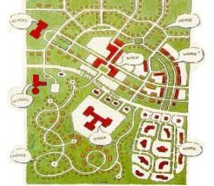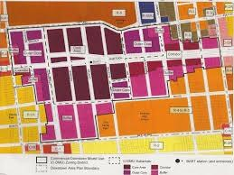

Single-Use Zoning Mixed-Use Zoning
http://www.snipview.com/q/Single-use_zoning http://www.berkeleyside.com/2012/03/09/taller-buildings-open-spaces-on-cards-for-downtown-berkeley/
Historically, single-use zoning has been the norm, particularly in suburbs. The salient difference is that single-use tends to be associated with long, curvilinear suburban streets, and mixed-use with classical grids of short, rectangular streets. This means that single-use tends towards automobile travel to ensure accessibility, whereas mixed-use can offer shorter travel times by a greater variety of modes.

2. Reform of Zoning Laws
The New Urbanists point out that zoning laws have been a principal obstacle to creating mixed-use urban developments, and indeed it follows naturally that zoning reform would be needed in order to practically implement a desire for mixed-use, walkable developments. This is because American land-use laws since the 1920s have historically developed—particularly in suburban areas—so as to prohibit both the mixing of land use types (i.e. residential, commercial, industrial, retail, office, recreational) as well as the installation of walking-friendly features (narrow streets, sidewalks, interconnected street grids). The New Urbanists often point out that highly desirable older communities such as Old Town Alexandria, Virginia, or downtown Boston, would actually be illegal to develop in contemporary America.

3. Context-Sensitive Design and Transect-Based Planning
A major thrust of New Urbanism is to match planning tools more sensitively to human context, social fabric, natural environment, and other intangibles. This overall approach is referred to as “context-sensitive design” and is an overarching leitmotif that runs throughout the entire philosophy / program.
In order to operationalize a working definition of what is meant by “context,” an analytical tool known as the “transect” has been developed. While this tool fills a need to define and articulate what is actually meant by “context,” to a non-expert its definitions seem rather vague; it is somewhat unclear what a transect actually is. Very broad definitions are given on the CNU and DPZ websites, which will be presented below, along with diagrams.

CNU - “What’s the Transect?”
On the CNU website, a page entitled “Ask CNU: What’s the Transect?” states that:
The Urban-to-Rural Transect is a tool for understanding and planning urban development devised by Duany Plater-Zyberk. Its marvelous simplicity and intuitiveness make it a good framework for devising plans and codes.
In this definition, a transect is essentially an overall construct for defining the gradient of land-use from rural to urban. The following graphic is presented in the Glossary of the CNU website:
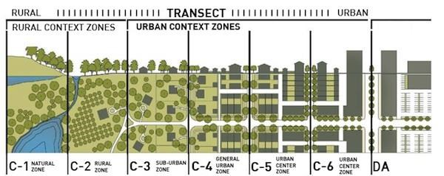
Source: http://www.cnu.org/streetsglossary
This is a great graphic but I am not sure how to get permission to use it, or if simply copying, pasting, and citing is good enough. My lawyer says that text can be quoted without express permission, but that graphics do need express written permission under fair-use laws.
DPZ Website: Transect
The very same “Ask CNU: What’s the Transect?” page links to the DPZ website. Here, some very lengthy definitions are presented. Excerpts are as follows:
“Transect is a geographic cross-section of a region used to reveal a sequence of environments. For human-occupied environments, this cross-section can be used to identify a set of habitats that very by their level and intensity of urban character – a continuum that ranges from rural to urban.
This range of environments is the basis for organizing the components of the built world…. “
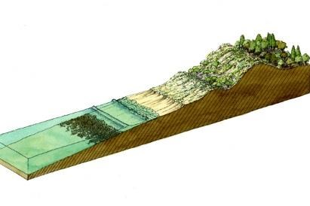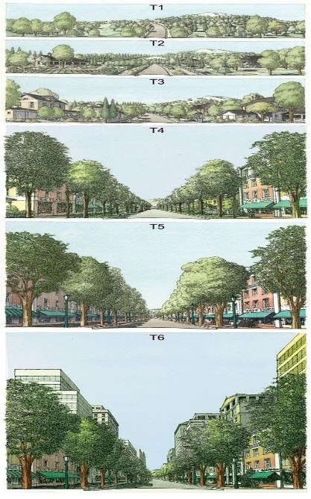

Source: DPZ website, http://www.dpz.com/Initiatives/Transect
The Transect works by allocating elements that make up the human habitat to appropriate geographic locations…wide streets and open swales should be allocated to more rural areas whereas multi-story buildings and public squares should be allocated to more urban zones. This proper geographic “appropriation” serves to better integrate natural and urban systems because one is defined in tandem with the other. Conventional zones ignore this interrelationship. (emphasis added)
The connection with mixed-use and zoning reform is more evident here, and the motif of context-sensitive design emerges more clearly, but nevertheless there is vagueness of definition.
Linkages Between Transect and Transportation Trends
For the purposes of this study – defining New Urbanism and assessing its impact on vehicle travel – the relevance of Context-Sensitive Design and Transect Planning lies in gaining the ability to recognize the underlying patterns and harmonies of New Urbanism. These themes animate many of the more specific planning tools and consequently a general awareness can help to better comprehend the full effect of other tools on urban land-uses and urban transportation.

Assess Regional/National Scope
Awareness can also help in terms of recognizing the potential nationwide scope of New Urbanist development. The transect concept seems to want to harmonize rural and urban areas, which means that the scope potentially extends far beyond metropolitan areas to all areas of human habitation in the United States. Although rather vague, this is nonetheless helpful to know in terms of understanding possible future dissemination of the movement particularly as the United States adds 100 million new persons between 2015 and 2060, and as this population growth provides opportunity to substantially (if slowly) redesign America’s land-use settlement patterns.

4. Street Connectivity: Networks and Choices
New Urbanists believe that a “networked” road layout, in the shape of an interconnected grid (as opposed to cul-de-sacs) can enhance the choices of individual travelers and enhance the efficiency of vehicle trips. In addition, street connectivity would make it easier to create walkable, mixed-use, highly accessible urban districts, because the amount of store frontage would be increased and the mixture of uses more directly accessible on foot.
It is thought that the road pattern on the left, in the following diagram, will give the greatest amount of connectivity, particularly within a situation of mixed-use development:
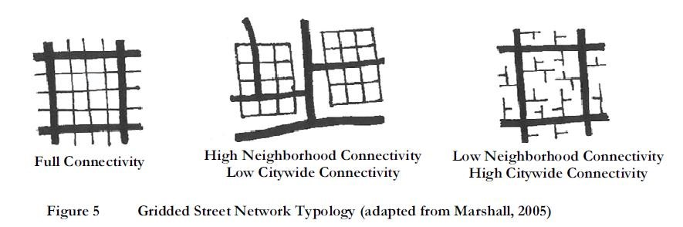
Source: “Striving for New Urbanist Transportation in an AASHTO World: Stapleton’s Challenges and Opportunities.” Wesley E. Marshall, University of Colorado – Denver.
Great graphic – should we go ahead and use it? How to get permission?
The above diagram breaks out into several different planning techniques:
Narrower roads –narrower roads are said to foster better communities through causing people to drive more slowly, enhancing safety, and thus making it more attractive for pedestrians to use the roads. It is argued that the current specifications of road widths, which have gotten much wider than several decades ago, encourage very fast driving and scare away pedestrians.
More intersections – the New Urbanists actually track the amount of intersections per street, or per acre, in their plans. The idea is that the more intersections per length of roadway, the greater the connectivity, and thus the greater the amount of travel choices and the more resilient the network. Theoretically this could reduce congestion by opening more pathways to traffic and helping it flow more smoothly.
Shorter blocks – A cousin to greater “intersection density” is the concept of shorter blocks. It follows logically, in a traffic grid, that shorter blocks will necessitate more intersections, and vice versa.
More Connectivity, Better Sense of Community
One of the motivations of Smart Growth is that the time Americans spend driving reduces their opportunity for family, community, and civic engagement. The street connectivity, mixed-use walkability, and travel efficiencies promoted by New Urbanism are intended to respond to this problem, by permitting some trips to be made on foot, and by shortening other vehicle trips. It is hoped that people would have more time to spend interacting face-to-face with one another, and that this would foster a richer, more in-depth sense of community.
Complete Streets Movement
Encapsulating all of these tools, and adding some additional ones, is a sister movement of New Urbanism, known as “Complete Streets.” The National Complete Streets Coalition, an initiative of Smart Growth America, creates handbooks of best practices, convenes practitioners for trade conferences, and lobbies governments to implement zoning laws that are friendly to “complete streets” features. It is a very widespread movement. The website claims that “to date, over 700 agencies at the local, regional, and state levels have adopted Complete Streets policies.”
The following features are all part of “Complete Streets,” as described in a PowerPoint presentation on the website of the National Complete Streets Coalition:
- Bike Lanes
- Roundabouts
- Angled Head-Out Parking
- Neighborhood Greenways
- Traffic Circles
- Bus Rapid Transit
- Paved shoulders on bridges
- Rural roads with shared use trails
- Low-traffic, low-speed skinny residential streets
- Skinny Residential Streets
- Main Streets
- Shared Commercial Streets

5. From Highways to Boulevards: Urban Highway Removal

Several cities, including Milwaukee, Boston, and San Francisco have either removed elevated urban highways, or else placed them underground, since the early 1990s. While this is nothing new, as discontent with urban highways dates back to the very beginnings of the Interstate in the 1950s and was expressed in numerous political battles, today’s contemporary trend of Interstate removal has emerged as a mainstay component of New Urbanism’s political program.
The CNU website contains a section entitled “From Highways to Boulevards,” and this slogan summarizes the general attitude of the New Urbanists towards highways. They believe that the urban Interstate fundamentally destroys the livable, community character of urban neighborhoods, through literally bisecting neighborhoods and destroying the street connectivity. The Interstate often constitutes a distinctive physical barrier to all modes of travel other than high-speed private vehicle, and thus undermines nearly all New Urbanist goals for coherent, mixed-use neighborhoods.
The CNU website lists no fewer than 18 different active campaigns to remove urban highways, as well as 6 already-complete highway removal campaigns.
To assess the scope of implementation for the New Urbanists’ highway removal program, it may be helpful to look at the national statistics on the physical extent of the urban Interstate:

Source: Federal Highway Administration

As it turns out, lane-miles of urban Interstate have actually doubled since 1980. The data tables show uninterrupted year-on-year growth, for every single year dating back to 1981. Despite efforts to remove isolated stretches of Interstate, it does not appear as if the system is disappearing anytime soon – in fact, just the opposite appears to be true.

Quantitative Scope of New Urbanism – Limited but Useful Statistics
This section will investigate how many New Urbanist projects might exist in the United States, in which cities, states, or regions they are most commonly found, and at what scale—building, neighborhood, district, city, or region—projects are most commonly developed.
It is very difficult to obtain comprehensive data on New Urbanism, since at 30 years old, it is a relatively new movement, and no single stakeholder has had the motivation to conduct detailed research on the full scope of its implementation. However, some approximate aggregations do exist to provide an overall sense of the amount and location of New Urbanist projects in the United States.
The two major sources are the project database on the website of the movement’s flagship association, The Congress For A New Urbanism (CNU, www.cnu.org), as well as The Town Paper (www.tndtownpaper.com), which tracks the synonymous metric of “traditional neighborhood developments.” Neither of these lists exists in the form of a searchable database on their respective websites, so each one was hand-entered into an Excel spreadsheet and then tabulated and sorted for insights. Data from both lists will be utilized in the exploration below, since especially with a topic where data are uncertain and preliminary, it is important to cross-reference in order to verify the general range of estimates and gain a comprehensive sense of what the national benchmark might actually be.
It should be kept in mind, in the charts which follow, that these data are under-estimates, as it was discovered during the data-input process that many fields were blank and in the CNU database that some of the older projects were not updated. The main value of this section is thus to gain a general sense of the cities, states, or regions where one is most likely to find specific implementations of New Urbanism, as well as the prevalence of different scales of development – i.e. neighborhood, district, city, region and so forth. The overall goal is to begin an exploration and to set the table for future research should it be found desirable.
National Count of Projects
The following bar chart lists the total amount of New Urbanist (NU) projects as well as Traditional Neighborhood Developments (TNDs) found on each website’s list:

Source: CNU Project Database; The Town Paper
Even these initial data highlight the enormous disparity between the two databases. There is much overlap of individual projects, but the TND list is much longer, almost double the length of the NU database. Unhappily, it is actually the more incomplete NU list, from CNU, which contains the most depth of detail on type and scale of specific developments, but regardless many trends can be gleaned even from these approximate databases. The following sections will analyze present the axes of scale, city, and state for every list for which this is available.
Typical Scale of Projects
The following graph is derived from the CNU’s project database website, and gives a clear cross-section of the scale of individual new urbanist projects:

Source: CNU Project Database
In overview, it seems most appropriate to say that by the New Urbanists’ own database, the vast majority of their projects are relatively small-scale.
The graph clearly illustrates that the vast majority of New Urbanist developments take place at the “micro level” of buildings, districts, blocks, or neighborhoods. “Region” is in third place with 27 projects, but in fact many of the entries in the CNU database which are labeled “Region” seem mislabeled and would more properly be referred to as Building, Block, Street, or Neighborhood.

Projects by City

It will be helpful to get an idea of the cities where the greatest amount of New Urbanist developments exist, in order for Fuels Institute participants to place this trend within a concrete geographic context. Both the CNU and TND databases can be utilized. The graphs are as follows:

Source: CNU Project Database Source: The Town Paper
Both these databases show that the Washington DC metro area is a clear leader in New Urbanist developments among American cities. The high level of “traditional neighborhood developments” in Baltimore may actually reflect successful activist efforts, in the 1960s, 1970s, and 1980s, to reroute planned Interstates to save older neighborhoods from being demolished and/or bisected. In addition, Alexandria, VA is a widely touted example, in New Urbanist publications, of a city that could not be built today due to single-use zoning laws.
In Milwaukee, the NU/TND projects are at least in part connected to a nationwide trend of removing urban Interstates, which is a New Urbanist goal and which took place in Milwaukee in the early 2000s. The Park East Freeway, an elevated highway which separate sections of Milwaukee’s downtown, was removed beginning in 2002, and in its place streets were reconnected in a classic New Urbanist spirit.
Some of the other cities on the list may actually reflect efforts as-yet incomplete, to revitalize what had become extremely auto-dependent cities, particularly Atlanta and Denver. If it is remembered that the scale of New Urbanist projects tends to be very narrowly localized, then the high amount of TNDs in Atlanta and Denver may been seen as merely an initial wave of urban repurposing, to be followed potentially in future. The point is that the largest cities with the worst sprawl may have the greatest inducement to try and implement New Urbanism.
Projects by State
The following charts show the amount of NUs, and TNDs, respectively, by state:

Source: CNU Project Database Source: The Town Paper
The two states with the most New Urbanist projects are California and Florida, although the order is reversed depending on who’s doing the counting. It is not surprising to see these two at the top. Florida, for one, is the birthplace of the movement. California is the state with the largest population, so given the small scope of most new urbanist developments, it stands to reason that in California there might be many small “pockets” of demand.
Virginia, third on the list, has many projects located in the Arlington County area adjacent to Washington DC. This county is well-known for its decades-long attempts to make itself walkable and revitalized alternate travel modes. The Rosslyn-Ballston corridor, to cite a well-known example in Arlington County, contains several projects.

New Urbanist Effects on Vehicle Travel: Walkable Urbanism?
The VMT Equation has been applied to the compact development movements as a whole in chapter ___, “Assessment of Compact Development Movements,” so such analysis will not be repeated here, except for one point of note, that of walkable urbanism. There has been an increase in walking as a travel mode choice since the 1990s, during the very time when New Urbanism has begun to gain momentum and accumulate its project list. The increase in walking as mode choice can be seen in the following graph:

Source: National Household Travel Survey
While still comprising only 10% of all household trips in 2009, walking remains a relatively marginal mode choice—but nevertheless, its 2009 level was double its 1995 level. It is interesting to see this trend, given that one of the main goals of New Urbanism has been to increase walkable accessibility of neighborhoods, and that most New Urbanist projects in existence today were created either in the mid-1990s or more recently.
Unfortunately, it is extremely hard to disentangle which specific New Urbanist features have specific effects on vehicle travel, since the features of New Urbanism are intended to work together as a cohesive whole, and if one feature is not present, then all the others may be ineffective at reducing vehicle travel. For example, if a highly connective street grid, with narrow streets, sidewalks, and frequent intersections, replaces the previous set of long curvilinear roads, cul-de-sacs, and collector arterials – but the settlement is far away from the workplace of most of the residents and requires long daily commutes, then driving may not be reduced at all.
As another example, if walking is reduced in a given neighborhood, it is hard to tell whether that is due to that neighborhood’s specific design features, or whether there had been an independent, exogenous shift in consumer preferences which would have happened anyways.
Overall, this is certainly an area where further research could be beneficial in order to balance the findings put forth by Smart Growth America, Urban Land Institute, and various scholars, that walkable design can generally reduce VMT by 20% to 40%. Most such studies have been done either by advocacy groups, government research councils such as the Transportation Research Board, or professors who specialize in this topic, and who tend to have a strong bias in favor of environmentalism and smart growth. Studies done from a transportation industry perspective are lacking; the closest to an industry perspective in existence would probably be those from various traffic engineering groups, but these groups produce very technical reports which may not directly touch the broad, unanswered, interrelated questions of business, policy, or economics which are so central to the future of fuels.
Idealized Design in “The Middle of Nowhere”
Notwithstanding the travel mode numbers for walking, there is a critique which holds that New Urbanism has no effect on travel at all, because of the placement of its settlements on the far outskirts of existing metropolitan areas—or even up to 35 miles away from densely settled areas.
In other words, many say that New Urbanists tend to build model mixed-use settlements in “the middle of nowhere.” As an urbanization textbook opines,
“In contrast to the hype surrounding New Urbanism, it has succeeded only in producing a plethora of middle-class subdivisions that are isolated from their host communities by private management and retro architecture that is too naively artificial to bear its own stylistic weight. New Urbanism’s claims about car use and sustainability are belied by actual commuting patterns and levels of SUV ownership.”
This criticism refers to early communities such as The Kentlands, MD, or Seaside, FL, which are situated so far away from major metro areas that anybody who could afford to live there—if not retired or tele-working—would probably need commute to a job by private vehicle 30+ miles away.
Stapleton, Colorado: former Denver airport
The town of Stapleton, Colorado, provides at least one opportunity to analyze objective data on New Urbanism and its effect on commuting patterns. Stapleton is a model New Urbanist settlement developed in the mid-1990s on the grounds of the former Denver airport. Many years of planning, public consultations, and policymaking went into its construction, in advance of the decommissioning of Stapleton Airport, in order to design a mixed-use, mixed-income town which would apply the tenets of “walkable urbanism.”
Commuting patterns from the “Stapleton experiment” can be seen in the Front Range Travel Survey, conducted in 2009-2010. Since neighboring cities’ commute patterns were surveyed as well, it is a very unique chance to compare the New Urbanist development objectively to nearby cities which feed into the same metropolitan area. In addition, since Denver-Boulder is the lone metropolitan area in the region, the study results are all the more valid in terms of not having confounding variables of commutes to other nearby metropolitan areas.
The results of the survey show that Stapleton was not very successful in changing the choice of travel mode away from driving:

Source: Denver Regional Council of Governments
The above chart gives very strong support to criticisms of “middle-of-nowhere” New Urbanist settlements, and their effect (or lack thereof) on mode choice for work commutes. Of all the Denver suburbs/neighborhoods surveyed, Stapleton residents actually had the highest “drive to work” mode choice of all. Each of the other places is closer to downtown Denver, with a greater variety of travel modes available, and the residents utilized a much greater mix of travel options for their daily commute.
Conclusion: Open Questions
The incomplete data on New Urbanism raise some tantalizing questions, none of which have a ready-made, clear answer:
- Is New Urbanism on its way to becoming a ubiquitous national movement?
- Could it indeed affect vehicle travel as much as it intends?
- Could it one day have a measurable national effect on VMT? Has it already?
- Has New Urbanism caused the upsurge in walking since 1995, or was this due to other, unrelated factors?
Tipping Point / Critical Mass
In responding to these questions, it should be remembered that the data show most New Urbanist projects to be at small scales of the neighborhood or even of individual buildings. This raises the interesting question of a “tipping point” or “critical mass” phenomenon. If enough small New Urbanist projects are developed within a metropolitan area, is there a point at which they can coalesce to entirely change the character of large swaths of the city, if not the entire city? Is there a “fractal effect” whereby if enough smaller components are installed, the entire system begins to resemble the network of smaller systems? If this were indeed true, how close would today’s New Urbanist developments be to arriving at this kind of situation?
Many of the general New Urbanist principles may seem vague and abstract at first, but it is this very level of abstraction which enables them to filter into numerous types of development, in innumerable small ways, and which thus makes the “critical mass” question much subtler and more powerful for New Urbanism than for the other movements.
Even with the limitations to compact development, as outlined in chapter ___, New Urbanism contains in it, conceptually, the potential to have significant impact. This is because its potential for very small-scale applications lends its designs an adaptability, versatility, and flexibility which smart growth (with its need for fiscal reallocations, higher densities, and desire to avoid new construction) and transit-oriented development (with its limit to a ½ mile walkable radius around fixed-guideway stations) simply cannot match. It is not despite, but because of, its small scale that New Urbanism may become extremely influential in the long-run.
Call for Further Research
The “unknowns” of New Urbanism and vehicle travel are likely to continue unfolding, slowly but relentlessly, over the coming decades. There is ample opportunity to undertake in-depth research in this field, in order to better describe and characterize what has already taken place, as well as to track what happens in the future, as it happens. Of particular interest would be tracking the way in which New Urbanist “micro” design traits may filter into “macro” trends.
Summary

In sum, New Urbanism is most definitely a movement to watch. Because of its versatility, building-level applications, and potential for effecting small but permanent changes to micro regions of cities, it could conceptually have a significant impact on travel patterns over time.

Transit-Oriented Development (TOD)
Much has been made of a trend visible in many large American cities, where middle-income or high-income apartment buildings are constructed on a “mixed-use walkable” basis, next to a transit station as well as a large variety of retail services. Some have wondered whether, as part of the “sustainability” movement, young professionals who in former generations would have lived in a single-family suburban house and driven to work, are now choosing to live in apartments, ride transit to/from work, and walk everywhere else. A further question has been how widespread this trend is, if it indeed exists – are these transit-oriented developments (TODs) merely the early precursors of a massive shift in travel patterns?
The short answer is “no, not by a long shot.” This chapter will explain why.
Brief History
TOD as a movement must be distinguished from transportation-related real-estate development in general. The latter has occurred all throughout recorded history; it is a well-known fact that transportation and urban forms are closely interrelated. TOD as a formal movement, however, seems to have emerged in the 1990s along with the Smart Growth and New Urbanist movements, as part of the broader movement of modern environmentalism. Like these other movements, it has its advocates, promoters, and trade associations, who form a stakeholder nucleus.
Stakeholders
An umbrella group known as the Center for Transit-Oriented Development (CTOD) promotes TOD projects at a national level in the United States. Founded in 2004, CTOD is a collaboration of three other organizations: Strategic Economics, Reconnecting America, and Center for Neighborhood Technology (CNT). The CTOD publishes best practices research and provides joint forums for stakeholders.
The three partners of CTOD can be summed up as follows:
Strategic Economics is an economic consulting firm located in Berkeley, California, which explains on its homepage that “we specialize in real estate, urban, and regional economics consulting.” Strategic Economics appears to do most of the economic research, and to author many of the reports, which appear on the CTOD website.
Reconnecting America is a non-profit which serves as the managing partner of the CTOD. Reconnecting America has a wide variety of activities, including lobbying, public-private collaboration, and research. It appears that the CTOD is its major research arm for transit-related issues, but that it undertakes many other activities as well, particularly in terms of creating transit collaboratives. Reconnecting America states the following on its Who We Are webpage:
“Reconnecting America is a national nonprofit that integrates transportation and community development. Reconnecting America advises civic and community leaders on how to overcome community development challenges to create better communities for all. Reconnecting America develops research and innovative public policy, while also building on-the-ground partnerships and convening players needed to accelerate decision-making.”

Center for Neighborhood Technology (CNT), founded in 1978, is a Chicago-based nonprofit which deals with issues of urban sustainability and livability. According to its website, the specific issues it deals with range widely, including housing affordability; car-share programs; energy efficiency; location-efficient mortgages; climate change policy; and various urban advocacy projects.

Definition of TOD
Transit-Oriented Development (TOD) is defined by the Center for Transit-Oriented Development as:
“a type of community development that includes a mixture of housing, office, retail, and/or other commercial development and amenities integrated into a walkable neighborhood and located within a half-mile of quality public transportation.”
In essence, the design principles of new urbanism are utilized in order to create a walkable neighborhood within the vicinity of a transit station. In terms of the VMT equation:
VMT = (vehicle trips) (average trip length)
The goal of TOD is to reduce the rate of vehicle trips for those who reside in the immediate vicinity of the transit station, through changing their mode choice. Instead of either driving to work, or driving to a transit station, parking there, and then riding transit to work, TOD aims to shift the mode choice totally away from automobiles, towards walk-to-transit.

Effects on VMT
TOD is a very marginal movement, which has little to no effect on VMT, whatever the claims of its various promoters. The main reason is simple: The cities where TOD takes place are already built up and TOD does little or nothing to change their built environment. Rather, as the author of this study observed in riding the light-rail, heavy-rail, or bus rapid transit systems of Atlanta, Boston, Charlotte, Chicago, Cleveland, Dallas, Houston, Los Angeles, Nashville, Philadelphia, Phoenix, and San Diego, newer-built transit systems simply run through the various zones of the city that already exist. Large portions of transit lines, in all of the above cities, run either through industrial zones or big-box retail zones that will never remotely resemble the idealized TOD planning schemes of its promoters.
Few comprehensive studies of TOD exist at the national level, and those which do tend either to confirm the author’s firsthand observations of its extremely limited effect, or else to focus very selectively on the one or two neighborhood districts in the entire nation which actually are ideal candidates for TOD, but for reasons beyond the control of any given team of urban planners.
Arlington County, Virginia, is a particular favorite of TOD promoters, but its traits are so unique as to be irrelevant to assessments of TOD elsewhere. While it does appear to be true that transit commuting ridership is very high in Arlington, as a result of a concerted planning effort by local officials in the 1970s and 1980s to create such an environment, this depends upon an extremely large, predictable pool of federal workers and federal contractors, which no other city can depend upon to consistently emerge from the private sector. The ideal transit-oriented population exists in this area, a constant stream of young, educated, and highly mobile federal workers, who don’t mind living in high-rise apartments for a few years next to transit, and who are nearly always replenished in equal measure as one cohort moves on and the next one arrives. This is an extremely unique situation which cannot be duplicated elsewhere.
Companion to Transit Chapter
This chapter should be read as a companion to the previous chapter on transit. That chapter reviewed historical trends in transit ridership, and concluded that while there has been some amount of increase in transit ridership since the 1990s, it pales in comparison to the high, even dominant, levels of transit ridership that prevailed during the period from 1890 through 1950. In addition, that chapter concluded that the low densities at which most Americans live, and the flexibility of the automobile to generate trips and VMT on a much vaster scale than transit ever could, mean that it is extremely unlikely that transit would ever regain the dominance that it once had. The fixed guideposts of rail, as well as the low speeds of buses and streetcars, are no match for the speed, flexibility, ubiquitous private ownership, and convenience of the private automobile.
This chapter, then, should be read within the context of those findings, in terms of assessing whether transit-oriented development could ever lead to a mass revival of transit. It cannot; there are simply too many factors arguing against it. One of the most important of these factors is the need for walkability and the distance limits which this imposes. Even the most ardent advocates of TOD explain that its maximum catchment area for passengers and/or commuters is within half a mile of a transit station, since this is the distance from which one can walk to a transit station in ten minutes or less. Any longer than a 10-minute walk severely undercuts the attractiveness of transit in comparison to the automobile, because much of the speed advantage of the automobile comes from the fact that one normally needs neither to walk to it nor to wait for it, especially when one’s own home is the trip origin. In contrast, a transit trip where the walking portion is greater than 10 minutes can double the time of the trip, even for the most direct itinerary, and is also less likely to contribute to the walkable retail that is ideally situated next to a TOD.
These limitations can actually be shown photographically, in some real-life TODs. In visiting many cities in preparing this report, the author took many photos and made many PowerPoint slides of TODs. Some of these will be presented below to give a pictorial sense of TOD’s limitations.

Charlotte, North Carolina – Bland light-rail station
The Bland station is located roughly halfway on the Charlotte LYNX light-rail line, perhaps two to three miles from downtown. The station looks as follows:
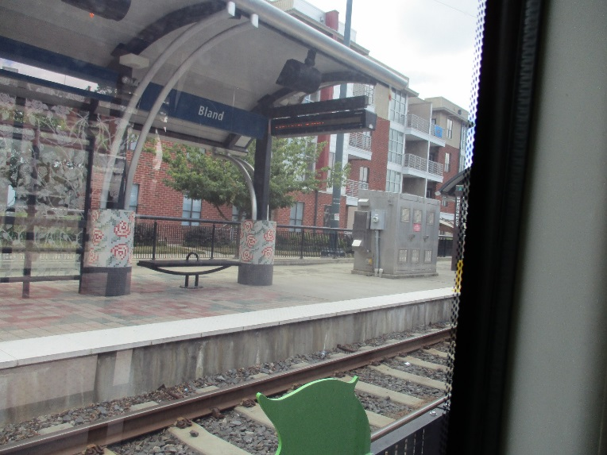
Source: Author’s photograph, 5.27.2015
One can see the apartments directly behind the station, but it is actually across the street where attention will be focused. The author discovered what seemed to be a TOD station which literally “had it all.” The following PowerPoint slide, copied and pasted, explains:
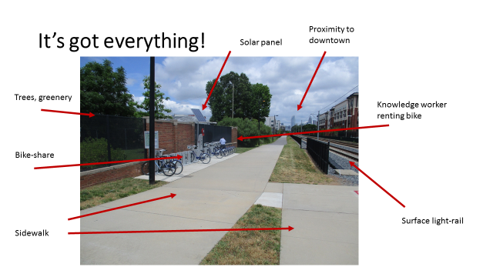
Source: Author’s photograph, 5.27.2015
However, the following slide starts to give a sense of what is missing:
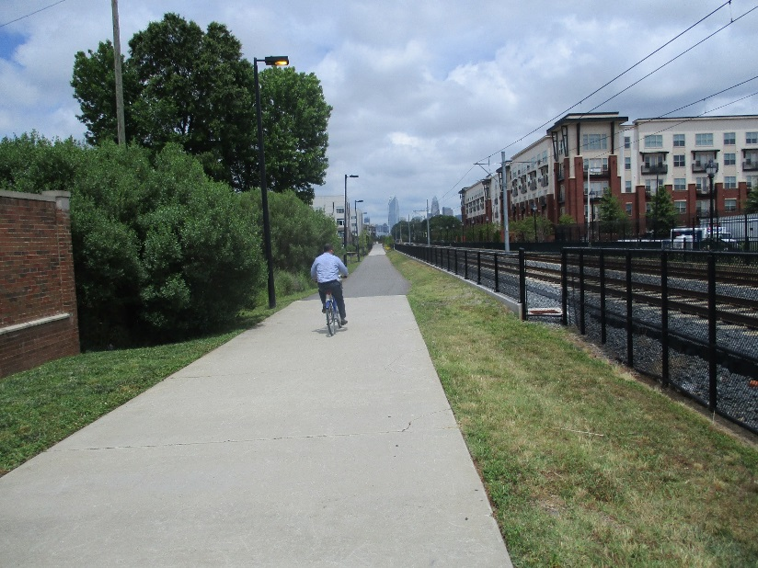
Source: Author’s photograph, 5.27.2015
As the bike-rider goes off into the sunset, the sidewalks are completely empty; they may be walkable but nobody is present to experience the walkability.
When surveying the area directly around the apartment complex, the amount of parking makes it painfully clear that auto ownership levels are high even within this complex:
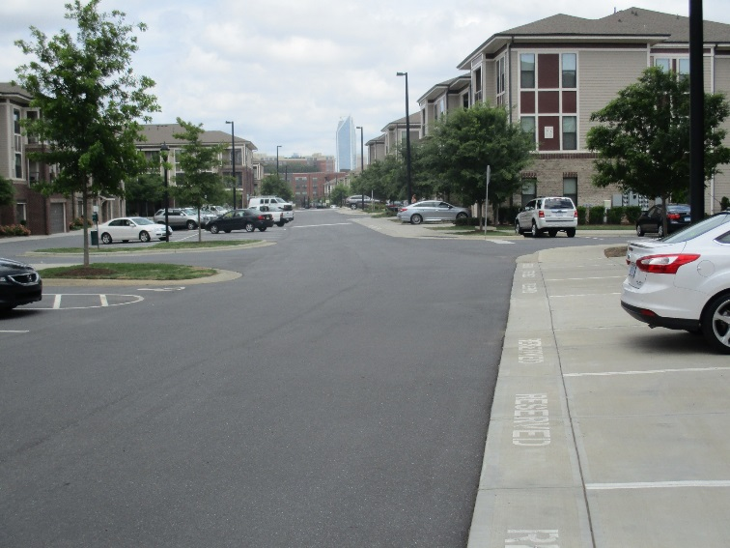
Source: Author’s photograph, 5.27.2015

Further, photos of the streets immediately surrounding this complex make it further clear, that not much has changed in the adjacent streets. Just around the corner, one can find the following streetscapes:
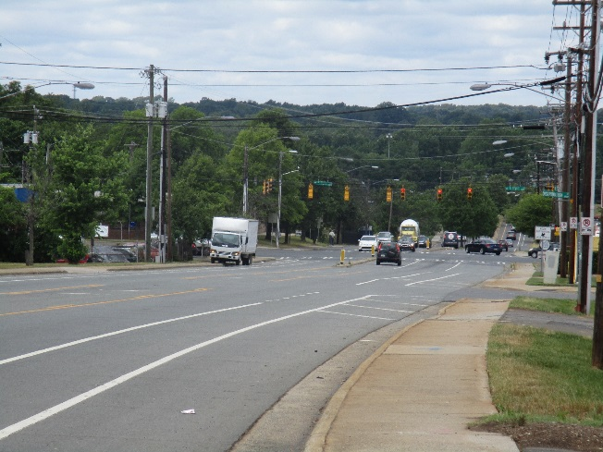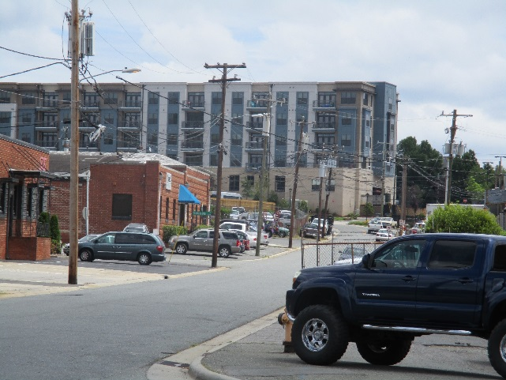
Source: Author’s photographs, 5.27.2015
In sum, while a very comprehensive effort has been made to institute TOD at this particular light-rail station, it remains very much a work-in-progress in terms of changing the walkable feel of the entire district in which it is located. In fact, given the longstanding factories and office buildings in the immediate vicinity, which appeared to be “going concern” companies that were not rundown at all, it appears unlikely that the surrounding landscape would change anytime in the foreseeable future to become less auto-dependent.
Atlanta, Georgia – Lindbergh City Center
Another TOD visited by the author was Lindbergh City Center in Atlanta. This station sits at the geographic center of the MARTA network, one block away from MARTA’s head office, and next to a large AT&T office building which is the centerpiece of the complex. The redevelopment of this station into a TOD, which was quite lengthy and involved many rounds of civic planning discussions, was a case study featured in the guidebook The New Transit Town: Best Practices in Transit-Oriented Development.
This TOD’s genesis began when MARTA’s search for additional operating funds coincided with federal rule changes to permit agencies receiving project grants to “to develop the land for mixed use or sell it and keep revenues for operations and capital improvements.” Around the same time, AT&T stepped forward to announce that it wanted to relocate some of its suburban office space to this location, to demonstrate its belief in Atlanta’s metro future. In planning charrettes (public consultation processes), the local residents expressed concerns about higher-density buildings, the effect of the TOD on housing affordability, and the amount of new parking that was required. After extremely lengthy discussions, and lawsuits from neighborhood groups, the project received approval and went forward.
When one emerges from the underground station, the project appears to be a textbook model of how to undertake TOD. There is a walkable plaza with medium-rise, mixed-use buildings, and there is an AT&T office complex that is tastefully designed and does not tower like a skyscraper over the landscape:
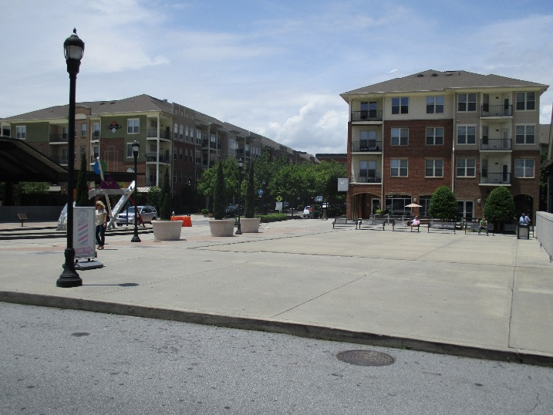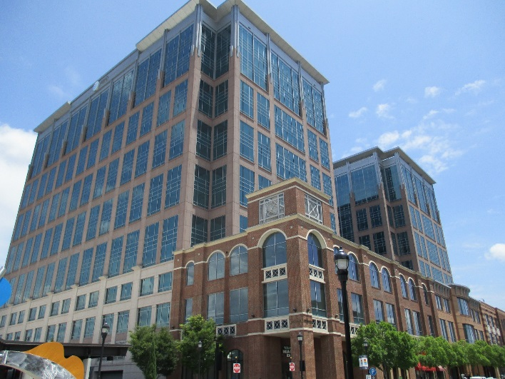
Walkable Plaza Mixed-Use Office Complex
(Source: Author’s photographs, 5.28.2015)
In addition, what parking there is, is very tastefully tucked into the landscape within a pair of covered, multi-story garages:
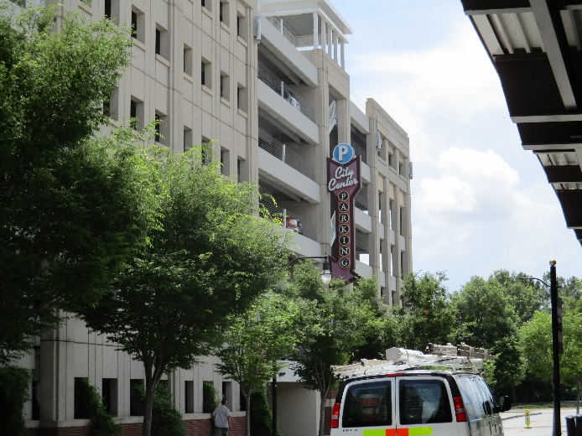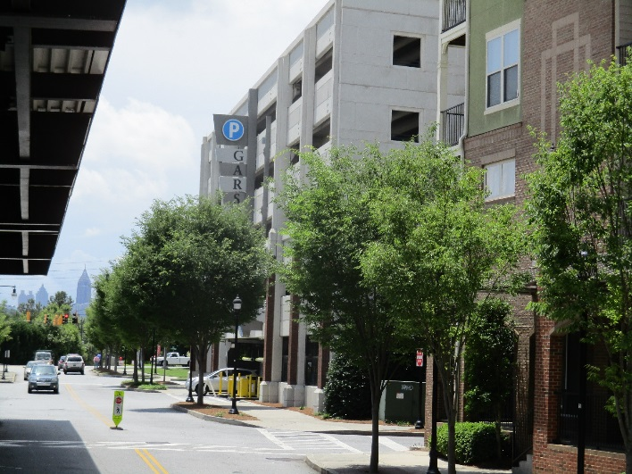
Garage #1 Garage #2
(Source: Author’s photographs, 5.28.2015)
However, if one walks one block in any direction, the spatial limitations of the TOD become very clear. The following photos show typical street scenes – traditionally auto-dependent in every way – located within 2 walking blocks or less from the Lindbergh City Center station:
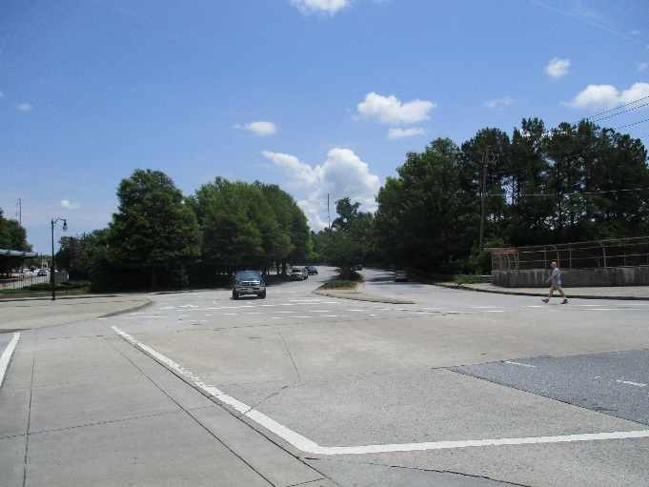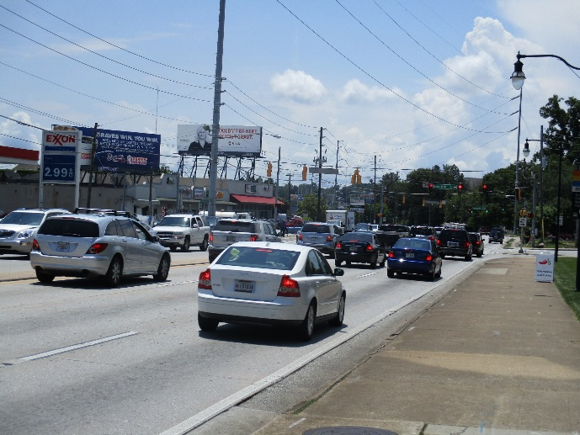
One block away One block away
(Source: Author’s photograph, 5.28.2015)
Thus, while there is no doubt that the Lindbergh City Center TOD has been tastefully and skillfully designed, it cannot have a transformational effect all by itself on the shape of metro Atlanta. Its effect is incremental, and symbolic as much as anything else – to show that such projects can indeed be undertaken even in a heavily auto-dependent metropolis such as Atlanta. Nevertheless, from the photos presented above, it would appear that even if twenty or thirty such projects were completed, a very ambitious goal, that their limited radius of impact means that even in aggregate, they would likely only have a very limited effect on the walkability of metro Atlanta. Thus even the rosiest, most ideal scenarios of blanketing Atlanta with TODs would likely only have the most minimal aggregate effects on transit usage.
In addition to considering the placemaking efforts in the direct vicinity of the station, there is the regional question of the jobs/housing balance to consider. Any TOD placed in a sprawling metropolis will necessarily exist within a geographically large labor pool. If a TOD were built within a central city but drew most of its workers from distant suburbs, who were accustomed to auto-dependence, then they would likely continue their habit of auto-commuting.
The fact of the matter is that journeys to work take place at both the origin and the destination, and if the origin remains in a distant, auto-dependent suburb, then there may be no choice but to continue driving to work even in the presence of a model TOD steps away from one’s place of work. The parking garages at Lindbergh City Center, which contain more than 10,000 parking spaces in all, provide evidence that this was a serious consideration even in a symbolic “example TOD” such as this, which had been constructed with much media fanfare and which is located 1 block from the regional transit authority’s head office.
The issue of parking raises a very interesting, often overlooked tradeoff between station walkability and parking availability. A competing function of transit—reduction of traffic congestion by taking vehicles off the road at rush hour—requires significant space for parking so that drivers can “park and ride” in sufficient numbers to reduce traffic congestion. This sometimes this entails a very large number of parking spots and, depending on available space, may crowd out the space available for constructing the walkable retail features so prized by TOD advocates.
In fact, the author’s travels in preparation of this study revealed that there are many such rail stations in the United States, where parking takes up nearly all adjacent space at a fixed-guideway rail transit stop. This occurs not only in cities with newer rail transit networks, but also in cities with robust, long-established transit networks. The following photographs illustrate the relatively widespread existence of what might be termed, “Parking-Oriented Development,” or POT:
Parking-Oriented Transit (POT)

Charlotte, North Carolina: I-485 and South Blvd, LYNX Station
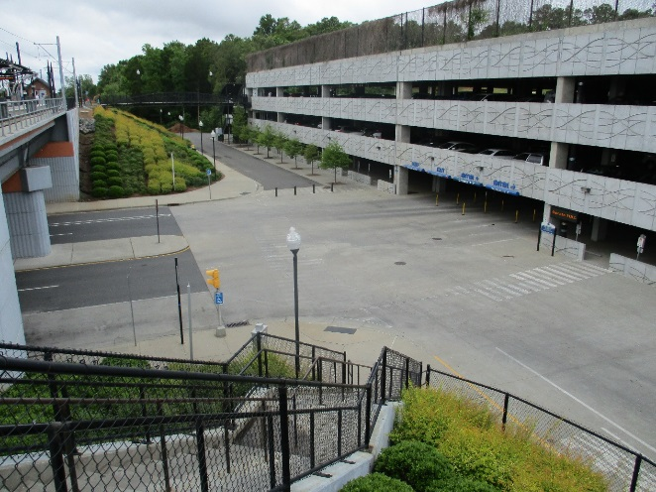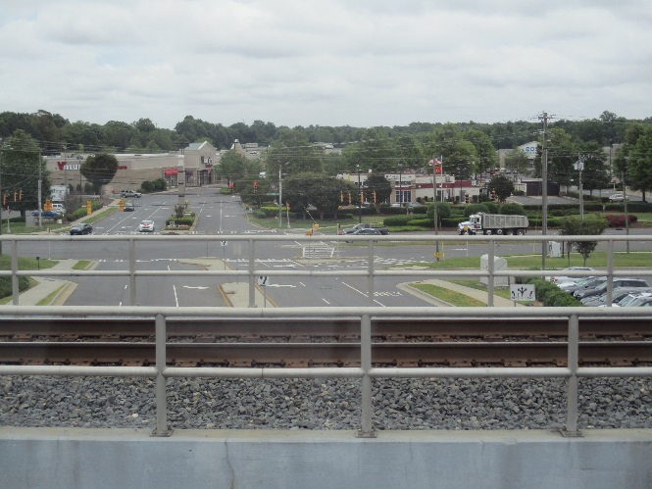
West of station: Parking Garage East of Station: Big-Box Retail
(Source: Author’s photographs, 5.27.2015)
This station is the terminus at the southern end of the LYNX, Charlotte’s only light-rail line, a 9.6-mile north-south line. Even though there is a multi-level parking garage, it takes up viritually all walkable space adjacent to the station. The shopping mall across the street contains big-box retail such as Target, Gregg, Old Navy, and so forth, and is only accessible through crossing South Blvd, a very wide, high-speed thoroughfare.
Atlanta, GA – Indian Creek Station, eastern end of Blue line
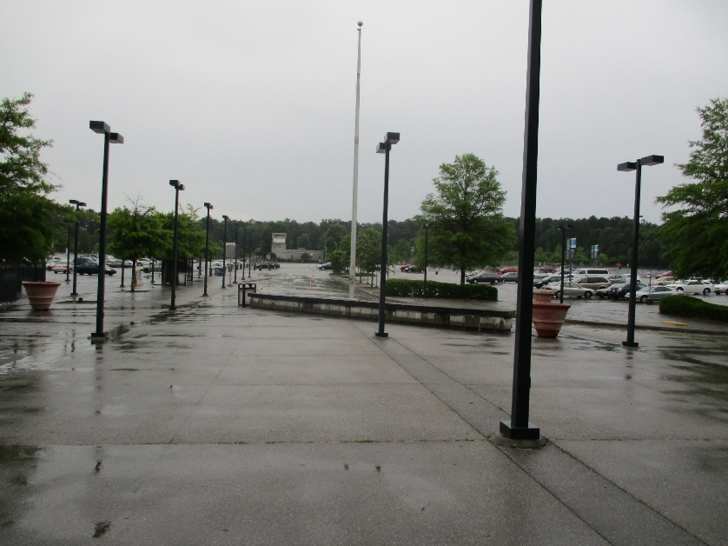
Source: Author’s photograph, 5.28.2015
The Indian Creek station in Atlanta is situated at the eastern terminus of the blue MARTA line; MARTA is the heavy-rail transit system of metro Atlanta. The station opens out onto a vast parking lot, only a fraction of which can actually be captured by the camera lens. The notion of walkable TOD at such a station seems extremely remote, not only given the emphasis on parking, but also the sparse foot traffic at the station at 8 pm on a weeknight. Those passengers who were not driving seemed to be at the station only to wait for transfer buses to points even further distant, in counties outside of Atlanta proper.
Greenbelt, Maryland (end of Washington, DC green line)
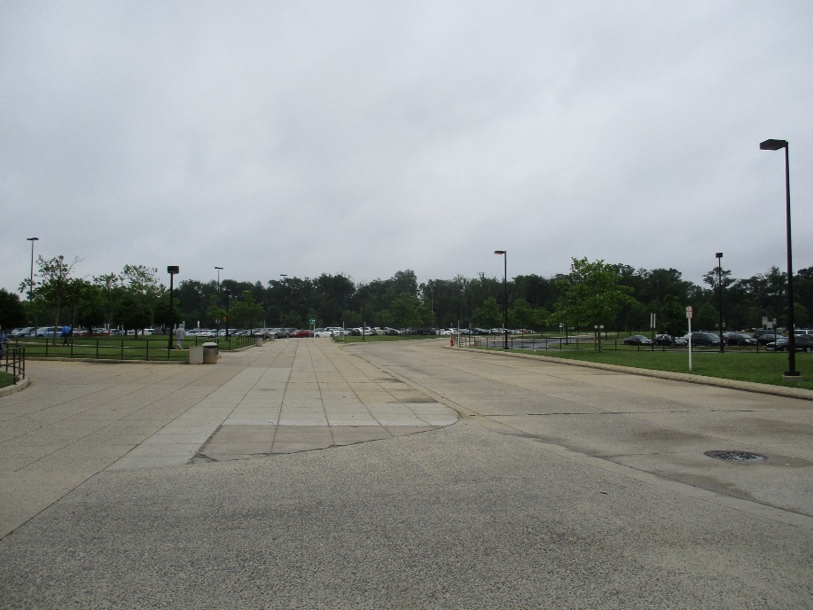
Source: Author’s photograph on 6.4.2015
The Greenbelt station can be found at the end of the WMATA green line in the Washington, DC metro area. As the photo suggests, and as real-life confirms, there is not any sign of development whatsoever at this station, other than the vastness of the parking lot and some buses waiting nearby, bound for parts further along. Some irony can be found here, because the town of Greenbelt was planned in the 1930s as a New Deal model example of a green, community-based town – but the model green town is nowhere to be found at the metro station that bears its name.
Radnor, PA (Philadelphia)
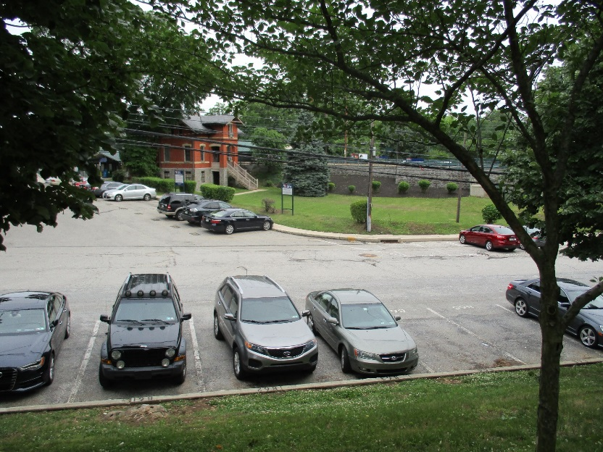
Source: Author’s photograph on 6.3.2015
Radnor, Pennsylvania was originally a “railroad suburb” located along the Main Line of the Pennsylvania Railroad, one of the many “string of pearls” developments along this prestigious rail line, in a very well-to-do neighborhood. Today, it is hard to even tell the presence of a station, due to the sizable parking lot. Another view of the parking lot can be shown looking outward from the station:
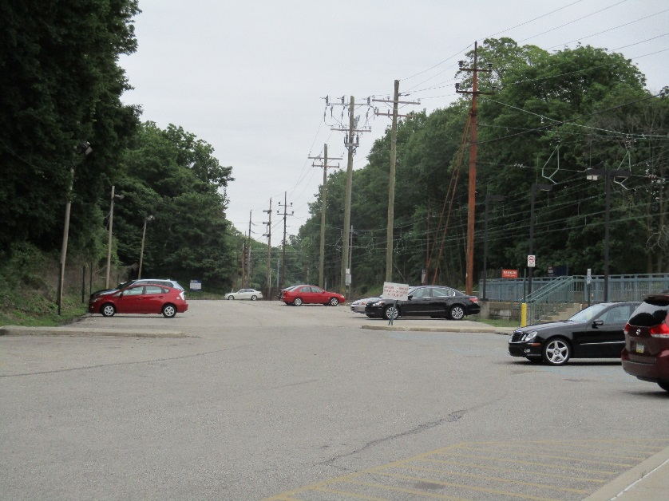
Source: Author’s photograph on 6.3.2015
There is no walkable development in sight, unless one counts the parking spaces as “walkable development.” The only major development near this station is a “corporate center,” a 5-minute walk away, where the parking lots seemed larger than the buildings themselves:
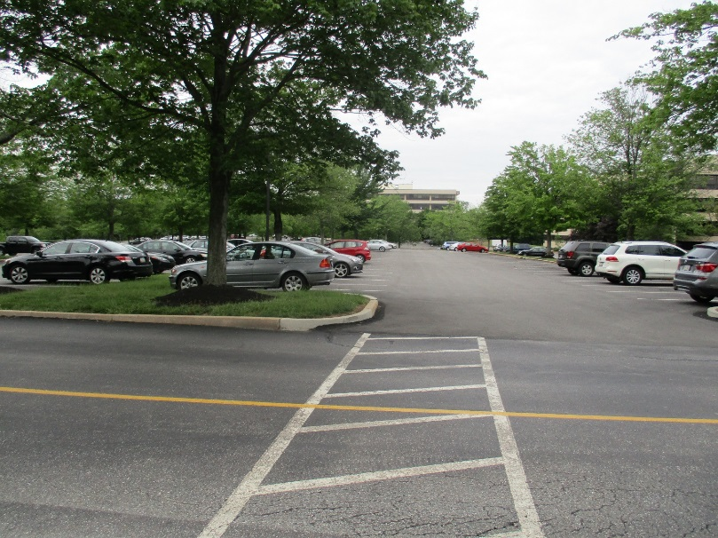
Source: Author’s photograph on 6.3.2015
Many of the roads adjacent to the Radnor station were classics of non-walkability—wide, with no sidewalks, and engineered for high speeds:
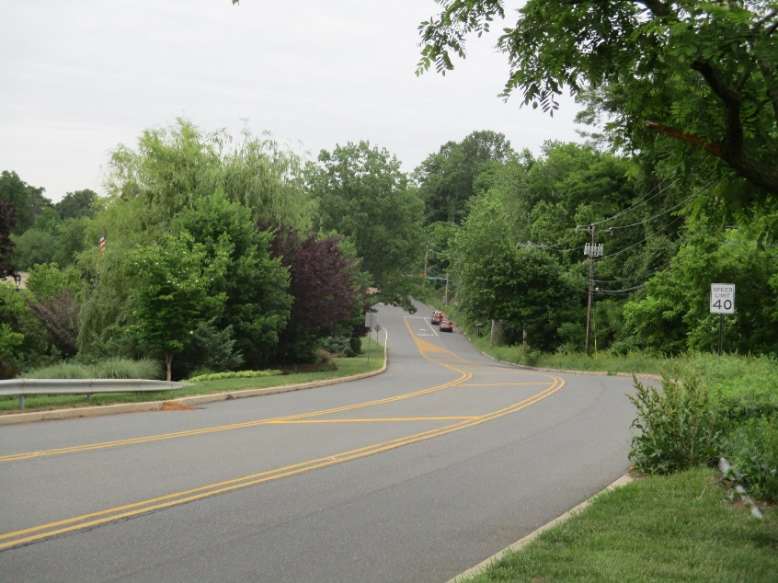
Source: Author’s photograph on 6.3.2015
Clearly, a lot has changed since the original walkable railroad suburbs were laid out!
There is one other TOD pattern of note, which is very distinctive and which appears deeply inimical to ever being changed to accommodate walkable development. This is the placement of a heavy-rail transit line on the same right-of-way as an Interstate highway, the two installations adjacent and parallel to one another. In Chicago this is taken a step further, with freight rail lines on the other side of the passenger rail, so that the passenger transit rail is located in-between the Interstate on one side, and heavy freight rail on the other side. One might be tempted to name this type of transit development “HOT,” for Highway-Oriented Transit.
Highway-Oriented Transit (HOT)
The following photographs were taken on the blue line at or near Oak Park station. The first pair, below, show an overview of the situation:
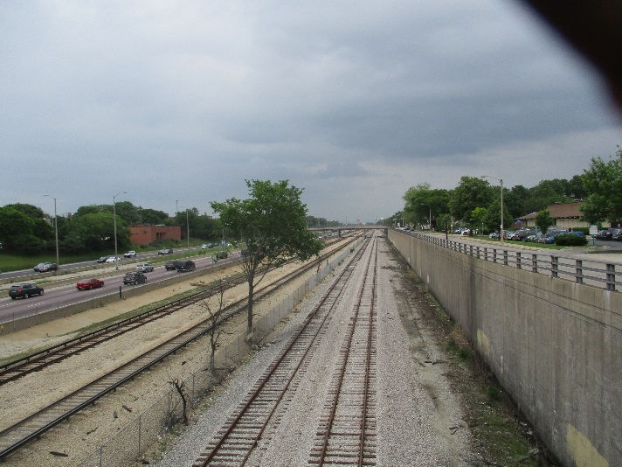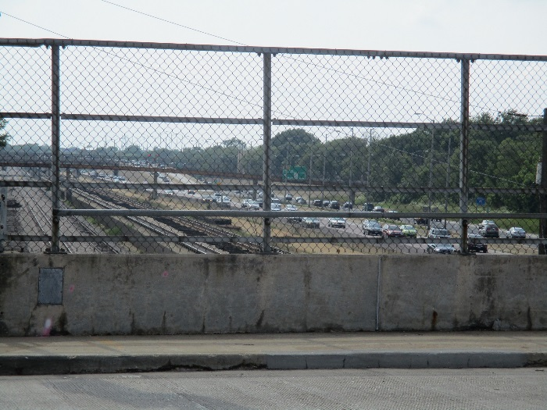
Source: Author’s photographs on 6.7.2015
The following photographs show how one actually walks down to the train platform: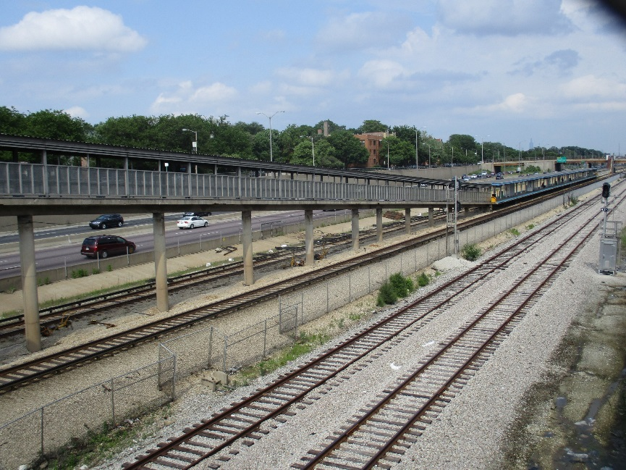

Sour
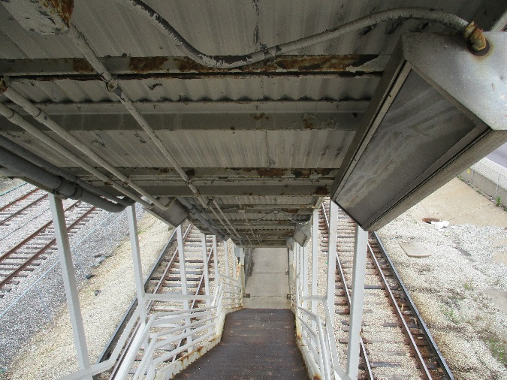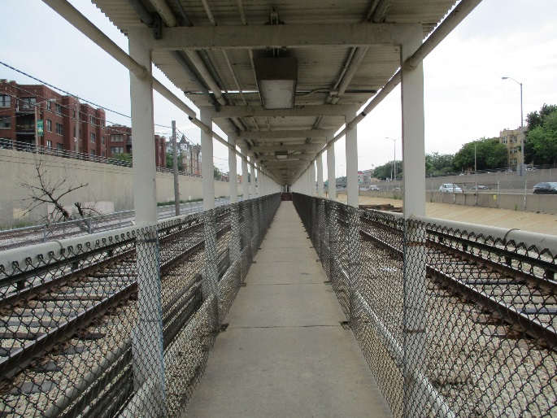
View
View inside the walkway
Source: Author’s Photographs, 6.7.2015
Finally, a view from inside the train:
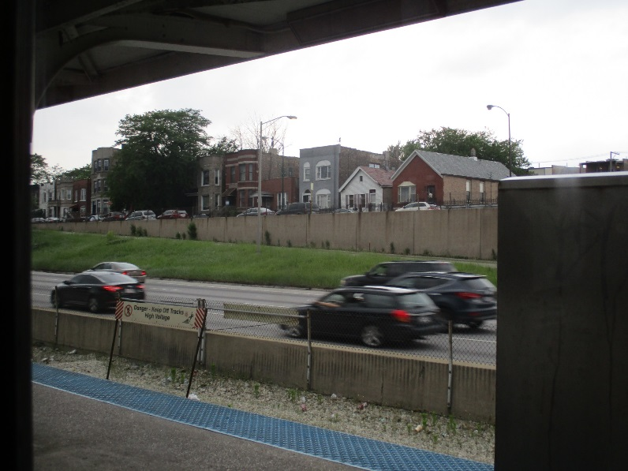
Source: Author’s photograph, 6.7.2015
While the station entrances themselves are often adjacent to relatively walkable inner-ring Chicago suburbs such as Oak Park, the entire aesthetic of the installation clearly does not appear built for the kind of smoothly integrated walkability and human scale that the TOD theorists seem to desire.
The Chicago pattern of development was copied in parts of Atlanta, as well, which built its heavy-rail system during the 1980s. The following photograph shows the view from the North Springs station of the Atlanta MARTA:
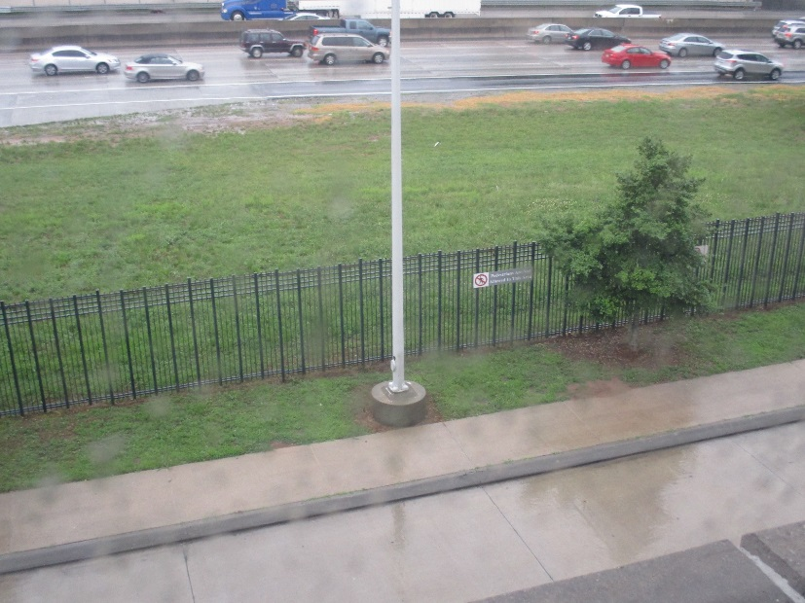
Source: Author’s photograph, 5.28.2015
As if to emphasize the point that this development is not walkable, a close-up of the gray sign on the fence actually says that walking is prohibited:
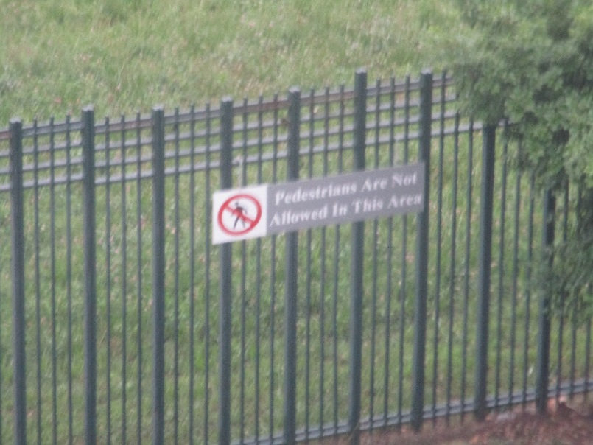
Source: Author’s photograph, 5.28.2015
What can be learned from these photos?
The lesson to take away from this pictorial journey in America’s metro transit systems is that reinventing parts of existing ones may be very hard to do, if not impossible, given the enormous fixed investment in physical infrastructure of a very distinctive kind, such as POT (Parking-Oriented Transit) or HOT (Highway-Oriented Transit). When transit lines are shoehorned along the Interstate, or when many stations empty into enormous flat parking lots with no urbanism anywhere in sight, then it seems a very far stretch to think that existing transit lines in America’s largest metropolitan areas could somehow be uniformly be made walkable. The above photos do not represent a highly select minority of stations—nor do they represent all stations—but they do represent a sizable, non-trivial amount of stations.
Even with “up-and-coming”, brand-new transit lines, such as Charlotte’s, the model TOD project shown here is clearly a very small incursion into an extremely auto-oriented metropolis. The other Charlotte TOD project shown in photographs seems to have been inserted into a landscape of big-box retail and sprawling parking lots which continues to carry on as if the transit stop weren’t there at all. Whether its transit system is old or new, each city examined seems to have a variety of types of stations, some of which are more amenable to TOD than others—but most of which aren’t.
Research Studies: Does it work at reducing mode shares?
The photographic studies above can be supplemented by research studies on TOD’s effectiveness at shifting travel modes. The main finding, in the limited amount of studies that have been carried out, has been that TODs do have some effect on mode share, but a very limited one. There is no study that shows it to be a panacea that will relieve auto-dependence, but it can shift mode shares in some situations.
The data presented below derive from a national research review of TOD published in 2008 by the federal government’s Transit Cooperative Research Program (TCRP), a division of the Transportation Research Board. This review was entitled TCRP Report 128 – Effects of TOD on Housing, Parking, and Travel (authors G.B. Arrington and Robert Cervero), and was a survey of the most up-to-date research on TOD.
One study referenced in TCRP 128 looked at journey-to-work data for selected TODs in Arlington Country, Virginia; San Francisco; and Cook Country, Illinois, analyzing Census data for the areas surrounding specific transit stations, in order to determine whether the presence of the TOD altered their mode choice to/from work.
The results show that, at least in the immediate vicinity of this station, that the presence of the station had a substantial effect on mode shares:

Source: TCRP Report 128, Table 1.1
For comparison, the national benchmarks for commute mode share can be seen in the following chart:

Source: US Census Bureau
The following two graphs show TOD commute mode shares for two TODs in the San Francisco metro region as well as seven TODs in Chicago:

Source: TCRP Report 128, Table 1.1

Source: TCRP Report 128, Table 1.1
To summarize, each of the TODs surveyed had a much lower mode share for driving, for commute trips to/from work, than the national benchmark mode share.
However, it is unclear exactly how many persons it affects—the number is probably relatively small, because the typical TOD intends to alter mode share only within a half-mile radius. Walking any further distance would in most cases take too much time to be feasible on a regular basis. The specific population densities around the study’s TODs were not included in the study results, but it is unlikely that these studies could have referred to more than a few tens of thousands of persons, respectively.
As a further caveat, it has to be understood that these studies have chosen locations already highly disposed to TOD. The very reason these particular reasons were studied was in order to demonstrate that TOD has an effect—but even with custom-picked locations, TOD does not cause mode choice anywhere near that of the 80% national benchmark share of the automobile. If one were to choose the vast majority of American neighborhoods as study locales, without respect to their suitability for TOD, the results would surely be very different and heavily automobile-favored in terms of mode share.
The next study presented, also from TCRP 128, takes a somewhat more sophisticated approach, since it includes a kind of “control group.” Through comparing the transit share in the TOD, for journeys to work, to transit share in the MSA as a whole, the study tries to benchmark the TODs within the context of their region. In addition, it incorporates results over time – 1970, 1980, 1990, and 2000—and studies a much larger amount of TODs. Once again using Census journey-to-work data, the following study investigated 103 TODs in 12 different metropolitan areas. It divided the metropolitan areas into the following categories:
Older and Redeveloping: Chicago, New York/New Jersey
Heavy Rail – Atlanta, Miami, San Francisco, Washington DC
Light Rail - Dallas, Denver, Los Angeles, Portland, Salt Lake City, San Diego
The study results show the following:

Source: TCRP Report 128, Table 1.2
With a more sophisticated, less biased benchmarking approach, the chart shows very marginal differences between the TODs and the MSAs. In fact, the increasing differential in 1990 and 2000 is due to a reduction in how often the rest of the MSA uses transit, as opposed to an increase in how much the TOD stations use transit.
The same investigation was also done for walking/biking share of journey to work trips. The results are shown as follows:

Source: TCRP Report 128, Table 1.3
This table shows that while walking and biking mode shares have declined over time in the TODs, the walk/bike share in the MSAs as a whole has actually declined even more. It appears, from this data, that metropolitan areas – or at least the twelve metro areas in question – became even more auto-dependent and less walking/biking-friendly over time, both at the TODs and in the MSAs as a whole.
Future Prospects
Transit-Oriented Development is actually part of a very old story. Part I of this research study looked at the historical development of today’s American city, going as far back as the 1810s in order to understand the forces affecting the layout of the American city from the 1810s until the present-day. During the entire period covered, it can be seen that there has always—continuously—been development created by the transportation technologies of the day. The electric streetcar, which had evolved from the horse-drawn omnibus of the 1860s, was a potent early facilitator of transit-oriented development, spurring widespread extensions of the residential zones of American cities. The automobile was even more potent, by allowing the areas not served by the streetcars to be filled in with development.
Of critical importance in understanding TOD, though, is that “you cannot go home again.” The initial situations encountered by the streetcar and the automobile, where nearly the entire land area of the United States was undeveloped, no longer holds. Even though today the USA still has only developed about 6% of its land, this figure was orders of magnitude smaller in the late 1800s and even into the 1950s.
The fact is, in the year 2015, America’s cities are already built. Consequently, newly installed transit lines, around which much fanfare has revolved, in practice traverse long zones of total irrelevance to TOD, such as warehouses, auto dealerships, shipbuilding yards, or big-box commercial retail. Moreover, many transit lines are built along the right-of-way of the Interstate or of freight rail, since this often is the only remaining space in a large metro area where it is possible to secure a right-of-way long enough, and contiguous enough, for rail or rapid bus lines.
Finally, the requirement of TOD for walkability means that it can never serve the travel needs of the vast majority of Americans, since by the time they have walked to the station, they could already have driven—and thus most of them will never choose transit, even if it means waiting on congested roads. If anything, the way to get Americans to use transit would be to build large multi-story parking lots beside transit stations, so that driving journeys could be reduced in large numbers – but then the land-use required to build all that parking would preclude much walking within the ½ mile radius of the TOD. The awkward dance between parking and walkability was visibly demonstrated in the photographic section on POT – Parking-Oriented Transit.
It seems that the future of TOD lies more as a specialty type of residential development for metro areas where transit is already favored by a stable percentage of the middle-income or higher-income end of the population, and where there is substantive market demand for mixed-use, loft style apartment living adjacent to transit stations. The author did observe such developments in every city which he visited – it is not that they do not exist, and it is not that “young professional” Millennials do not seem to be moving into them. Rather, it is that such developments’ proportion of all housing in a metro area of millions of persons is so small as to render them irrelevant for broader transportation trends.
So long as Americans own an average of one vehicle per licensed driver and live in dispersed, decentralized cities, transit is simply very unlikely to become as dominant of a mode as it once was, no matter what type of urban planning proposals say otherwise. Thus development centered around transit is very unlikely to become the dominant type of real-estate development in the United States, or to divert much VMT. The flexibility of the automobile has allowed for vast areas of land to be developed that transit simply cannot reach, due to its needs for population density in order to be financially feasible and its awkward requirements for land to create a right-of-way in already-built areas (especially rail transit). This flexibility only seems likely to continue entrenching the automobile as America adds new population and inevitably grows its metropolitan areas even further. In today’s American metropolis, transit fits into a broader panoply of types of “transportation-oriented development”—insofar as transportation has always been integral to land uses in urban areas—but the last word is that TOD is but one small player on a very large metropolitan stage.

Assessment of Compact Development Movements
The previous three chapters have reviewed the three main compact development movements: Smart growth, new urbanism, and transit-oriented development. Each of these is interrelated, and they all share a common goal: To reduce sprawl and to reduce automobile-dependence in America’s cities, through mixed-use, walkable, compact development. Smart growth is the broad policy outline whereas new urbanism and transit-oriented development are the specific tools of implementation. Taken together, can these movements succeed at their goal of reducing VMT?
This chapter will first make an overall assessment of this question, within the structured, consistent framework of the VMT equation: trip rates, trip lengths, and mode choice. Then, it will outline a series of major obstacles that are likely to undermine or limit the total efficacy of VMT reduction proposed by either smart growth, new urbanism, or transit-oriented development. These obstacles include, consumer housing preference, land-use microeconomics, abundant US land supply, high cost of replacing existing road systems, and lack of infill opportunity.
Compact Development and VMT Equation
The purpose of reviewing the VMT equation is to create a stable framework, or benchmarking process, for how to assess the effect of compact development trends on VMT. These trends have gathered significant momentum in the past 15 to 20 years, and a stable framework is needed for determining whether anything meaningful has changed in terms of their possible aggregate effect on VMT.
As a caveat, this section will necessarily be very approximate, since the layered way in which existing smart growth, new urbanist, or TOD projects are blended into urban landscapes renders it very hard to make a direct, specific assessment of how these projects have actually affected VMT. Nevertheless, referring back to the simple but comprehensive framework of the VMT equation can at least give a coherent sense of what the most important pathways might be from compact development outcomes to specific travel variables.
Recall from the introduction of this study that VMT can be boiled down to the following equation:
VMT = (vehicle trips) (average vehicle trip length)
Simply put, the more trips that occur, and the longer each trip is, the larger the amount of VMT. In addition, there is a third variable—mode choice—which is the selection of a travel mode.
As a technical note, mode choice is implicit within the choice of vehicle trips instead of person trips in the equation, since in order to count for VMT, a trip must specifically be undertaken by motor vehicle and not by walking or biking. Furthermore, those trips which are taken by a privately-owned vehicle (POV) tend to increase VMT more than those taken by a motor bus, since a bus holds many people, who if they all traveled separately in their own POV, would account for many additional VMT.
At any rate, the following sections will examine vehicle trips, trip length, and mode choice in succession, and will relate them to the possible effects of the compact development programs. Some of these charts have been shown in other areas of this study, but showing them again, here in direct relation to the compact development movements, may provide arithmetical clarity and help to operationalize context.
Trip rates
Since the middle 1990s, household trip rates have actually stagnated:

Source: National Household Travel Survey, US Census Bureau
The data in the above chart was obtained by multiplying annual average household trips (from the National Household Travel Survey) by total US households (from the US Census Bureau).
It seems that since 1995, the United States has stabilized at the staggering total of roughly 240 billion household trips per year, in aggregate. Could it be possible that this stabilization has been somehow effected by changes towards walkable urbanism?
Average trip length
On the other hand, average vehicle trip length has been increasing steadily since a low point in 1983:

Source: National Household Travel Survey, 2009 Summary Trends
Some of the above trend could be thrown off by variability in survey methods, particularly for the 1983 NHTS, which due to budget constraints contained a relatively small sample size. Nevertheless, the stabilization in gross vehicle trip rates seems to have been offset by a continually rising average trip length. Could it be, that urban development has rendered some origins and destinations further apart, which may have either discouraged some trips from taking place at all, or else pushed those trips to other modes? What is the interrelation between trip rates and trip lengths?
Mode Choice
Reviewing data on mode choice gives perhaps the most compelling hint of a limited statistical move towards walkable urbanism. The choice of a POV (privately-operated vehicle) for vehicle trips has indeed declined in recent years:

Source: National Household Travel Survey, 2009 Summary Trends
These lost POV trips have not been replaced by public transit, which has more or less remained at the same proportion as always:

Source: National Household Travel Survey, 2009 Summary Trends
Rather, the slack has been taken up by walking:

Source: National Household Travel Survey, 2009 Summary Trends
It appears that since 1995, the year when total household trips began to stabilize, there has been a doubling of the amount of walking that is done, as a proportion of all household trips.
This figure should be viewed cautiously, in that the amount of walking trips still represents only 10.4% of all trips, and only a slight surpassing of the original high of 9.3% back in 1977. Nevertheless, it still does show some empirical evidence for a resurgence of walkable urbanism.
Summary of VMT Equation
To summarize this analysis of the VMT equation, it seems that household trips have stabilized at a very large number, and that this stabilization may be due in part to a renewed preference for walking.
At the same time, since the average trip length has continually increased, the shift to more walking may not indicate any greater amount of compact development at all, since if developments are becoming more compact, then why are trip lengths increasing?
Conversely, the smart growth advocates would likely say that since extreme auto-dependence tends to force people to take even the shortest trips by driving, the increase in average trip length could show that walkable urbanism has succeeded at changing the shortest trips from driving to walking. This would then create a higher average trip length, since the short vehicle trips that used to hold down the average are now not being taken at all by car.
Obstacles to implementation of compact development programs
Notwithstanding the stabilization of VMT, there are any number of obstacles to the widespread implementation of the compact development programs. These movements claim to potentially reduce VMT by as much as 20% - 40%, but these programs are unlikely to ever be implemented in a pure form, since most of the American built landscape has already been built. This gives rise to the concept of “blended density,” which even these movements recognize the necessity of. As explained in Smart Growth America’s “Growing Cooler” publication:
“The term ‘compact development’ does not imply high-rise or even uniformly high density, but rather higher average ‘blended densities.’ Compact development also features a mix of land uses, development of strong population and employment centers, interconnection of streets, and the design of spaces and structures at a human scale.”
The bottom line, even with the large and sophisticated toolbox of compact development, must necessarily always come right back to density, whether defined by population or by some other factor, such as buildings. For the purposes of this study, population density is used, because it is the most readily available statistic over the longest period of time.
The reason density is so critical is that population growth presents a very clear choice: build up, in or out. If one cannot increase the population density of existing land through either building upward or building on infill lots, then the only choice becomes building outward – creating the sprawl deplored by these movements by expanding the built landscape of metropolitan areas past the existing developed areas. Even if the outward building is at higher population density than older suburban areas, it would still constituted building outward and would still contribute to sprawl.
Thus, looking at population density in an overall, comprehensive sense presents a holistic offsetting problem. Actions taken to increase density, such as purchasing low-density industrial lots in suburbs to convert into mixed-use, medium-density loft apartments, may result in the bought-out owners of those purchased lots relocating their very same low-density warehouses, or factories, to newly developing areas on the metropolitan periphery. In the aggregate, this may actually cause a lower overall density than if nothing had been done at all, depending on the relative densities of the smart growth loft development versus the displaced industrial building. This offsetting problem expresses a fundamental feature of land-use within a capitalist, democratic framework which respects property rights: Density cannot be mandated and anyone who has the capital to build low-density installations may do so.
Within this economic construct, where density is so critically dependent on individual decisions and can never be mandated, there are many limits to the smart growth development programs fully achieving their aims. The organic forces which drive urban development, and which drive the spatial decisions of individual Americans, households, firms, and factories, are very often at odds with compact development. All of the below factors relate to reasons why density cannot be easily increased across the board, and why even when it seems that it can be increased, that there are offsetting factors that might tend to reduce density, for any action that might tend to increase density.
Socio-Demographic Trends: “Social Sprawl”
As shown in chapter 5: Social Trends and Consumer Housing Preference, that Americans are getting married later, having fewer children, and living more often in single-person as well as single-parent households. As a result, average household size has fallen from 3.33 in 1960 to little more than 2.50, from 1990 onward. This tends to increase the amount of housing units per capita, and thus to increase the amount of land needed for any given new level of population.
Consumer Preference: Low-Density Housing or “Housing Sprawl”
Chapter 5 also documented the clear and longstanding American preference for single-family housing, on large lots, with very few persons per room, per dwelling. This intensifies the socio-demographic trend of smaller household sizes, and places additional pressure towards the amount of land that will tend to be needed to accommodate a given increase of population.
Together, these social and housing trends create a deceptively stubborn obstacle toward increasing population densities or land-use per person.
Extremely High Levels of Vehicle Ownership
Internationally, the United States stands out for having runaway vehicle ownership rates. The following chart is taken from the Transportation Energy Data Book, published by Oak Ridge National Laboratory:

Source: Oak Ridge National Laboratory, Transportation Energy Data Book
The United States has a higher vehicle ownership rate than any other region of the world. Even its nearest neighbor, Canada, a country with similarly abundant land supply and relatively similar socio-demographic trends and housing preferences, falls far short of US-level vehicle ownership.
What this breaks down to, in terms of the average person or household, is quite striking. The following chart shows the rate of vehicle ownership per person, per driver, and per household:

Source: Federal Highway Administration, US Census Bureau
Already in 1950, there was more than one vehicle per household, as well as 0.79 vehicles for every licensed driver. During the next 60 years, this grew to more than two vehicles for the average household, and to more than one vehicle per licensed driver.
The growth in household vehicle ownership breaks out to a sustained increase in the number of two-car and three-car households:

Source: National Household Travel Survey, 2009 Summary Trends
All told, the information presented clearly shows a near-overwhelming amount of vehicle ownership in the United States, whether one views it at the level of the person, driver, or household. Consequently, it seems that the US population is very much capable of sustaining an auto-dependent pattern of life, for the foreseeable future, at least in terms of possessing the requisite hardware for personal transportation.
Further, the knowledge among policymakers that such high level of vehicle ownership exists places heavy pressure for the continuation of upkeep of the current configurations of development, in order to satisfy voters. Drivers are voters and will expect their tax dollars to support the infrastructure of their everyday lives. The high level of auto ownership also places heavy pressure on retailers, office employers, factories, and so forth, to continue designing their products or services, and locating their establishments, around the needs of the automobile. Drivers and workers are consumers, and will naturally demand accessibility to goods, services, and jobs via the mode of transport which they already possess: the automobile.
One particular factor which ties into auto ownership that is unavoidably noticeable, when walking city streets anywhere in America, is that of parking. Whether downtown or in outlying areas, parking eats up tremendous amounts of land, since nearly every person in any building, at any given point in time, needs somewhere to place his or her car. If it is not parked at the building per se, then it may be parked in the lot at a transit station where that person did a “park and ride” mode switch, or it may be parked at home in a garage or on the street in front of the person’s residence.
Either way, the high propensity of Americans to own cars means that all new development – even smart growth, new urbanist, or transit-oriented – must be designed with parking in mind. Even if resourceful ways to reduce parking demand or reduce land consumption by parking can be found, the fact remains that absent some radical sort of paradigm shift, the need for parking to contain America’s motor vehicles tends to inflate the amount of land needed for all kinds of development, no matter the function – residential, commercial, office, retail, industrial, civic, or religious. Mixed-use would not reduce the parking demand any more than single-use would, since every type of use requires parking.
In sum, such extremely high levels of auto ownership tend to create a self-perpetuating cycle in favor of maintaining an auto-based lifestyle and continued high levels of auto ownership. Since this kind of lifestyle tends to equate with what the compact development activists would refer to as “sprawl,” the high levels of auto ownership would tend to place limits on the realistic extent to which compact development programs can be implemented.

American Mentality: Living on the edge?
Joel Garreau, in his book on the Edge City, documented what he considered to be a significant and lasting part of the American psyche: A desire to live on the edge, both physically and psychologically. Although he touches on this theme many times, such that it is hard to choose any one single quote that defines his view, an except will nevertheless be presented below.
The background to the excerpt is that in the introduction to the book, as he explains why he decided to tackle the Edge City topic and write a book about it, Garreau explains that he had noticed that high-rises were going up near his home in formerly rural Virginia, and began to wonder why this was occurring. The following is from page xxi of the introduction to his book, and is quoted at length to give a sense as to how deeply he feels the edge city current runs in the American psyche:
“In the early 1980s, then, when I began to see high-rise buildings erupt near my home in outlying Virginia far from the old downtown of the District of Columbia, I knew instantly what I was looking at. This basically was Houston.
Less clear to me was why or how this could be. Or should be. For my first reaction to the phenomenon I would later dub Edge City was to feel threatened. I had always believed that there were only two sensible ways to live—in a yeasty urban neighborhood reminiscent of a Dickens-style nineteenth-century city, or a remote, leafy glade that recalled Thoreau’s nineteenth century Walden Pond. If that made me a nineteenth-century man, so be it. I never could understand why anybody would want anything in between.
This new world being built along the Washington Beltway, however, was not only “in between.” It was “in between” triumphant. It seemed insane to me. It was a challenge to everything that I had been taught: that what this world needed was More Planning; that cars were inherently EVIL and our attachment to them Inexplicable; that suburbia was morally wrong—primarily a product of White Flight; and that if Americans perversely continued to live the way they have for generation after generation, it couldn’t be because they liked it; it must be because They Had No Choice. I even thought that cities were built by Master Architects.
Ah, yes. Live and learn.
Every man is a product of his environment, and mine was the newsroom of the Washington Post. Thus, when I decided to “get to the bottom of this,” in the back of my mind was the notion that if I could find out who was “doing this to us,” it might be possible to get the SOBs indicted. Were not, after all, Edge Cities a clear and present danger to Western Civilization?
What I found when I dug into the story was a tale far more rich and complex. It was by turns inspiring, discouraging, heartwarming, and frustrating. It was, of course, summed up in the wisdom of Pogo. I have met the enemy. And he is us.
That is why there is so much “edge” in Edge City. It is a psychological location—a state of mind—even more than a physical place:
- This new world is the cutting edge—of how cities are being created worldwide.
- This upheaval is occurring physically on the edge—of the urban landscape.
- The rules that govern its creation involve a search for edge—for advantage.
- And right now, at least, Edge City puts people on edge. It can give them the creeps.”
At any rate, if “the enemy is us” and Americans have an unquenchable need to build at the metropolitan periphery, in order to satisfy a national, psychological quest for reinvention, then it may be a long time indeed before sprawling development patterns would be voluntarily reversed.
Abundant Land Supply
The above four trends – the preference for single-family, low-density housing; “social sprawl” or declining household size; high rates of vehicle ownership; and the edge mentality, are joined with the abundance of land supply in the United States. Despite rapid development in the past few decades the amount of developed US land, as a percentage of all land in the United States, is still very small. The following graph illustrates this:

Source: USDA National Resources Inventory
As such, it would seem that housing sprawl, social sprawl, auto-dependence, and the edge mentality would have ample land in future on which to play themselves out.
Incidentally, those viewing this graph may wonder, “what is all the other land used for?” The following graph fills in the blanks:

Source: USDA National Resources Inventory
Land-Use Microeconomics
The previous issue of land supply brings up a basic question of micro-economics. What is the “highest and best use” of land? This term “highest and best use” comes from the concept of the bid-rent curve, whereby rents are determined by a capitalist bidding process, and the party that can derive the greatest revenues from using the land will bid the highest rent, and ultimately win the land. Urban economists have long believed this bid-rent process to be an integral part of micro-economic decision-making on land-use.
Practically speaking, this breaks out into a question of, at what point do farm owners desire to reap financial profits from selling their cropland to developers who will convert it into a suburban subdivision? At what point will a warehouse owner, who is located in a downtown area or in a secondary downtown within an edge city, decide that selling the land to a developer who will place high-density infill housing on that space, will be economical? Even if a warehouse owner makes such a decision, where does he or she then relocate to, and what would cause any new warehouse built to be built in a less land-intensive manner than the abandoned warehouse?
This is basically the question of land density offsets which was discussed earlier in this chapter, under the heading “Obstacles to implementation of compact development programs.” If a property-owner sells land, but then relocates the previous use to an even greater expanse of land, then it is possible that on balance, the amount of developed land per person has actually increased, not decreased. While the incoming developer, who may be influenced by smart growth principles, may build an ideal smart growth settlement with higher-density, mixed-uses, and walkability, there is no telling what the outgoing property-owner will do. Unless both are heavily influenced by smart growth principles, the ironic result of a piece of infill smart growth could end up being a displaced building, somewhere else in the metro area, which actually causes an overall reduction in density and overall increase in land consumption.
As discussed above, the bottom line is that within the economic and political system of the United States, land uses cannot be mandated. To be fully effective, smart growth must occur at the level of the individual property-owner, to a level of uniformity which is probably not plausible in the near-term future, because otherwise the offset factor will likely negate the density gains of any particular smart growth development project.
Lack of relevant infill opportunity: “Suburbs” are already mixed-use
The smart growth desire to transform existing metropolitan areas into mixed-use environments is a rather superfluous idea, because a casual walk, or drive, through most edge or edgeless cities reveals a landscape as dense in buildings and roads, and as mixed-use, as any in a central city. Iin the author’s personal visits to more than a dozen major metropolitan areas, a consistent observation that emerged was that even the most automobile-oriented places were profoundly mixed-use. Houses, shopping malls, warehouses, offices, parks, restaurants, and other uses all appeared to be within short drives of one another.
There may be fewer humans per square foot than in a traditional central city, but this does not mean there is any land available for development, because the amount of buildings and roads per square foot appears roughly the same as in any central city. Mixed-use has apparently already been factored into land-use decisions at the level of individual firms and households. An area for future research may be to create objective metrics for measuring the amount of mixed-use developments nationwide. But while metropolitan areas may not be laid out in the way desired by smart growth activists, the fact remains that they have very little empty space, and that they are already mixed-use, so long as one possesses an automobile. This was noted very eloquently in Chapter 4, “Living on the Polycentric, Metropolitan Edge,” by Robert Fishman, in his description of the “new city” which he calls the technoburb.
Unlikelihood of transforming existing road systems
Even if infill did occur where a spate of new, higher-density buildings replaced older, low-density buildings, it would be extremely unlikely to effect a major change on auto-dependence or overall land-use patterns, because one can normally change the buildings but not the roads.
Roads are key factors in determining land uses, because once laid out, they are extremely hard to pick up and move, particularly once the surrounding land contains buildings. Older central cities could change their grid patterns only at prohibitive cost, and the same goes for newer edge cities and suburbs, once fully developed. The economic cost, and the day-to-day disruption, inherent in changing the nation’s roads toward a scheme more favored by the compact development movements, would be prohibitively high.
To be sure, it is possible that small changes to the roads can be accomplished one step at a time, through adding or widening sidewalks, adding intersections, or similar measures. But these incremental changes are unlikely to change the fundamental character of the roads within an entire metropolitan area, as the scope of the land area involved in such a conversion would be vast and overwhelming. New roads in new suburbs, or in new edge cities, can potentially be laid out differently, but this already implies new building in new communities, something which would encourage the sprawl that the compact development movements are so adamantly against.
Another factor to consider is the Interstate. There is little doubt that the Interstate constitutes a fundamental component of America’s built landscapes. It lurks in the background no matter where one goes in the United States, whether in an urban, suburban, rural area, or any permutation thereof. Carrying high volumes of auto traffic at high speeds, both passenger and freight, it has become integral to the American way of life. The following graphic shows how much traffic the urban Interstate carries relative to its share of the national road system:

Source: Federal Highway Administration
While small adjustments can be made to the Interstate, such as removing a portion of an urban expressway here and there as with the Park East Freeway in Milwaukee or the Embarcadero in San Francisco, it seems extremely unlikely that the entire system could be totally reworked. Enormous sums of money have gone into creating the Interstate as we know it, and even renovating or repairing a few miles of Interstate may cost several billion dollars. The cost of going even further, and completely replacing the Interstate, seems conceptually to be prohibitively high.
Ineffectiveness of Public Transit
It is extremely unlikely that public transit would overtake the automobile as a preferred mode of transit. Chapter 7, “Public Transit,” showed how the mini-revival of transit since the 1990s is extremely unlikely to become an all-pervasive, ubiquitous revolution. The low density (under 2,000 persons per square mile) at which most Americans live, as well as the high levels of auto ownership and exceptional flexibility of automobiles in relation to transit, render a significant increase in transit distinctly unlikely.
The current statistics on transit versus the automobile show a staggering automobile dominance. As of 2009, 1.9% of all person trips were by transit, whereas 83% were by privately-operated motor vehicle. There were 240 billion personal vehicle trips versus 10 billion public transit trips, and the VMT of motor vehicles, at three trillion, dwarfed the VMT of transit, at three billion. This means that there is one thousand times more automotive travel than transit travel, on an annual, national basis.
The central dynamic, as hinted at in several sections above, is the enormous expanses of land in the United States, the consumer preference for individuality, and the willingness to explore the “edge” of new frontiers. Automobiles are far more suited to these circumstances than transit, because they enable individual settlement of frontiers of land which the rigidity of fixed-guideway rail lines (and the cost of constructing such rail lines) would never permit. An interesting example would be the hills of San Diego, Los Angeles, or San Francisco, where it is hard to imagine viably placing rail lines, but which have been covered with residential settlement by homeowners who possess automobiles.
Transit-oriented development appears to be a very specialized case which can only succeed in a very limited amount of situations. While it is true that a few specific locales (such as Arlington County, Virginia), which have invested heavily in transit-oriented development, have seen much higher levels of transit commuting use than the national average, these locales are very much the exception to the rule, with facilitative local circumstances that are hard if not impossible to duplicate elsewhere. The half-mile walkable limit of transit-oriented development means that even where it succeeds, as in Arlington County, its applicable range is limited to a few thousand people, or few tens of thousands.
TOD’s potential influence is further limited by the fact that it must be built into an urban environment which already exists. This is unlike at the beginning of the twentieth century when the electric trolley lines extended real-estate development into virgin, unbuilt land, and could determine the character of the land-use—resulting in dense, walkable, mixed-use “streetcar suburbs”—far more than TOD efforts can today. In today’s built-up environment, new transit lines normally take years of government planning and community consultations, and typically most of the line runs through industrial warehouse zones, or directly parallel to the Interstate with high, barbed-wire fences separating it from high-speed, limited-access expressways. Consequently, when pedestrians emerge out of a transit station on a new transit line, they are as likely as not to be faced with a factory, warehouse, or Interstate service road, as they are onto a walkable retail strip. To be sure, there are some successful TODs in existence, even some very successful ones, but the possibility for ubiquitous application is very low, due to the circumstance where almost any new transit line will run through a pre-existing urban zone which may not be suitable for TOD.
In all, transit remains a useful tool but with limited uses. It can ensure transportation access to citizens who do not own a personal vehicle, and through “park and ride” schemes can help to alleviate auto-commuting congestion. But it cannot reshape, wholesale, the metropolitan environment, which has already been formed and which is too vast for fixed-guideway transit to serve.
Summary: Obstacles to “Pure” Implementation
The bottom line comes back to population density. In short, the numbers do not add up. The following chart shows the population density of US central cities in 1950, where 49 million Americans, or 58% of metropolitan residents, lived as the flight to the suburbs commenced:

Source: US Census Bureau
Compact development advocates never explain how they will reverse the startling drop in population density which has occurred since the end of the Second World War, at least to a large enough extent to slow the rate of new building at the metropolitan edge. Their concept of “blended density” does indicate a measure of pragmatism, but a concrete number is never attached to this blending of densities. As population grows, will the proposed higher density developments go in the suburbs, or the central cities, or in cities which have not yet even been built? What is the ideal density? How will it be known if smart growth is succeeding?
New Urbanism does list hundreds of projects in its online database, and transit-oriented developments have gone up in many cities where they did not exist before, at the very least as demonstration projects. City governments do appear to be reaching out, on a regular basis, to professionals well-versed in these movements when opportunities come up to redevelop parcels of land. Psychologically, and politically, these are prevailing trends that bear notice.
But the physical scope of these projects tends to be small; they may cover a few blocks, or less than 1 acre. As of 2010, America’s metropolitan areas constituted approximately 913,000 square miles. Even if one wants to limit this to the more narrowly-delimited Census category of “urbanized areas,” one is still looking at 86,000 square miles. Given that most of the pre-built features of these 913,000 square miles (or 86,000) are “built to last” as described in this chapter, it seems highly unlikely that small developments of a few acres each could fundamentally change the way that Americans live.
The workings of land-use decisions within a capitalist economy, within the context of an already built-up landscape where marginal benefit vs. marginal cost considerations by millions of individual households and firms have already evolved into the landscape seen today, seem to argue strongly against it. While it is entirely possible that more mixed-use, walkable projects at the level of buildings, neighborhoods, or districts could be attained, it is very unclear how such small projects could ever attain a “critical mass” at a national scale. Due to the relative lack of infill availability, to reorient all of America along these lines would be to undertake an extremely vast project that would likely as not involve building on open, virgin lands and thus contributing to the very sprawl that is deplored by the compact development activists.
A caveat to this assessment, which must apply to any attempt to predict the future, is that of paradigm shifts and unexpected events. America went from being an agrarian nation in the early 1800s, to an industrial one by the end of the 19th century, and a post-industrial nation by the end of the 20th century. It is a nation known for rapid shifts in mentality, technology, science, etc., and which is more comfortable than most countries with rapid-fire, systematic changes in the way of life, particularly when these are technology-driven. So it is not impossible, even if very unlikely, that an unexpected sequence of events could alter the equation, particularly as 100 million new Americans are added to the population between 2015 and 2060.
But directly counter to this caveat is that many of the compact development programs seem to ultimately depend upon fundamentally reworking the nation’s infrastructure. This is a much vaster challenge than paradigm shifting in other realms, such as introducing a new consumer product. Mobile phones and iPods have had spectacularly fast adoption rates in part because they are portable and disposable; infrastructure is neither. Even a larger appliance, such as a radio, television, or washing machine, can cycle through many generations in the space of a few years, since these are relatively portable and relatively disposable. They take up space within homes and warehouses, and are transported along roads; but they are not the home, the warehouse, or the road itself.
Any future paradigm shifts, towards densities high enough to make an appreciable difference in sprawl, would likely need to incorporate advances in infrastructure paradigms, as well as integrate pre-existing infrastructure, in order to be nationally applicable. Such a shift would probably require a self-sustaining method of financing new infrastructure paradigms, perhaps analogous to the way that the automobile stimulated funding of the flight to the suburbs in 1945 – 1980. This does not appear to be on the horizon, but history is full of unexpected surprises.
The last word on compact development has likely not been written yet. These movements do point out compelling social and environmental problems, do provide very extensive and concrete solutions for addressing these via land-use adjustments, and to date have certainly had a visible, if somewhat limited, impact on America’s urban landscapes. However, this impact is likely to remain very limited, due to the factors presented in this chapter: consumer housing preference, shrinking household sizes, “edge” mentality, abundant land supply, land-use microeconomics, lack of sufficient infill opportunity, entrenched road infrastructure, and rigidity of public transit.
For the time being, it would appear that absent unexpected events, the compact development movements will progress in a very incremental fashion, and will constitute merely one portion of a very diverse metropolitan landscape.

Conclusion: A Story of Intended and Unintended Consequences
There is a duality to the evolution of urban form: Sometimes the best-laid plans lead to totally opposite results, as when 1950s urban planners believed that the Interstate would revitalize urban downtowns, when in fact it destroyed many downtown neighborhoods which were otherwise healthy. Many such examples could be given. Conversely, many of the most dramatic transformations of American cities have occurred due to advances in technology or changes in economics which no one person could have predicted, and which played out in urban spaces with unpredictable, unforeseen consequences. The way in which the “flight to the suburbs” seems to have given way to a “new city,” mixed-use but auto-oriented and spread out over a decentralized land area, would be an example.
This study has chronicled both the organic and inorganic, planned and unplanned historical evolution of cities .The first part looked at the history and geography of America’s cities from 1776 to the present, with a particular emphasis on transportation systems. The second part reviewed the data on urban phenomena such as socio-demographics, consumer housing preference, traffic congestion, and public transit. The third part looked at the compact development movement—including smart growth, new urbanism, and transit-oriented development--describing this movement’s dissatisfactions with American cities as well as what it proposes to do about the problems it perceives.
A particularly compelling idea put forward by these movements is that with an expected population growth of almost 100 million persons between 2015 and 2060, ¼ of the American built environment has likely not been constructed yet. There will thus be, according to their telling, a particularly acute opportunity during the next half-century to incrementally craft American city forms along the lines recommended by these groups. However, deeper investigation into the claims of these movements, and the practical applications of their solutions within the American metropolis which currently exists, revealed many objective limitations and more than a few hints of implausibility of an overreaching scope.
When all is said and done, the bottom line is that cities are very complex creatures, and nobody can truly foresee or predict what will happen to them over the next fifty years. The planning movements, with their seemingly precise prescriptions, must contend with an environment which is so profoundly auto-oriented—where automobile VMT outnumbers transit VMT by a ratio of nearly 1,000 to 1 and where millions of housing and firm siting choices have been made based upon the automobile—that it would seem to require a perhaps implausible amount of effort to change American urban landscapes, en masse, to match what these movements desire. It seems that the burden is on them to demonstrate how their proposed land-use initiatives would truly change the enormous momentum of America’s built infrastructure, which in the oldest metropolitan areas such as Boston and New Orleans, as well as the newest ones such as Phoenix, has been developed along extremely auto-dependent lines since 1945.
A recurring theme, and one which most concretely ties together all of the findings of this study, is that real-estate and transportation are integrally related, and always have been. “Transit-oriented development” is nothing new, and has been going on for thousands of years. In an American context, urban form has always been integrally interrelated with urban transportation. Even though not the only factor in the complex dance of urban development, transportation has certainly been a dominant factor. Successive revolutions of technology throughout the 19th century, followed by the definitive transition from streetcar to automobile after 1945, have shown that American urban forms have always, with rare exception, been directly dependent upon the dominant transportation technology at the time that an urban area was built.
This plays into another sub-theme, the layering of buildings and neighborhoods on top of what has come before. Cities tend to accumulate layers, like those of a wedding cake. There is no one set geometric or geographic form for the nation’s cities. Rather, they slowly accumulate a blend of buildings, architectural styles, street layouts, etc., according to what is fashionable and valued at the time of construction. As times change, and new values emerge, new layers are constructed on top of the old ones. The previous layers normally remain a visible part of the urban landscape, but become stagnant.
Moving forward, the layering of today’s cities, in line with the transportation and other developing technologies of the future, should be closely monitored by Fuels Institute members in order to understand how these layers accumulate, in what sorts of unique new permutations they agglomerate. The vocabulary presented in this study, such as edge cities, edgeless cities, polycentric metropolis, and technoburb, can help to frame an understanding of the relevance of metropolitan forms for the long-term VMT curve, and the effect of urban development on industries which depend on transportation demand. In addition, the concrete data presented in this study, particularly that illustrating the enduring roles of consumer housing preference, decentralization, land supply, vehicle ownership, as well as the eclipse of public transit in favor of the automobile, can help to inform and elevate future industry discussions.

Works Cited Executive Summary Estimates derived from US Census Bureau, “2014 National Population Projections,” available at http://www.census.gov/population/projections/data/national/2014.html.
Ewing et al, “Growing Cooler: The Evidence on Urban Development and Climate Change,” (Washington DC: Urban Land Institute, Smart Growth America, et al, 2008), section 1.7.2.
Robert Fishman, Bourgeois Utopias: The Rise and Fall of Suburbia. (New York: Basic Books, 1987), 191 – 192.
Paul L. Knox and Linda McCarthy. Urbanization: An Introduction to Urban Geography. Third edition. Chicago: Pearson Education, 2012. Pages 336 – 337.
Fishman, 199.
Kenneth T. Jackson, Crabgrass Frontier: The Suburbanization of the United States (New York: Oxford University Press, 1985), 20 – 44.
Jackson, 181.
Knox and McCarthy, 65.
Jackson, 183 – 184.
Joel Garreau, Edge City: Life on the New Frontier (New York: Doubleday, 1991), 15.
John F. Kennedy. “Transcript: 1960 Democratic National Convention, 15 July 1960.” John F. Kennedy Presidential Library and Museum, available at http://www.jfklibrary.org/Asset-Viewer/AS08q5oYz0SFUZg9uOi4iw.aspx
Robert Bruegmann, Sprawl: A Compact History. (Chicago: University of Chicago Press, 2005), 199 – 202.
Knox and McCarthy, 78.
Several books contain a very full discussion of “what’s wrong with zoning?” See Leigh Gallagher, The End of the Suburbs: Where the American Dream Is Moving (New York: Penguin, 2013), 39 – 42. See also Benjamin Ross, Dead End: Suburban Sprawl and the Rebirth of American Urbanism (New York: Oxford University Press, 2014), which devotes many chapters to a perceptive discussion of exclusionary “snob zoning” and rigid “suburban land tenure.” Finally, see Duany, Plater-Zyberk, and Speck, Suburban Nation: The Rise of Sprawl and Decline of the American Dream (New York: North Point Press, 2000), a manifesto-style guidebook which folds zoning into a much larger discussion of “what’s gone wrong with suburbs and how can we fix them?”
Samantha Salden. “The Seaside Code: The Poster That Started It All.” The Seaside Research Portal: Archiving the First New Urban Community. Available at https://seaside.library.nd.edu/essays/the-code.
See CNU Project Database at https://www.cnu.org/resources/projects. See also Hank Dittmar and Gloria Ohland, The New Transit Town: Best Practices in Transit-Oriented Development (Washington DC: Island Press, 2004).
Fishman, 185.
Ibid., 185 – 186.
Growing Cooler, 1.
Jackson, 7.
Garreau, 1991.
Thorstein Veblen, The Theory of the Leisure Class: An Economic Study of Institutions. New York: Macmillan, 1899.
Reconnecting America’s Center for Transit-Oriented Development. “Hidden In Plain Sight: Capturing the Demand for Housing Near Transit.” September 3, 2004. Available at http://www.reconnectingamerica.org/resource-center/books-and-reports/2004/hidden-in-plain-sight-capturing-the-demand-for-housing-near-transit/
Table B25024: Units in Structure. 2013 American Community Survey, US Census Bureau.
US Census Bureau is source of record for these demographic figures.
See Christine Woodside, “A Public Transit Revolution Is Afoot: Ridership Numbers Rising.” Yale Climate Connections. October 21, 2008. Available at http://www.yaleclimateconnections.org/2008/10/a-public-transit-revolution-is-afoot-ridership-rising/. For Millennials specifically, see articles such as, Rockefeller Foundation, “Access to Public Transportation a Top Criterion for Millennials When Deciding Where To Live, New Survey Says,” Available at http://www.rockefellerfoundation.org/about-us/news-media/access-public-transportation-top/ or U.S. PIRG, “Millennials in Motion: Changing Travel Habits of Young Americans and the Implications for Public Policy,” released October 24, 2014, available at http://www.uspirg.org/reports/usp/millennials-motion.
These data comparisons calculated from National Household Travel Survey, 2009 Summary Trends for motor vehicle VMT and trips, and APTA 2014 Factbook, Appendix A, for transit VMT and trips.
For a complete discussion of these obstacles, see Benjamin Ross, Dead End: Suburban Sprawl and the Rebirth of American Urbanism (New York: Oxford University Press, 2014).
Introduction Reid Ewing et al, “Growing Cooler: The Evidence on Urban Development and Climate Change.” Urban Land Institute and Smart Growth America. Washington DC, 2008. Page 9.
American Urban History, 1776 – 1945 Paul L. Knox and Linda McCarthy. Urbanization: Introduction to Urban Geography. Third edition. Glenview, IL: Pearson Education, 2012. Pages 42, 55.
Kenneth T. Jackson. Crabgrass Frontier: The Suburbanization of the United States (New York: Oxford University Press, 1985), 20 – 44.
Knox and McCarthy, 57 – 58.
Joel Garreau, Edge City: Life on the New Frontier (New York: Doubleday, 1991), 104 – 105.
Knox and McCarthy, 91 – 94.
Boris S. Pushkarev and Jeffrey M. Zupan. Public Transportation and Land Use Policy (Bloomington, IN: Indiana University Press, 1977), 5.
Peter Hall. Cities of Tomorrow (Oxford: Blackwell Publishers, 1988), 36 – 40.
Ibid., 14 – 46, 87 – 135.
Leonard Ruchelman. Cities in the Third Wave: The Technological Transformation of America. Second Edition. (New York, Rowman & Littlefield Publishers, 2007), chapter 1.
Ibid.
Robert Fishman. Bourgeois Utopias: The Rise and Fall of Suburbia (New York: Basic Books, 1987), 186.
Fishman, 184.
Ibid.
Paul Johnson. A History of the American People (London: Weidenfeld & Nicholson, 1997), 1 – 3.
Congress for the New Urbanism. Charter of the New Urbanism. Page 184. Available at http://www.cnu.org/sites/files/charter_book.pdf
Tom Vanderbilt. “It’s A Mall World After All: Disney, Design, and the American Dream.” Harvard Design Magazine. No. 9, Fall 1999. Available at http://www.harvarddesignmagazine.org/issues/9/it-s-a-mall-world-after-all-disney-design-and-the-american-dream
Hall, 129 – 132.
National Association of Convenience Stores. NACS State of the Industry Report 2015. Available at https://www.nacsonline.com/Solutions/store/pages/default.aspx?site=nacs_Store&webcode=storeCatList&cat=State%20of%20the%20Industry%20Reports%20(SOI)
US Energy Information Administration. “U.S. Number of Operable Refineries.” Time series available at http://www.eia.gov/dnav/pet/hist/LeafHandler.ashx?n=PET&s=8_NA_8O0_NUS_C&f=A
For an example of the “FDR saved capitalism” viewpoint, see Seymour Martin Lipset and Gary Marks, “How FDR Saved Capitalism,” Hoover Digest: Research and Opinion on Public Policy, 2001 No. 1, January 30, 2001. Available at http://www.hoover.org/research/how-fdr-saved-capitalism See also James Flanigan, “FDR Met Social Needs and Saved Profit System,” Los Angeles Times, October 25, 1999. Available at http://articles.latimes.com/1999/oct/25/news/ss-26179
There are many examples of Communist organizing in 1930s and 1940s America. For Communist activities in the South, among sharecroppers and tenant farmers, see PBS Online, “The Rise and Fall of Jim Crow: Communist Party, USA.” Available at http://www.pbs.org/wnet/jimcrow/stories_org_communist.html. For Communist organizing among northern factory-worker unions, see Victor G. Devinatz, “Communist Party of the United States of America (CPUSA),” Encyclopaedia Britannica, available at http://www.britannica.com/topic/Communist-Party-of-the-United-States-of-America
Jon C. Teaford. The Metropolitan Revolution: The Rise of Post-Urban America. (New York: Columbia University Press, 2006)
Sam Bass Warner, Jr. Streetcar Suburbs: The Process of Growth in Boston (1870 – 1900). 2nd Edition. Cambridge, MA: Harvard University Press, 1978. Pages 25 – 26.
Office of Highway Statistics, Federal Highway Administration.
Permanent Exhibit, 2nd Floor. Boott Mills Museum, Lowell, Massachusetts.
Kenneth T. Jackson, Crabgrass Frontier: The Suburbanization of the United States. New York: Oxford University Press, 1985.
Jackson, 20.
Jackson, 20 – 35.
Jackson, 35 – 39.
Robert Fishman, Bourgeois Utopias: The Rise and Fall of Suburbia (New York: Basic Books, 1987), 126 – 133.
Fishman, 18 – 23, 77 – 84.
Jackson, 39.
Ibid.
Jackson, 41.
Jackson, 104.
Jackson, 104 – 105.
Based on author’s visits to Boott Cotton Mills Museum in Lowell, MA, and Levine Museum of the New South in Charlotte, NC.
Carolyn Dimitri, Anne Effland, and Neilson Conklin. “The 20th Century Transformation of U.S. Agriculture and Farm Policy.” United States Department of Agriculture, Economic Research Service. Economic Information Bulletin Number 3. June 2005. Available at http://www.ers.usda.gov/media/259572/eib3_1_.pdf.
Paul L. Knox and Linda McCarthy. Urbanization: An Introduction to Urban Geography, 3rd Edition (Chicago: Pearson Education, 2012), 65.
Jackson, 103.
Dimitri et al, USDA Economic Research Service, page 2.
John Brooks, Telephone: The First Hundred Years (New York: Harper & Row, 1976),
Downloaded from National Historical Geographical Information System, University of Minnesota Population Center, available at www.nhgis.org
Office of Highway Statistics, Federal Highway Administration.
US Census Bureau and Federal Highway Administration.
Jackson, 108 – 109.
Jackson, 111.
Jackson, 114 – 115.
Fishman, 185.
Jackson, 116 – 117.
Ibid.
Jackson, 113.
Jackson, 158.
Jackson, 181.
Jackson, 175 – 176.
Blake McKelvey. The Urbanization of America, 1860 – 1915. New Brunswick, NJ: Rutgers University Press, 1963.
Post World War II – Present (1945 – 2015) Christopher C. Sellers. Crabgrass Crucible: Suburban Nature and the Rise of Environmentalism in Twentieth-Century America (Chapel Hill: The University of North Carolina Press, 2012), 39 – 40.
Paul L. Knox and Linda McCarthy. Urbanization: Introduction to Urban Geography. Third edition. Glenview, IL: Pearson Education, 2012. Pages 107 – 110.
Fishman, Bourgeois Utopias, 185.
United States Census Bureau. “Metropolitan and Micropolitan: Historical Statistical Area Delineations.” Available at http://www.census.gov/population/metro/data/pastmetro.html.
Knox and McCarthy, pp. 91 – 94.
Ibid., 91.
Raymond A. Mohl. “The Interstates and the Cities: Highways, Housing, and the Freeway Revolt.” Poverty and Race Research Action Council, 2002. Available at http://www.prrac.org/pdf/mohl.pdf.
Congress for the New Urbanism. “Highways to Boulevards.” Available at http://www.cnu.org/highways.
Knox and McCarthy, 78.
Pushkarev and Zupan, 1 – 12. Jackson, 181.
Jon C. Teaford. The Metropolitan Revolution: The Rise of Post-Urban America. (New York: Columbia University Press, 2006), 90.
Ibid, 91.
Ibid, 93.
Ibid, 100.
Living on the Polycentric, Metropolitan Edge Robert Fishman, Bourgeois Utopias: The Rise and Fall of Suburbia (New York: Basic Books, 1987), 184.
Jon C. Teaford, The Metropolitan Revolution: The Rise of Post-Urban America (New York: Columbia University Press, 2006), 90 – 124.
Christopher Leinberger and Charles Lockwood, “How Business Is Reshaping America: The rapid growth of office space in suburbs is creating ‘urban villages,’ which are confronting local governments with new kinds of urban-planning problems.” The Atlantic Monthly. October 1986. Volume 258, Number 4. Pages 43 – 52. Available at https://www.theatlantic.com/past/docs/issues/95nov/malls/howbiz.htm
Ibid.
Joel Garreau, Edge City: Life on the New Frontier. New York: Doubleday, 1991.
Garreau, 13 – 14.
Garreau, 6 – 7.
Peirce F. Lewis. “The Galactic Metropolis.” In Rutherford Platt and George Macinko, eds., Beyond the Urban Fringe. Minneapolis: University of Minnesota Press, 1983. Pages 23 – 49.
Garreau, 426 – 439.
Robert E. Lang. Edgeless Cities: Exploring the Elusive Metropolis. Washington DC: Brookings Institution Press, 2003.
Lang, 1 – 2.
Lang, 9.
Lang, 11 – 12.
Fishman, Bourgeois Utopias, 184 – 185.
Fishman, 185.
Fishman, 191.
Kenneth T. Jackson, Crabgrass Frontier: The Suburbanization of the United States (New York: Oxford University Press, 1985), 148 – 156.
Jon C. Teaford, The American Suburb: The Basics (New York: Routledge, 2008), 123 – 158 .
Geoffrey K. Ingram, Armando Carbonell, Yu-Hung Hong, and Anthony Flint. Smart Growth Policies: An Evaluation of Programs and Outcomes (Cambridge, MA: Lincoln Institute of Land Policy, 2009), 2 – 9.
Garreau, 13.
PBS Online, The American Experience. “Primary Resources: Reagan’s Farewell Speech.” Available at http://www.pbs.org/wgbh/americanexperience/features/primary-resources/reagan-farewell/
USDA National Resources Inventory. “Land Use Status and Trends 2007.” Available at http://www.nrcs.usda.gov/wps/portal/nrcs/detail/national/technical/nra/nri/?cid=stelprdb1083124
Social Trends and Consumer Housing Preference US Census Bureau. “Current Population Survey (CPS) – Definitions.” Available at http://www.census.gov/cps/about/cpsdef.html.
Ibid.
Robert Fishman, Bourgeois Utopias: The Rise and Fall of Suburbia (New York: Basic Books, 1987), pp. 18 – 38.
Kenneth T. Jackson, Crabgrass Frontier: The Suburbanization of the United States (New York: Oxford University Press, 1985), 45 – 72.
Ibid., 128 – 129.
For a prominent example of this genre, see Center for Transit-Oriented Development. “Hidden in Plain Sight: Capturing the Demand for Housing Near Transit.” September 2004. Available at http://www.reconnectingamerica.org/assets/Uploads/2004Ctodreport.pdf
Congestion See Jackson, Crabgrass Frontier, 116 – 119. See Peter Hall, Cities of Tomorrow (Oxford: Blackwell Publishers, 1988), 34 – 44.
Hall, 276.
Hall, 227 – 234, and 290 – 292. See also Raymond A. Mohl, professor of history, University of Alabama at Birmingham, “The Interstate and the Cities: Highways, Housing, and the Freeway Revolt” (Washington DC: Poverty and Race Research Action Council, 2002, available at http://www.prrac.org/pdf/mohl.pdf), 2 – 3.
Paul L. Knox and Linda McCarthy, Urbanization: An Introduction to Urban Geography, 3rd Edition (Chicago: Pearson Education, 2012), 83- 84.
Todd Litman, “Generated Traffic and Induced Travel: Implications for Transport Planning,” (Victoria, British Columbia: Victoria Transport Policy Institute, 27 January 2015), page 1.
Christopher B. Leinberger. The Option of Urbanism: Investing in a New American Dream. Washington DC: Island Press, 2008.
Texas A&M Transportation Institute. “2012 Urban Mobility Report.” December 2012. Page 1. Available at http://d2dtl5nnlpfr0r.cloudfront.net/tti.tamu.edu/documents/mobility-report-2012.pdf
Public Transit Data on city light-rail and heavy-rail systems can be found in the Federal Transit Administration’s Transit Database, as well as on the APTA website and on the respective city websites.
Eric Jaffe, “Be Careful How You Refer To The ‘Great American Streetcar Scandal’: The finer details of this urban legend deserve their own book.” The Atlantic City Lab, June 3, 2013. Available at http://www.citylab.com/commute/2013/06/be-careful-how-you-refer-so-called-great-american-streetcar-scandal/5771/
See for example, “L.A.’s Transit Revolution: How a ballot initiative, a visionary mayor, and a quest for growth are turning Los Angeles into America’s next great mass-transit city.” Matthew Iglesias, Slate Online, posted Sept. 17, 2012. See also “A Public Transit Revolution Is Afoot: Ridership Numbers Rising,” Christine Woodside, Yale Climate Connections, Sept. 21, 2008.
For example, see the Denver “FasTracks” initiative which has been approved by voters to add 122 new miles of rail service – www.rtd-denver.com/Fastracks.html. See also the Houston Regional Transit Plan, which will add 30 miles of new light-rail through 2025 - https://ridemetro.org/Pages/AboutMETRO.aspx.
Boris S. Pushkarev and Jeffrey M. Zupan, Public Transportation and Land Use Policy (Bloomington & London: Indiana University Press, 1977), pp. 1 – 12.
See Peter Calthorpe and William Fulton, The Regional City: planning for the end of sprawl (Washington DC: Island Press, 2001), as well as Jonathan Barnett (editor), Smart Growth in a Changing World (Chicago: American Planning Association, 2007).
See “Preview: What Different Stages of California’s High-Speed Rail Will Look Like,” Matthew Green, KQED News, January 7, 2015. See also “The California High-Speed Rail Debate—Kicking Things Off,” James Fallows, The Atlantic, July 9, 2014.
See website of Midwest High-Speed Rail Association, “The Vision”, http://www.midwesthsr.org/vision. See also “A Transportation Network For The 21st Century,” Midwest Regional Rail Initiative, 2000, http://miprc.org/Portals/0/pdfs/Feb2000mwrrireport.pdf.
Pushkarev and Zupan, 1.
For an intelligent discussion of the blurring of public and private transit, see “The Coming Private Transit Revolution,” Reihan Salaam, National Review, August 7, 2014, http://www.nationalreview.com/agenda/384802/coming-private-transit-revolution-reihan-salam.
Introduction to Compact Development Movements Reid Ewing et al. “Growing Cooler: The Evidence on Urban Development and Climate Change.” Washington DC: Urban Land Institute and Smart Growth America, et al, 2008. Page 1.
Smart Growth Christopher C. Sellers. Crabgrass Crucible: Suburban Nature and the Rise of Environmentalism in Twentieth-Century America. Chapel Hill, NC: The University of North Carolina Press, 2012.
Ibid., 39 – 136.
Adam Rome. The Bulldozer in the Countryside: Suburban Sprawl and the Rise of American Environmentalism. (New York: Cambridge University Press, 2001), pp. 128 – 137. Subtitled, p. 128, “William Whyte’s Campaign to Save Open Space.”
Robert Bruegmann. Sprawl: A Compact History. (Chicago: University of Chicago Press, 2005), p. 126.
Rachel Carson. Silent Spring. (New York: Houghton Mifflin Company, 1962).
Jane Jacobs. The Death and Life of Great American Cities. (New York: Random House, 1961)
William H. Whyte. The Last Landscape. (Garden City, NY: Doubleday, 1968)
Rome, 139 – 152. Subtitled, “Open Space and the Environmental Movement.”
Paul Ehrlich. The Population Bomb. (New York: Ballantine Books, 1968)
Environmental Protection Agency. “About EPA: EPA History.” Available at http://www2.epa.gov/aboutepa/epa-history
The Oregon Encyclopedia. “Urban Growth Boundary.” Available online at http://www.oregonencyclopedia.org/articles/urban_growth_boundary/#.VYS6sPlViko
Real Estate Research Corporation. The Costs of Sprawl: Detailed Cost Analysis. Washington DC: Council on Environmental Quality, 1974. Prepared by RERC for HUD Office of Policy Development and Research; and for EPA Office of Planning and Management.
Virginia Preservation Alliance. “State Growth Management Summaries.” Available at http://www.vapreservation.org/growth/state.htm
National Center for Smart Growth Research and Education. “Smart Growth in Maryland.” Available at http://smartgrowth.umd.edu/smartgrowthinmaryland.html
EPA. “Smart Growth Network.” Available at http://www2.epa.gov/smart-growth/smart-growth-network
See http://smartgrowthamerica.org
EPA and Smart Growth Network, This Is Smart Growth, inside cover. Available at http://www2.epa.gov/smart-growth/smart-growth-network
See http://smartgrowth.org/smart-growth-principles/
Bruegmann. p. 123.
Robert Burchell, lead author. G. Lowenstein, W. Dolphin, C. Galley, A. Downs, S. Seskin, K.G. Still, and T. Moore. TCRP Report 74: Costs of Sprawl – 2000. Transit Cooperative Research Program (TCRP) of Transportation Research Board, National Research Council. Washington DC: National Academy Press, 2000.
Ibid., Preface.
Ibid.
EPA, “Our Built and Natural Environments: A Technical Review of the Interactions Among Land Use, Transportation, and Environmental Quality.” 2nd Edition. Page 57.
Ibid., 58.
Ibid., 59.
Ibid., 60.
Reid Ewing et al, “Growing Cooler: The Evidence on Urban Development and Climate Change.” (Urban Land Institute, Smart Growth America, Center for Clean Air Policy, National Center for Smart Growth Research and Education. Washington, DC: 2008.) Page 1.
Ibid.
Ibid., 11. Executive Summary, under “Total Estimated VMT Reduction and Total Climate Impact.”
The census definitions for “urbanized area” as presented on the Census Bureau’s website are tangled and complex. The interpretation of the Census Bureau’s given here was found in Robert Brueggman, Sprawl: A Compact History (Chicago: The University of Chicago Press, 2005), footnote 24 to page 61, “Chapter 5: Sprawl since the 1970s.”
EPA, “Our Built and Natural Environments,” 36.
Ibid.
The data was obtained from the pamphlet by Michael T. Sucik and Elizabeth Marks, “The Status and Recent Trends of Wetlands in the United States,” USDA Natural Resources Conservation Service, available at http://www.nrcs.usda.gov/Internet/FSE_DOCUMENTS/stelprdb1262239.pdf.
EPA, “Our Built and Natural Environments,” 37.
The historical data was taken from “U.S. Forest Facts and Historical Trends,” USDA Forest Service, 2001. The 2007 data point was obtained from USDA Forest Service, W. Brad Smith et al, “Forest Resources of the United States, 2007: A Technical Document Supporting the Forest Service 2010 RPA Assessment.”
EPA, “Our Built and Natural Environments,” 38.
Ibid., 41 – 44.
Cheryl D. Fryar, Margaret D. Carroll, and Cynthia L. Ogden. “Prevalence of Obesity Among Children and Adolescents: United States, Trends 1963 – 65 Through 2009 – 10” CDC National Center for Health Statistics, September 2012. Available at http://www.cdc.gov/nchs/data/hestat/obesity_child_09_10/obesity_child_09_10.pdf
EPA, “Our Built and Natural Environments,” 71.
Li, Fuzhong, et al. “Built Environment, Adiposity, and Physical Activity in Adults Aged 50 – 75.” American Journal of Preventive Medicine, 35, no. 1 (2008): 38 – 46.
Ibid.
EPA, “Our Built and Natural Environments”, 71.
Ibid., 71.
Howard Frumkin, “Urban Sprawl and Public Health.” (Public Health Reports, May-June 2002, Volume 117) pp. 207 – 209. Available at http://www.cdc.gov/healthyplaces/articles/Urban_Sprawl_and_Public_Health_PHR.pdf.
EPA, “Our Built and Natural Environments,” 209.
Ibid., 207.
New Urbanism For a well-written account of how New Urbanism has been gaining in influence, see Leigh Gallagher, The End of the Suburbs: Where the American Dream is Moving (New York: Penguin, 2013), 113 – 142.
New Urbanism See Kevin Charles Redmon, “The Man Who Reinvented The City: Andres Duany, the father of New Urbanism, talks about ‘gold-plated’ environmentalism, the problem with suburban teenagers, and why democracy can’t be trusted to build smart cities.” The Atlantic. May 18, 2010. See also, Philip Langdon, “Neo-Traditionalist Architect Andres Duany Explains How to Build Better Communities.” The American Enterprise Online.
Gallagher, 115 – 118. Also, for further information on Duany, simply type his name into YouTube in order to watch one of his speeches.
See research library on CNU website, for numerous articles on these topics. For a book-length treatment, see Andres Duany, Elizabeth Plater-Zyberk, and Jeff Speck, Suburban Nation: The Rise of Sprawl and the Decline of the American Dream (New York: North Point Press, 2000). See also Emily Talen, Charter of the New Urbanism: Congress for the New Urbanism (New York: McGraw Hill Education, 2013).
See Duany, Plater-Zyberk, and Speck. Suburban Nation, pp. 9 – 17.
Telephone interview, April 2015, with Alex McKeag, program analyst at Congress for the New Urbanism.
(http://www.cnu.org/cnu-salons/2007/06/ask-cnuwhats-transect)
http://www.dpz.com/Initiatives/Transect
Ibid.
Telephone interview with Alex McKeag, Congress for the New Urbanism, April 2015
Laurence Aurbach, “The Power of Intersection Density,” posted June 1, 2010. Available at http://www.cnu.org/cnu-salons/2010/06/power-intersection-density
New Urbanism: Creating Livable Sustainable Communities. “Principles of Urbanism.” Available at http://www.newurbanism.org/newurbanism/principles.html. See also National Geographic, “Virtual World: The New Suburb?” Available at http://www.nationalgeographic.com/features/00/earthpulse/sprawl/gallery1.html
Steven Conn. “Let’s make suburbs into cities: New urbanism, car culture, and the future of community.” August 17, 2014. Salon.com. Available at http://www.salon.com/2014/08/17/lets_make_suburbs_into_cities_new_urbanism_car_culture_and_the_future_of_community/ For research into New Urbanism and sense of community, see also Trevor Keith and Vicente Del Rio, “New Urbanism, Automobile Dependency and Sense of Community: A Comparative Study of Two Residential Developments in California.” Focus, Volume 1, Issue 1, Article 16. April 2004, pp. 55 – 60. Available at http://digitalcommons.calpoly.edu/cgi/viewcontent.cgi?article=1017&context=focus
“Welcome to the National Complete Streets Coalition.” National Complete Streets Coalition. Available at http://www.smartgrowthamerica.org/complete-streets
“Introduction to Complete Streets,” National Complete Streets Coalition. Available at http://www.smartgrowthamerica.org/complete-streets/complete-streets-fundamentals/#slideshow
Official Website of the City of Milwaukee: Department of City Development. “Park East Freeway – Removal and Redevelopment History.” Available at http://city.milwaukee.gov/Projects/Park-East-Redevelopment/Park-East-History.htm#.VYxuNhtViko
The Official Website of the Massachusetts Department of Transportation. “The Central Artery/Tunnel Project – The Big Dig.” Available at http://www.massdot.state.ma.us/highway/TheBigDig.aspx
Morris Newman. “Freeway Gone, San Francisco Reclaims Waterfront.” New York Times. July 4, 1999. Available at http://www.nytimes.com/1999/07/04/realestate/freeway-gone-san-francisco-reclaims-waterfront.html
Raymond Mohl, Department of History, University of Alabama at Birmingham. “The Interstates and the Cities: Highways, Housing, and the Freeway Revolt.” Available at http://www.prrac.org/pdf/mohl.pdf. Also see Paul L. Knox and Linda M. McCarthy, Urbanization: An Introduction to Urban Geography (New York: Prentice Hall, 2012. Third edition), and Benjamin Ross, Dead End: Suburban Sprawl and the Rebirth of American Urbanism (New York: Oxford University Press, 2004), 74 – 77, 80.
Congress for the New Urbanism. “Highways to Boulevards.” Available at http://www.cnu.org/highways
Ibid.
Duany, Plater-Zyberk, Speck. Suburban Nation, 15 – 18.
See “Milwaukee’s Park East Freeway,” available at https://www.cnu.org/highways/sfembarcadero
Paul L. Knox and Linda M. McCarthy, Urbanization: An Introduction to Urban Geography (New York: Prentice Hall, 2012. Third edition), 339.
Smart Growth Network. “This Is Smart Growth.” Page 4. Available at http://www.epa.gov/smartgrowth/pdf/2009_11_tisg.pdf.
Transit-Oriented Development (TOD) See for example, Brian Martucci and Kyle Mianulli, “Rail-volution Recap: the power of millennials and transit planning in the twin cities.” The line. October 15, 2014. Available at http://www.thelinemedia.com/features/railvolutionrecap10152014.aspx See also, for example, Roger K. Lewis, “Expect to see more transit-oriented housing in the near future,” Washington Post, May 6, 2015. Available at http://www.washingtonpost.com/blogs/where-we-live/wp/2015/05/06/expect-to-see-more-transit-oriented-housing-in-the-future/
Strategic Economics website, http://strategiceconomics.com/
Reconnecting America website. “Who We Are.” Available at http://reconnectingamerica.org/who-we-are/
CNT website, http://www.cnt.org/
CTOD website. “Frequently Asked Questions: What Is Transit-Oriented Development?” Available at http://www.ctod.org/faqs.php.
Ibid.
Hank Dittmar and Gloria Ohland, editors. The New Transit Town: Best Practices in Transit-Oriented Development. (Washington DC: Island Press, 2004), 179.
Ibid., 175 – 191.
Ibid.
CATS, Charlotte Area Transit System. “LYNX Blue Line.” Available at http://www.charmeck.org/city/charlotte/cats/lynx/Pages/default.aspx
G.B. Arrington and Robert Cervero. “TCRP Report 128: Effects of TOD on Housing, Parking, and Travel.” Transit Cooperative Research Program. Washington DC: Transportation Research Board, 2008.
Ibid., 8.
Ibid., 8 – 9.
Ibid., 9 – 10.
Assessment of Compact Development Movements Todd Litman with Rowan Steele. “Land Use Impacts on Transport: How Land Use Factors Affect Travel Behavior.” Victoria Transport Policy Institute. 17 April 2015. Available online at: http://www.vtpi.org/landtravel.pdf
Ewing et al, Growing Cooler, 1.
Garreau, Edge City, xxi – xxii.
Paul L. Knox and Linda McCarthy. Urbanization: An Introduction to Urban Geography (New York: Prentice Hall, 2012) pp. 73 – 74.
For vehicle trips, multiply annual household vehicle trips, from National Household Travel Survey, by total number of households, from US Census. For transit trips, see APTA 2014 Factbook, Appendix A.
For this figure of 913,000 square miles, see US Census Bureau. 2010 Census of Population and Housing. United States Summary: 2010. Population and Housing Unit Counts. Issued September 2012. Page 146, Table 40: Population and Housing Units: 1990 to 2010; and Area Measurements and Densities for Metropolitan Statistical Areas: 2010.
For the 2010 urbanized area land area figures, see 2010 Census Gazetteer Files, US Census Bureau, available at https://www.census.gov/geo/maps-data/data/gazetteer2010.html. The land area is discovered by downloading the “Urban Areas Gazetteer File,” under Urban Areas, selecting only those coded as “U” in column 3, removing cities in Puerto Rico, and then summing column 8, “ALAND_SQMI.”

